CURRICULUM VITAE (C.V)
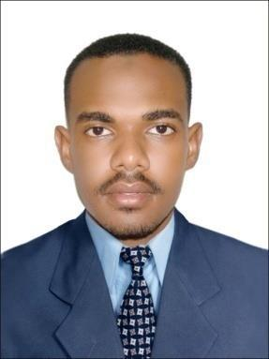

AHMED

NATIONALITY :Sudanese.
DATE OF BIRTH: 14/4/1991.
MARTIAL STATUS: single.
LANGUAGE: Arabic (Mother Tongue).
:English (Excellent).

Email: ahmed.382637@2freemail.com
Driving License: Valid KSA Driving License

Academic Qualifications

- Bachelor of Science in Electrical Engineering from Lyceum North Western University. Philippines 2016

- Diploma in electrical engineering (six semesters),
Sudan University of Science & Technology. Sudan 2010

General Experience in Sudan

  - National Electricity Corporation as Trainee for one Month, I had exposed to :

    - Three phase transformer testing and maintenance.

  - Danfodio Company for Contracting, Roads& Bridges as Trainee for two mothes, I had exposed to:

    - System of Electrical supply and distribuition.
    - Load calculation.
    - Building wiring design.

- Sudan Company for Electricity Distrbution.For two years in.
    - Maintenance of PowrStaytions.
    - Maintenance of Electricity Cables.
    - Maintenance of Electricity Lines.
    - Pre-paid Bills processing Operation.

General Experience in Saudi Arabia

- Enjazat Al-Bilad Contracting Co. For two years at :

  - Saudi Electricity Company.
- Installation Digital Meters(CT/VT)&(CT)

- Programming Meters.

- Maters testing and maintenance.
- The King Abdullah FinacialDistrict.
Load analysis and assessment.
Diversity and demand.
Building wiring and design.

Training Courses

- Electrical Installation.
- Course of AutoCAD (2D&3D) for Electrical Engineering.
- Diploma of Programmable Logic Controllers ( PLC).

- Diploma of Computer.
- Construction Occupational Safety and Health.
- Occupational Safety and Health Officer Course (120 Hours).
  - Competencies in Safety Inspection.
  - Job safety analysis.
  - Working at height safety- Fall Production.
  - Scaffolding Safety.
  - Fire safety.
  - Overview of oil and gas process and hydrogen sulfide safety.
  - Work permit system.
- Project management using PRIMIVERA
- BPO documentation specialist
  - Basic transcription
  - New opportunities of winning
  - BPO strategies
  - BPO career specialization and creative industry
  - Digital office management

Personal Strengths

- Able to work under pressure.

- Open-minded and very keen to learn new methods, applications and technologies.

- Cooperative and a good team player.

