PRASANT
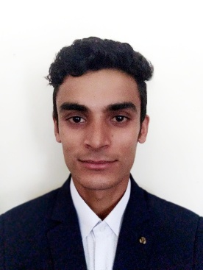
DUBAI – U.A.E
Email: prasant.382641@2freemail.com
Carrier Objective:
To become a competent & dynamic professional working in an organization that places high value on professional growth for self-motivated individuals seeking challenging assignments for responsible positions.
Key Skills:
- Self Motivation
- Excellent interpersonal and communication skills in a professional manner.
- Ability to learn and work under pressure.
- Confident and good team player.
- Ability to learn quickly and adapt to changing environments and willingness to accept responsibilities.
- Ability to deal effectively with multicultural environment
Educational Qualification:
- Completed SLC from Gyankunj Higher Secondary School in 2068 B.S
- Completed basic computer course.
Professional Experience:
Name of the Organization :Red House Jungle Resort
Duration : 5th March 2017 to 20th June 2018
Position held : waiter
Name of the Organization :Annnapurna hotel Kathmandu Nepal
Duration : 2nd Feb 2016 to 7th July 2016
Position held : waiter
Name of the Organization : kantipur hotel Kathmandu Nepal
Duration : 5 months
Position held : waiter

Responsibilities:
- Greet and escort customers.
- Present and provide detailed information when asked by customers.
- Inform customers about the day’s specials offers.
- Offer recommendations upon request
- Communicate order details to the customer
- report any problems to you seniors.
- Provide excellent customer service.
Personal Details:
Date of Birth : 09-10-1995
Nationality : Nepalese
Marital status : Married
Gender : Male
Languages : English, Hindi & Nepali
Personal Details:

Date of Issue : 1st June 2014
Date of Expiry : 31st May 2024
Visa Status : Visit Visa

ASSETS:
Good understanding of Human Behavior, keen desire to achieve Success, Self-Discipline, Optimistic attitude, Good planning skills, spirit of team work and cooperation, Adaptability and learning ability, believe only in results, regular and punctual.
DECLARATION:
I hereby declare that the facts given in resume are correct to best of my knowledge and belief.

