**AKSA**

Dubai, UAE

E-mail: [aksa.382648@2freemail.com](mailto:aksa.382648@2freemail.com)

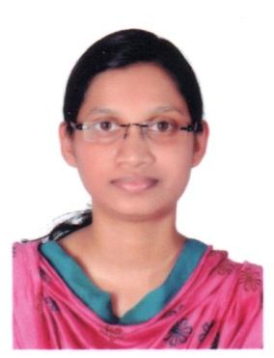**CURRICULUM VITAE**

**OBJECTIVE**

To pursue a career with reputable healthcare facility that allows me to acquire and develop the vital skills and enable me to serve the humanity with utmost care and accuracy. Flexible, quick learner who adapts easily to new situations and enjoys a challenge and self motivated professional with commitment to providing quality patient care

**ACADEMIC CREDENTIALS**



|  |  |  |
| --- | --- | --- |
| **Course** | **University/Board** | **Year** |
| B.Sc Optometry | Bharathiyar University, Tamilnadu. | 2015 |
| HSC | State Board of Higher Secondary Education, Kerala | 2011 |
| SSLC | State Board of examination, Kerala | 2009 |

**PROFESSIONAL LICENCE/REGISTRATION**

|  |  |  |
| --- | --- | --- |
| **DHA-OPTOMETRIST** | **DHA ELIGIBILITY LETTER** |  |

**CAREER HIGHLIGHTS**

|  |  |  |
| --- | --- | --- |
| **INSTITUTION** | **DURATION** | **POSITION** |
| Vasan Eye care Hospital Malappuram | 10/04/2017 - 10/04/2018 | Optometrist |
| I-Trust Eye Care Hospital  Kannur | 10/10/2015 – 31/03/2017 | Optometrist |
| Al salama Eye Hospital,Perinthalmanna | **1**year Internship | Optometrist |

**PROFESSIONAL SKILLS**

* Assisting cataract surgery for adults and childrens.
* Assisting for corneal transplantation.
* Doing refraction ,retinoscopy, A-scan,HFA,Contact Lens,OP Assisting and counseling.
* Attended school screening for identifying defective vision in students.
* Subjective & Objective Refraction
* Contact Lens.
* Knowledge in biometry procedures(Keratometry , A-scan ,Lacrimal syringing )
* Knowledge in Automated Perimetry ( Humphery field analyzer)
* Knowledge In Slit Lamp Procedures
* Orthoptic Examination.
* IOP Measurements.
* Color Vision Testing.
* Emergency Ocular Management.

**KEY ACHEIVEMENTS**

* Attended more than 200 eye camps on Cataract detection, Diabetic Retinopathy Screening and Refractive Error correction under the community ophthalmology wing of Al Salama Eye Hospital, Perinthalmanna.
* Started clinical posting since the first session of the second year of the course
* Attended different CMEs organized at various centers in south India
* Presented several seminars in Al Salama College of Optometry- Kerala
* Conducted a survey on cataract in Angadipuram Municipality and Perinthalmanna Municipality...
* Done a Thesis on the topic of “colour vision changes in diabetic retinopathy pations”
* Experience in teaching theory classes for Opticianary course.

**PERSONAL INFORMATION**

Sex : Female

Age & Date-of-birth : 01-05-1994

Marital Status : Married Nationality : India

Mother Tongue : Malayalam

Languages Known : English, Hindi, Malayalam,

Visa Status : Visit Visa

**EXTRA CURRICULAR INFORMATION**

***Traits:***

Dedicated, efficient & hardworking

Competitive, flexible and committed to the Success of the organization.

Ability to learn and adapt at various settings



Being Trust worthy

A quick learner with Creativity and enthusiasm



***Declaration:***

*I hereby declare that the information furnished above is true to the best of my knowledge and belief.*