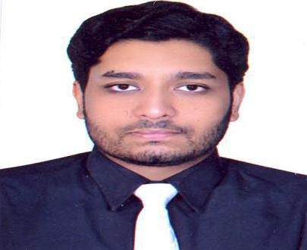
Curriculum Vitae

MUNEEB

MS Construction Management, United Kingdom.

Email: muneeb.382661@2freemail.com

OBJECTIVE:

To build my career in the field of Construction in an excellent organization with the team of brilliant individuals, where my knowledge and expertise can be utilized.

Also I get a chance to enrich my skills in this challenging arena so that my experience becomes worthy.

ACADEMIC PROFILE:
➢ Masters in Construction Management |  | (2008-2010)
University of Salford, Manchester, United Kingdom
➢ B Tech Civil Engineering |  | (2004-2008)
Jawaharlal Nehru Technological University, India

WORK EXPERIENCE:

Dutco Balfour Beatty, Dubai, U.A.E. (2014- till date)

Job Title: Civil Engineer

Projects Executed:
- Service Tunnel - Fountain View Development.
- Dubai Trolley – Downtown Dubai near Dubai Mall.
- Roads and Infrastructure development for Downtown Dubai.
- Installation of Polished TSE Supply network and other activities across Downtown Dubai.

- Installation of 11Kv DEWA cables across Boulevard Road.

Responsibilities:

- Site Management.
- Monitoring work progress.

- Solving problems arising during construction.
- Resource and manpower Management.
- Preparing daily progress reports and 2 week look-ahead programs.

- Getting approvals from authorities like Dubai municipality, DEWA, RTA, Etisalat and DU.

- Preparing drawings.
- Attending meetings organised by client and consultants.

- Managing different sub-contractors.
- Abiding with Health and Safety regulations

City Heights Construction, India | (2010 - 2014)

Job Title: Project Coordinator

Responsibilities:

- Construction of Residential buildings and apartments.

ACHIEVEMENTS:

- Completed Institution of Occupational Safety and Health (I.O.S.H.)
- Scored 7 Bands in International English Language Testing System (I.E.L.T.S)

COMPUTER SKILLS:

MS Office, PRIMAVERA (P6), Auto Cad

STRENGTHS:

- Excellent communication skills

- Ability to work in pressure

- Team player

- Good Leadership skills

- Proactive & Self motivated

PERSONAL DETAILS

Date & Place of Birth | : | 08 Nov 1986, Al- ain, United Arab Emirates.
Nationality | : | Indian
Gender | : | Male
Religion | : | Islam
Marital Status | : | Married
Driving License | : | U.A.E.
Languages Known | : | English, Hindi, Urdu and basic Arabic

DECLARATION:

I hereby declare that above details are correct as per my knowledge.

