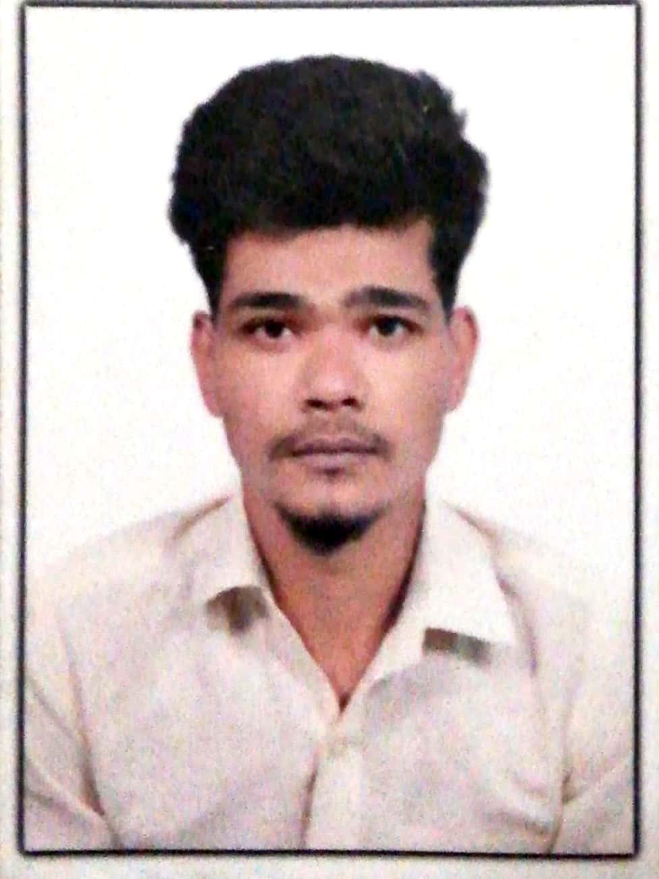
Shakib

Email: - shakib.382668@2freemail.com

UAE - DUBAI

Career Objectives

Dedicated hardworking, sincere, to the assignments with a pleasing personality and keen desire to commit to a career in a deserving and committed post, with skills to achieve my targets with hard work, determination and sincerity.

WORK HISTORY AND SKILLS DEVELOPED

JANUARY2016MAY 2018
WNS GLOBAL, INDIA
Sr. Executive (flipkart )
Customer service

- Handling and assisting the team
- creating new strategies
- Solving queries of the team
- Handling customer inquiries if required

NOVENBER 2014- OCTOBER 2015
SERCOGLOBALSERVICES, India
Sales Executive

- Solving sales related queries
- Promoting new offers
- Preparing sales report
- Ensure pricing is correct and maintainsales report.
- Ensure promotions are accurate.
- Handle the customers complain and issues.

JULY 2013 AUGUST 2014
Digicall -MUMBAI,INDIA
CustomerService and Sales Executive

- Handling the issue of the customer
- Analysis sales report of the Sales team
- Preparation of monthly reports for the Sales term
- Promoting new offers to the customers
- Preparing reports as required by the Management

QUALIFICATION

FEBRUARY2014: Highersecondary-MumbaiUniversity

Personal Details

- Date of Birth :5 march 1994
- Nationality : Indian
- Gender : Male
- Marital Status : Unmarried
- Visa status : Visit visa
- Professional Status : Sales Agent & Customer service

Language Skills

- English
- Hindi
- Basic Arabic

