CURRICULUM VITAE

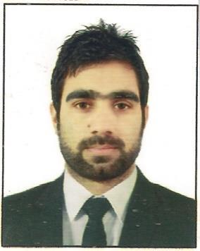

Najar

Email: najar.382680@2freemail.com

Career Objective:

To obtain a position that challenges me and provides me the opportunity to utilize my professional skills and experience with full potential in your organization that is progressive technically and intellectually.

Work Experience:

2 Years of Professional Experience.

- Worked as Assistant Mechanical Engineer in Harshna Naturals Private Limited, IGC Lassipora, Kashmir.

Duties & Responsibilities:
- Maintenance of machines and HVAC Ducts.

- To operate chiller and other machines.

- To keep a record of temperature in every chamber on daily basis.

- Worked as Trainee Engineer in Aadil Hamdaan Alsobhi Establishment in Saudi Arabia.

Duties & Responsibilities:
- To assist Senior Engineer in keeping daily data.

- To keep record of the material received on daily basis.

- Worked as Sales Engineer in Spinny Auto Rev Pvt. Ltd, New Delhi.

Duties & Responsibilities:
- To help customers to choose a better product according to their profile.

- To describe the products in detail to customers.

Educational Qualifications:

Degree/certification | Institution/Board | Year | CGPA/ %age
B.Tech (ME) | Lovely Professional University | 2015 | 7.59
 | Jalandhar Punjab.
SSC | J&K State Board | 2010 | 79
HSC | J&K State Board | 2008 | 73

Technical Skills:

- AutoCAD 2D/3D

- HVAC Designing

Project Undertaken:

Project Name: Vapor Absorption Refrigeration System (VARS)

Description: Modified Vapor Absorption Refrigeration System to increase the Coefficient of Performance (CoP) by adding Cellulose Pad and a fan.

Internship:

Organization: Mechanical Engineering Division, Anantnag , Jammu & Kashmir.

Description: Worked as a trainee in the engine repairing and servicing department.

Extra-Curricular Activities:

Inter school Quiz Competition (2008).

Inter school Cricket Tournament (2008)

Awards and Honours:

Best Student of The Year (2008)

Captain of School Cricket Team (2008)

Languages Known:

- English: Fluent in Speaking and writing

- Urdu: Fluent in speaking and writing

- Arabic: Beginner

Hobbies:

Playing games on PC and Watching Wrestling.

Personal Details:

Nationality: Indian

Marital Status: Unmarried

Date of Birth: August 03, 1992

Gender: Male

