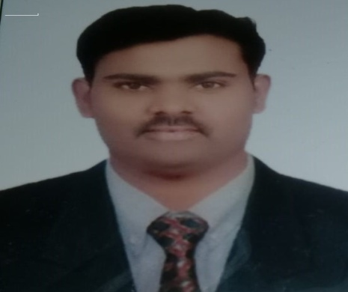
naveen

Email: naveen.382695@2freemail.com
Current Location: Dubai
Visa type: Employment Visa

Career Objective
I would like to contribute my qualification and working experience in challenging environment to the profitability of the organization. I have been successful in all my endeavors so far and believe in growth with the company.
Education & Credentials
- Graduated B.SC (BZC) with aggregate of 70% from Osmania Hyderabad, India.

Technical Skills
- Microsoft applications (Word, Excel, Office, PowerPoint, Outlook,) – Advanced
- Understanding of Windows 95, XP, 7,8.1,10
- Typing speed 30-40 wpm
- Excellent at Searching and Web Browsing skills.

Work Summary:
- Worked 3 and half years as a Assistant store keeper in Bahrain.

Employer : AL Hamad Construction & Development Company LLC

Position : Assitant Store Keeper

Period : June 2008 – Dec 2011

Job Description
      - To exercise general control over all activities in store department.
      - To ensure safekeeping both as to quality and quantity of materials.
      - To maintain proper records.
      - To initiate purchase requisitions for the replacement of stock of all regular stores items whenever the stock level of any item of store approaches the minimum limit fixed in respect thereof.
      - To initiate action for stoppage of further purchasing when the stock level approaches the maximum limit.
      - To check and receive purchased materials forwarded by the receiving department and to arrange for the storage in appropriate places.
      - To reserve a particular material for a specific job when so required.
      - To issue materials only in required quantities against authorized requisition notes or material list.
      - To check the book balances, with the actual physical stock at frequent intervals by way of internal control over wrong issues, pilferage etc.

Strengths:

      - Strong patience and self confidence, good interaction abilities.
      - Ability to demonstrate commitment and communicate professionally during stressful situations, maintaining composure and resolving problems effectively and positively.
      - Manage multiple tasks and respond to urgent requests in a positive manner.
      - Good interpersonal skills and strong analytical capabilities.
      - Team facilitator hard worker, quick learner, proactive, team player attitude.

Language Skills

- English - Advanced
- Hindi - Advanced
- Telugu - Native Tongue

Interests & Activities

- Travelling, Movies, Cricket, Volley Ball, Surfing

Personal Details:

- Date of Birth : 22-Nov-1984
- Nationality : Indian
- Marital Status : Married

