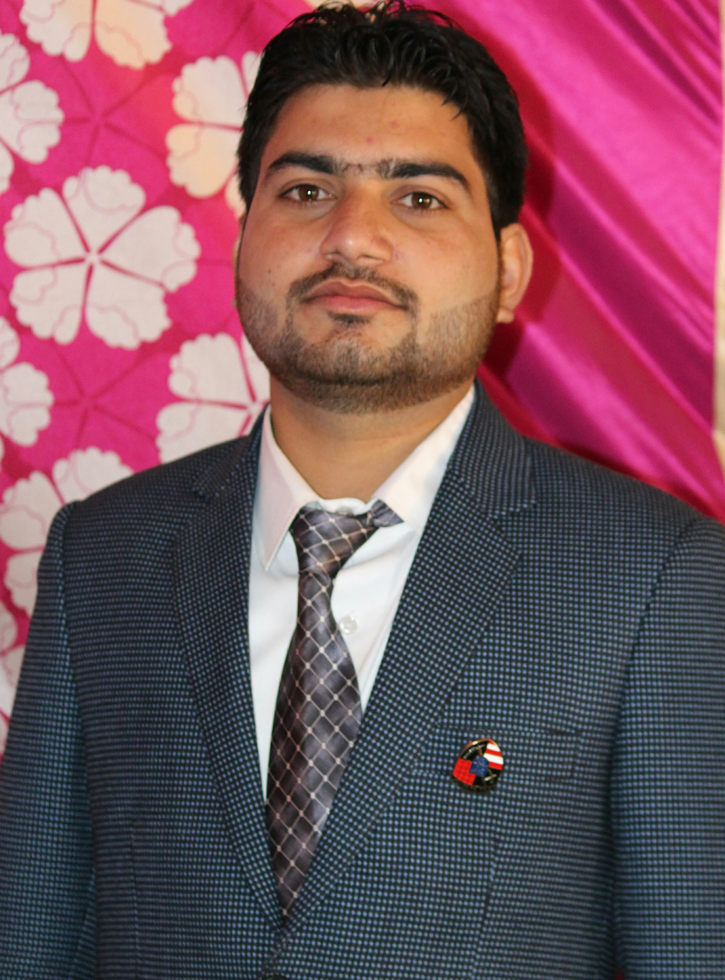
taj

Industrial Automation engineer with India Experience

E- MAIL: taj.382707@2freemail.com

CAREER OBJECTIVE:
Seeking for an opportunity to work with an organization that will provide a platform to utilize my technical skills and enrich my knowledge to help in the progress of organization.

PROFESSIONAL EXPERIENCE:
Experience | Destination | Post | company
3- years | Industrial automation engineer | PLC programmer | Vertex groups.com

RESPONSIBILITIES AND ROLE DETAILS:

- PLCs Programming MITSUBISHI SERIES of FX Series & Q- Series models.
- HMI programming of (GOT 1000 & 2000 & GS-2117 WTBD) created of HMI screens.
- AC- SERVO MOTOR & DC SERVO MOTOR parameter settings.
- VERIABLE FREQUIENCY DRIVE (VFD) Programming of j2 & j3 & j4 series models.
- ROBOTIC programming & teaching also completed.
- SCADA of programming Wonder ware software.
- Troubleshooting of completed automation panels.
- Modification of completed PLCs programming.
- Testing of I/Os PLCs hardware & software and LT panels testing.

ADDITIONAL CERTIFICATION:

- 6- weeks vocational training at 132Kv substation from roorkee
- 50- days PLE SCADA course from CETPA classes roorkee
- English speaking course 6- months from Howard institute roorkee
- NCC (National cadet core) from Dehradun.
- 6- Months Industrial automation course from softcon noida delhi

ACADEMY QUALIFICATION:

Roorkee College of engineering, Approved by AICTE, of HRD (Govt. of India), Affiliated to Uttrakhand Technical University, Dehradun Affiliated to Uttrakhand Board of Technical Education, Roorkee.
Educations | Year | Board / University
10th class | 2010 | UK board Uttrakhand INDIA
12th class | 2012 | UK board Uttrakhand INDIA
B. tech | 2012-16 | UTU Dehradun INDIA

.

PERSONAL QUALITY:
- Result oriented
- Quick learner
- Responsible and sincere
- Excellent communication skills and interpersonal skills
- Can be face the challenging jobs
- Good knowledge of all Industrial Automation machine

STRENGTHS:
- Positive attitude
- Confident
- Sincere
- Adaptability
- Honesty

PERSOANAL DETAILS:

Marital Single
Nationality Indian
Date Of Birth 25/06/1994
Religion Muslim
Gender Male
Language Known English, Hindi & Urdu (Read & Write)

DECLARATION
I hereby declare that all the above information mentioned particulars are true to the best of my knowledge.

