NIHANA
nihana.382718@2freemail.com
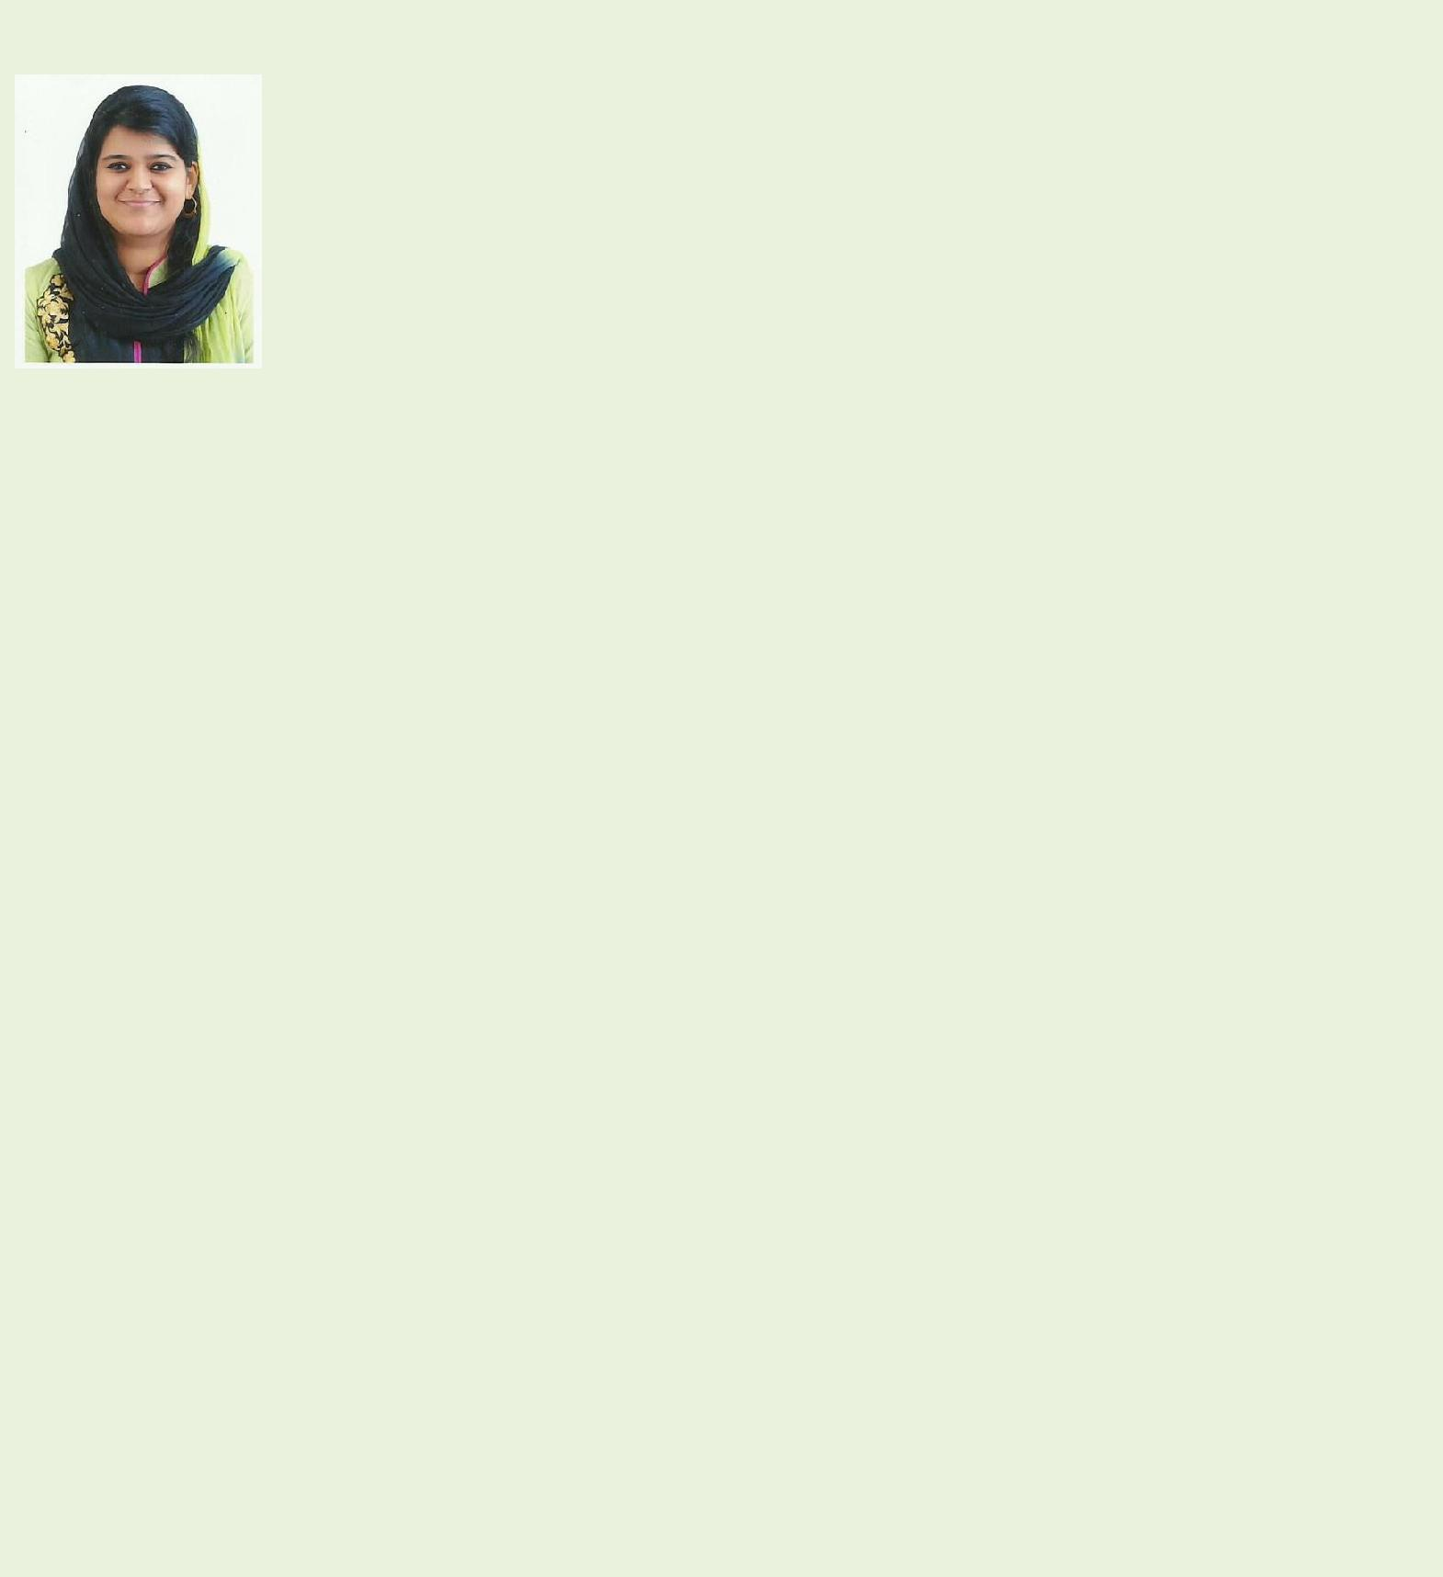

KNOWLEDGE and SKILL AREAS:

Software Development Lifecycle

Object-Oriented Programming

Problem Analysis & Resolution Technical and End User Documentation

Software Unit Testing & Troubleshooting

Project Teamwork & Communications

Maintain positive client interactions

Accurate estimation of delivery timescales

An analytical software developer with B.Tech degree, strong educational background in programming and more than 3 years hands on experience using cutting-edge development tools. Articulate and professional communication skills, including formal presentations and technical documentation. Productive in both team-based and self-managed works.

TECHNICAL SKILLS:
Programming Languages | C,C++,Java, VB.Net
Framework | Struts Framework, J2EE, .NET
 | Framework
Servers | Oracle Weblogic Application Server,
 | Apache tomcat, BEA Weblogic Server
Technology Platform worked | J2EE and Oracle RDBMS
with
WORK EXPERIENCE:
AKST Global
United Arab Emirates, Sharjah

Software Developer [Aug 2016 - present]

- Working with AKST’s ERP system, ‘Readysoft’ that integrates all facets of the operations dealing with readymix concrete business.

- Effective requirement capture from clients.

- Proper analysis of the requirement and the effectiveness of all the realizable solutions.

- Implementing the solution following the optimized coding standards.

- Efficient testing to ensure bug free deliverables.

- Takes every effort to ensure timely release within deadlines.

- Expertise in analyzing the impact of any solution to the existing system.

- Been a part of some major changes to the ERP systems and successful bug-free releases.

- Worked on many critical report generations from purged data.

- Worked on content management system to modify the website.

ACADEMIA:

Bachelor of

Technology

specialized in

Computer Science

Engineering from

Marian

Engineering

College, [2014]

Trivandrum, Kerala

GPA 8.04

Schooling Completed in UAE 12th-74.6% [2010]

10th-82.2% [2008]

LANGUAGES:
English,

Malayalam, Tamil

- Formal presentation of the works performed.

IBS SOFTWARE SOLUTIONS
Technopark, Trivandrum, Kerala

Software Developer [2014- April 2016]

- Worked with IBS’ largest project ‘iCargo’ for one of the major air cargo carriers, Qantas Freight.

- In depth business knowledge to identify the pain points and provide better services and solutions.

- Design and implement the most appropriate Object-Oriented software solutions for the software application.

- Proper documentation of the changes made to the application according to the department standards

- Presentation of seminars and knowledge transfers.

- Trained and mentored engineers in the team and provided comprehensive technical guidance.

- Undertook challenging Tasks and completion on or prior to the estimated time.

- Interactive participation in meetings and make valuable contributions.

- Participation in the development of various critical releases.

- Troubleshoot various software issues.

PERSONAL INFORMATION: Date of Birth-10th December 1992

Sex- Female

Nationality-

Indian

*References and additional information will be

gladly provided upon request.

NON-TECHNICAL SKILLS:
- Unmatchable Communication and presentation skills

- Excellent documentation skills

- Reliable, efficient and experienced in working with medium to large-scale teams.
- Quick learner

- Flexibility and Adaptability to work in any environment.

- Willingness to accept any challenge irrespective of its complexity.

ACCOMPLISHMENTS:

- Successful development and implementation of several new functionality requirements from the customer and released with least or no bugs.

- Stood first for the Second and Seventh Semester, and second for the rest of the semesters in College.
- Cleared the Infosys’ Innovative programming contest Aspirations 2020

- Presented the IEEE 2013 journal on Cuffless Differential Blood Pressure Estimation Using Smartphone.

