SUMITH

Result-oriented professional targeting challenging assignments in Accounting with an organization of repute preferably in UAE.

sumith.382727@2freemail.com

Key Skills

Accounts Finalization

Accounts Payable& Receivable

Cash Flow Management

Account Reconciliations

Payroll Management

Accounts Consolidation

Export Documentation& Submission

ERP ,Tally, Orion

Day today accounting

Profile Summary

An accomplished and dedicated individual with rich experience of 10 years in Accounting, Finalization of Accounts, Accounts Consolidations, Reconciliations, Tax Assessment, Costing, Budgeting and Reporting & Documentation
Offering skills in preparation, finalization, and consolidation of accounts like Balance Sheet, P/L Accounts, Accrued Account, and so on
Skilled in managing the daily cash flow & petty cash activities and preparing daily accounting entries in Tally ERP 9
Experience in preparing various returns like the Sales Tax Return, Income Tax Return, TDS, and Service Tax Return
Entrusted with the responsibility to manage the payroll related accounting tasks including reconciliation of salary and entry of the records in the ERP system
Expertise in managing day-to-day processing of Accounts Payable (AP) and Accounts Receivables (AR) transactions to ensure that organizational finances were maintained in an effective, up-to-date and accurate manner

Possess skills in using different ERP tools like Tally ERP 9, Orion, and Microsoft Dynamic Navation for efficiently executing the accounting tasks

Excellent communication, analytical, and coordination skills with the capability for driving teams to excel and win

Education

ICAI INTER from The Institute of Cost Accountants of India in 2008

MBA from Bharathiar University, India in 2012

M.Com. from MG University, India in 2008

Accounts Manager/ Oasis Group Palakkad, Kerala.

Accountant / Sedar Décor Factory LLC Sharjah, UAE.
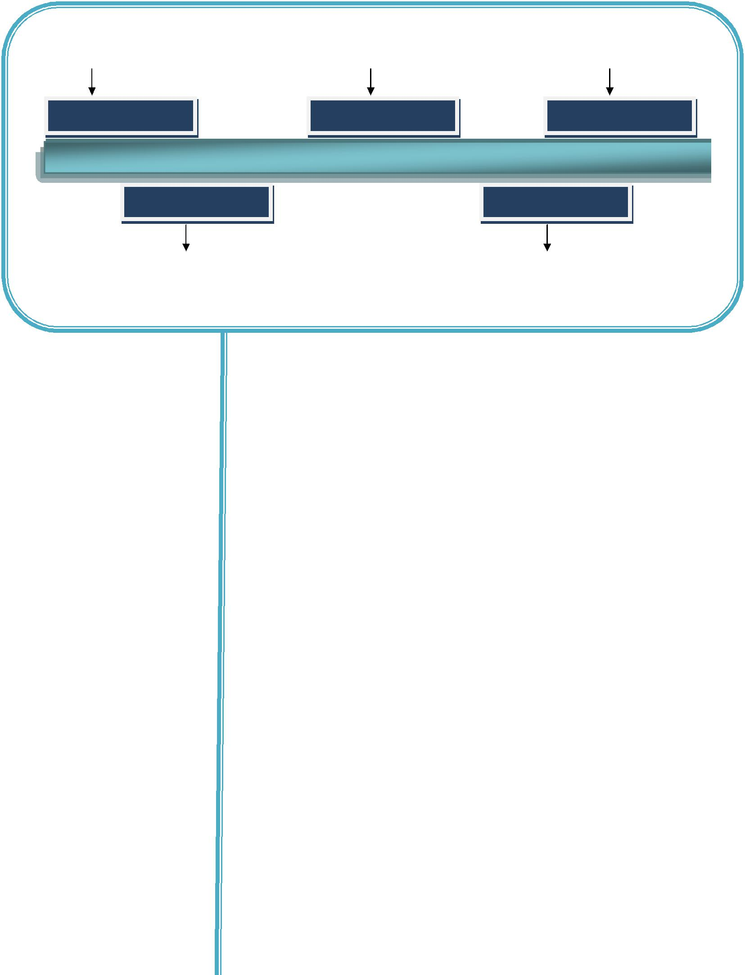

Senior Accountant/Cubes Interior concepts Pvt Ltd Cochin, Kerala.

Oct 2015 | - | June 2018 | March 2013 | - | Aug 2015 | Aug 2012 | - | Feb 2013

Dec

2008-

April

2012

July

2008-

Nov

2008

Internal Auditing & Accounts Finalization Executive/ Kerala State Backward Classes development corporation ltd Kerala, India.

Accountant/ Mardec RK Latex Pvt Ltd.

Cochin, Kerala.

Work Experience

Oct’ 15 – Jun ’18

Accounts Manager, Oasis Group, Palakkad, Kerala, India
Oasis Group includes – Waseem Asset Management Co Pvt Ltd, Alsatech

Renewable Energy Pvt Ltd, Waseem Real Estate Co Pvt Ltd, Oasis
International, Oasis Residency, Oasis Guest House, Oasis Tourist Home.

Mar’ 13 – Aug ’15

Aug ’12– Feb’ 13

Dec ’08– Apr ’12

Jul ’08 – Nov ’08

Accountant , Sedar Decor Factory LLC, Sharjah, UAE

Senior Accountant , Cubes Interior Concepts Pvt Ltd,Cochin, Kerala, India

Internal Auditing & Accounts Finalization Executive, Kerala State Backward
Classes Devolvement Corporation LTD , Kerala, India

Accountant, Mardec RK Latex Pvt Ltd, Cochin, Kerala, India

Key Result Areas:

- Complete control over financial & cost accounting.

- Internal auditing and finalization of accounts

- Preparation and checking of Profit & Loss A/c, Balance Sheet, checking inflow and outflow of funds, etc.

- Control over inventory management and reconciliation of inventory on monthly basis.

- Reconciliation of Bank Accounts and Related company accounts

- Preparation & Maintenance of Vouchers

- Handling Tax Matters

- Monthly and timely closing of Accounts.

- Posting of sales, purchase, journal, fixed asset, recurring, adjustment entries, etc.

- Liaising with bank, arrange and submit all necessary documents to the Bank.

- Control over Accounts Receivables- follow up of payment, preparation

and analysis of ageing report and reconciliation of customer accounts.

IT Skills

ERP Software:

Applications:

Personal Details

Date of Birth:
Languages Known:

Nationality:
Marital Status:

:

Declaration

- Control Over accounts payable-supplier accounts reconciliation and timely payment.
- Budget co-ordination and preparation.

- Pay roll Accounting

- Maintenance of Fixed asset register.

- Can independently perform all accounting and administration functions.

- Utility Payments – Telephone ,Electricity & Gas –for Office ,Stores &Accommodations; Maintain control sheet and ensuring the payment before due date

- Verifying recorded transactions and reporting irregularities to Management.

- Maintaining Project wise register and calculating project wise expenses.

- Tracking items purchased & previous purchased rates; tracking supplier wise purchase details & outstanding balances.

Tally ERP 9, ERP Software Orion

MS Office, Windows Applications

22nd January 1985

English, Hindi and Malayalam.
Married

I hereby declare that the information and facts furnished above are true to the best of my knowledge and belief.

