DEEPU

Deepu.382731@2freemail.com
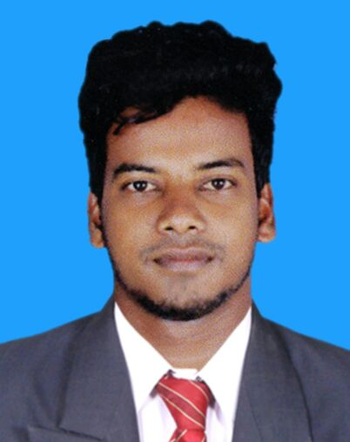

PERSONAL PROFILE:

I am a very ambitious, enthusiastic, flexible, organized and co-operative team member that enjoys producing high quality outputs, planning projects and seeing them through to completion. I am willing to take up new challenges. I always aim to fulfill my responsibilities to the highest standard of quality and professionalism as I consider professional development as my basic objective on all roles that I have been assigned.

OBJECTIVE:

Seeking a career in Production or Quality control. Hoping to capitalize on my education, strong interpersonal skills, excellent organizational abilities and business experience.

PROFESSIONAL SYNOPSIS:
- A competent professional offering over 2 years of experience in Production& Quality Control.
- Ensure full awareness of all products provided and is constantly updated on all changes and amendments on product features, procedures and processes.
- Excellent communication and people management skills that have been honed through managing multi- skilled teams.

CAREER CONTOUR:-

Worked in Sri GajalakshmiEngg Works (ISO Certified Company), Vellore,India. asProduction andQuality Check Inspection., Period May- 2016 to May 2018.

Roles:

- Identifying the Quality of Part Assemblies.
- Ensuring preventive action.
- Product dispatching.
- Analyzing the problems

EDUCATIONAL QUALIFICATION: -

Bachelor of Engineering – Mechanical: 2012 – 2016

TECHNICAL DETAILS: -

Operating System: Windows, MS Office, Auto CAD

PERSONAL PROFILE

Date of Birth : 05/09/1994
Gender : Male
Marital Status : Single
Language Know : English, Tamil and Malayalam
Nationality : Indian

