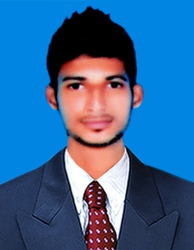
RESUME

JAISAN

Jaisan.382733@2freemail.com

PERSONAL PROFILE:

I am a very ambitious, enthusiastic, flexible, organized and co-operative team member that enjoys producing high quality outputs, planning projects and seeing them through to completion. I am willing to take up new challenges. I always aim to fulfill my responsibilities to the highest standard of quality and professionalism as I consider professional development as my basic objective on all roles that I have been assigned.

OBJECTIVE:

Seeking a career in Production or Quality control. Hoping to capitalize on my education, strong interpersonal skills, excellent organizational abilities and business experience.

PROFESSIONAL SYNOPSIS:

- A competent professional offering over 2 years of experience in Production& Quality Control.
- Ensure full awareness of all products provided and is constantly updated on all changes and amendments on product features, procedures and processes.
- Excellent communication and people management skills that have been honed through managing multi- skilled teams.

CAREER CONTOUR:-

Working with Sri Gajalakshmi Engg Works,(ISO Certified Company),Vellore, India
as production& Quality control dept.

Roles:
- Checking equipment and doing preventative maintenance to ensure it's in good working order
- Setting up quality-control procedures
- Product Dispatching
SKILLS & COMPETENCES: -
- Convert Basic Design information & requirements into working drawing
- Comfortable Writing Technical Reports
- Good numerical skills and an understanding of statistics.
- Communication and interpersonal skills.
- Problem-solving skills
- Specifying quality requirements of raw materials with suppliers

EDUCATIONAL QUALIFICATION: -

Bachelor of Engineering– Mechanical (2012 – 2016)

TECHNICAL DETAILS: -

Operating System: Windows, MS office& CAD

PASSPORT DETAILS: -

Date of Issue : 01-09-2016
Date or Expiry : 31-08-2026

PERSONAL PROFILE

Date of Birth : 27/02/1995
Gender : Male
Marital Status : Single
Language Know : English, Tamil and Malayalam
Nationality : Indian

