RESUME
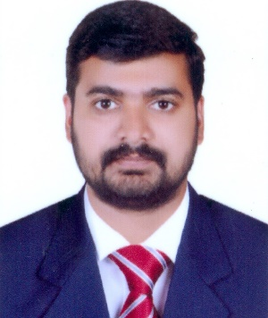
Tom

Email: tom.382736@2freemail.com
Dubai, UAE

Career Objective

To secure an appropriate position, this will provide growth opportunities with effective utilization of my skills and experiences also the opportunity to learn more in professional Atmosphere.

Modules Covered

Fundamentals of computer

- MS-Office: MS-Word, MS-Excel
- Operating System: Windows
- Accounting Software: Tally ERP 9, Quick Book

Areas of Expertise
- Sales And Marketing  - Financial Accounting  - Banks Dealing | - Accounts Receivable  - Fixed Assets  - Petty Cash Management  - Team Building | - Accounts Payable  - Invoicing  - Intercompany Transactions  - Administration Handling

Professional Experience

From July 2016 to July 2018.
Worked as Sales Executive&Assistant Accountant atGolden Touch Computer Graphics Design Services. Deira, Dubai.

JOB PROFILE
- Responsible for assigned sales targets (monthly, quarterly and annually).
- Goals set for centers month on month, maintaining relationship with target customers, customer service, ensuring high rate of return on investment, sales support and sales.
- Proper execution of order and dispatch it on time,
- Follow up for payment.
- Develop new sample for client.
- Maintain good relation with client.
- Preparation of Payment and Receipt Vouchers.
- Booking entries of sales and purchase.
- Daily, weekly, fortnightly and monthly reporting to regional office.

Education
- B.COM (COMPUTER APPLICATION) From IGNOU (2015)

Personal Profile

Date of Birth : 17/12/1994
Nationality : Indian
Marital Status : Single
Languages Known : English, Hindi, Tamil, Malayalam.
Visa Status : Employment Visa Till 20 Aug 2018.
Driving License :Valid UAE Driving License

DECLARATION

I hereby, vouch that the details mentioned above are true to the best of my knowledge and belief.

