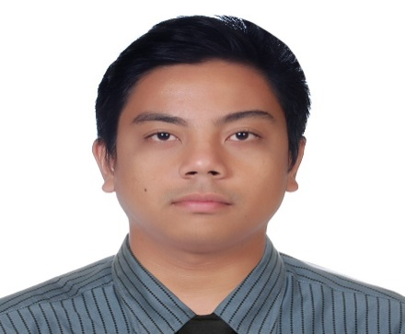
GLEXER
EMAIL: glexer.382805@2freemail.com

Summary

A self-driven and motivated Licensed chemical engineer with 2 years of experience in quality control process and proficient in interpreting data and performing root-cause investigations to implement corrective actions. A high-level performer with the ability to integrate test methods to assure the quality of assigned products and components. Adept in tracking and reporting quality metrics. Offering expertise in Production planning and 2 years of performance excellence. Proficient in using Aspen Plus V8.6.Suervised a team responsible for end line production of the company

SKILLS

- Workflow schedules
- Process simulation ( Visio and Aspen V8.6)
- Professional Engineering License
- Quality control
- Chemical processing
- Analytical equipment
- Strong decision maker

EXPERIENCE

12/2017 to 03/2018Technical Service Engineer
Alcophil Metal Inc. － Valenzuela, NCR
- To ensure the quality of the product according to the standard protocol of the company
- Diagnose and troubleshooting the technical issues on the quality of the product

01/2016 to 08/2016 Technical Foreman
Lloyd Laboratories Inc － Malolos, Central Luzon
- Production Planning and Weekly report
- Withdraws the raw materials from the dispensing area as per job order requirement a day before the compounding schedule
- Monitors and approves the proper filling of batch documents both master production records and all related logbooks
- Checks and approves the correctness of coded lot number, manufacturing and expiry dates on labels and trade boxes
- Assist the supervisor in carrying out solutions to technical problems encountered on duration of the process
- Creates, reviews and revises standard Operating Procedure(SOP) and record form pertinent to their area of assignment

02/2016 to 06/2018 Quality Assurance Engineer (Practicum Trainee)
Coca Cola FEMSA Philippines － Meycauayan, Bulacan
- Conduct qualitative and quantitative testing of beverages , syrups and raw materials throughout the process
- Conduct water and syrup analysis
- Ensure the package quality inspection
- Test the CO2 level of sample product every hour

EDUCATION AND TRAINING
2016 Bachelor of Science: B.S Chemical Engineering
Mapua Institute of Technology Intramuros Campus － Manila, NCR
- Thesis: : Simulation of Post Combustion Carbon Dioxide Capture Using [BMIM]- Based Ionic Liquid Solvent using Aspen V8.6
- Process and Equipment Plant design : Production of carbon steel
- Specalization track : Petroleum Engineering
- Industrial waste management and control : Textile industry
- Environmental Engineering and Environmental Safety : Life Cycle assessment of Polyethylene terephthalate (PET) bottles
- Chemical reaction ( Reactor design) : Design of a Plug Flow Reactor for the Production of Fructose by Isomerization of Glucose Using Sn-Beta as catalyst
2010 High School Diploma
Meycauayan College － Meycauayan, Central Luzon
- Special Science Class
- Captain ball of Sepak takraw varsity team 2008-2010
2006
Elementary
Sophia School － Meycauayan, Bulacan
- With high honor

cERTIFICATES AND TRAININGS
- Seminar for new employess (cCGMP, ISO awareness, IT policy and health and safety

