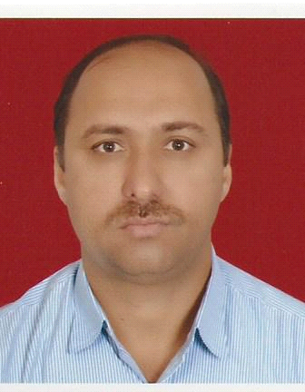
CARRICULAM VITAE

Noor

Email: noor.382818@2freemail.com

Objective:

Seeking Challenging and responsible position in an enterprising organization where opportunities exist for knowledge enhancement and professional growth.
Experience:
- 19 Years experience as a Fireman & pump operator by in associated with Abu Dhabi Marine Operating Company (ADMA) Das fire service
During his service he has attended emergency incidents which include:-
- Hydrocarbon Fires
- Commercial and Domestic Fires
- Gas Leaks
- Aircraft Incidents
- Casualty Handling
- Pump Operation
- Emergency Tender Lighting
- Chemical Spillage
- Marine Incident.
His routine responsibilities included the maintenance of the following items of fire service equipment:-
- Breathing Apparatus
- Resuscitators
- Fire Hose
- Firemain Valves and Fittings
- Fire Extinguishers
- Fixed and Portable fire fighting Equipment
- Rescue Equipment
- Fire Fighting Vehicle
Personal Details
Nationality : Pakistan
Date of Birth : 01/01/1970
Gender : Male
Religion : Muslim
Marital Status : Married
Language Known : English, Arabic, Urdu, Hindi
Educational Qualification
- Secondary School
Passport Details
- Date of Expiry : 27/12/2025
- Place of issue : Pakistan
Declaration
I hereby declared that all statement in this resume are true, complete and correct to the best of knowledge and belief.

