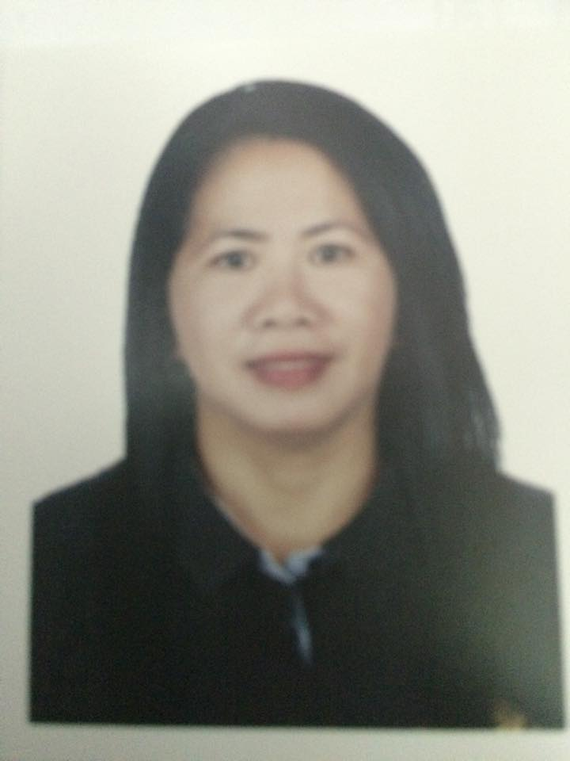
AURORA
Email: aurora.382819@2freemail.com
Language Spoken: English, Arabic, Tagalog
OBJECTIVE:
To secure a competitive position in a company where in I can prove and profound my skills as an individual. To expand my proficiency through the challenges and opportunity that may arise during my employment.
WORK EXPERIENCES:
- GULF BRIDGE INTERNATIONAL
Media City, Dubai UAE
Company Driver
January 20, 2015 – up to present

Duties and Responsibilities:
- Routine check-up(Oil, Brake, Lights, Radiator water, Tire pressure, Fuel consumption).
- Maintain assigned vehicles always clean and in good condition, necessary maintenance such as washing and /or cleaning of assigned vehicles shall be done and scheduled properly.
- Process the license of the company cars, deposited accounts in the banks.
- Perform miscellaneous clerical functions and special projects as assigned.

- GOLDEN BEACH NURSERY
Umm Suqeim 3, Street 17A, Villa 24 Dubai UAE
Personnel Report Officer (PRO) cum Lady Driver (School Bus)
December 30, 2012 until December 31, 2014
Duties and Responsibilities:
- Communicating in different government agencies.
- Process the contract, labor identification card of employees,renewal of license of school and other facilities.
- Keep the file 201 of employees.
- Attentive to traffic and weather conditions while staying on schedule and ensuring the safety of passengers.
- Must ensure that their vehicles are operating properly each day by testing brakes, tires and other components.
- Responsible for maintaining a safe environment within the bus by enforcing rules of conduct and responding to emergencies.
- Must keep track of the amount of fuel used, number of students transported and miles driven, which they typically report to supervisors each week.

- FAMILY LADY DRIVER
September 15 2008 to November 12, 2012

Duties and Responsibilities:
- Shall maintain assigned vehicles always clean and in good condition, necessary maintenance such as washing and /or cleaning.
- Shall endeavor to give attention of the client or its passenger whenever or wherever.
- Shall always drive the client vehicles safely and comfortably and must exercise defensive driving while on the road to prevent accident.

- LADY FAMILY DRIVER
Sharjah, UAE
April 04, 2004 to August 12, 2008
Duties and Responsibilities:
- Shall maintain assigned vehicles always clean and in good condition, necessary maintenance such as washing and /or cleaning.
- Shall endeavour to give attention of the client or its passenger whenever or wherever.
- Shall always drive the client vehicles safely and comfortably and must exercise defensive driving while on the road to prevent accident.
EDUCATION:
Vocational Course Baliuag Colleges,
Baliuag Bulacan, Philippines
Computer Programming
1984-1985
SEMINAR AND TRAINING:
- Lady Driver (School Bus) training and seminar
Roads and Transport Authority
Dubai, UAE
May 06, 2013

SKILLS:
- Good communication skills and professional presentation.
- Energetic, smart & excellent communicator in English.
- Team player with ability to work independently.
- Can work in minimal supervision.
- Optimistic and strong urge for self-development
- Computer Literate
PERSONAL DATA:
Date of Birth January 15, 1965
Citizenship Filipino
I hereby certify that the above statement are true and correct with the best of my knowledge and ability.

Aurora

