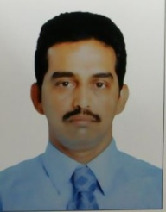
JERALD

Email Id: jerald.382833@2freemail.com

PERSONAL PROFILE

Gender : Male

Marital status : Married

Nationality : Indian

Religion : Christian - Roman Catholic
Driving License : Valid UAE driving License

Languages Known : English, Hindi, Arabic

Date of Birth : 01/01/1963

EDUCATION QUALIFICAIONS

SSC (10th Standard) Pass.

WORK EXPERIENCE

Worked in Kingdom of Bahrain as a Cleaner/ Room boy in Housekeeping division for 3 years.

Worked in Oman at Al Waheed Cateering Comapny as a Cleaner for 1 year.

- Worked in State of Kuwait Al Zahim Tire Retreading co as a helper (A/C Spare parts shop and workshop) for 3 years.

DECLARATION

I, hereby declare that the above mentioned information are true to the best of my knowledge.

