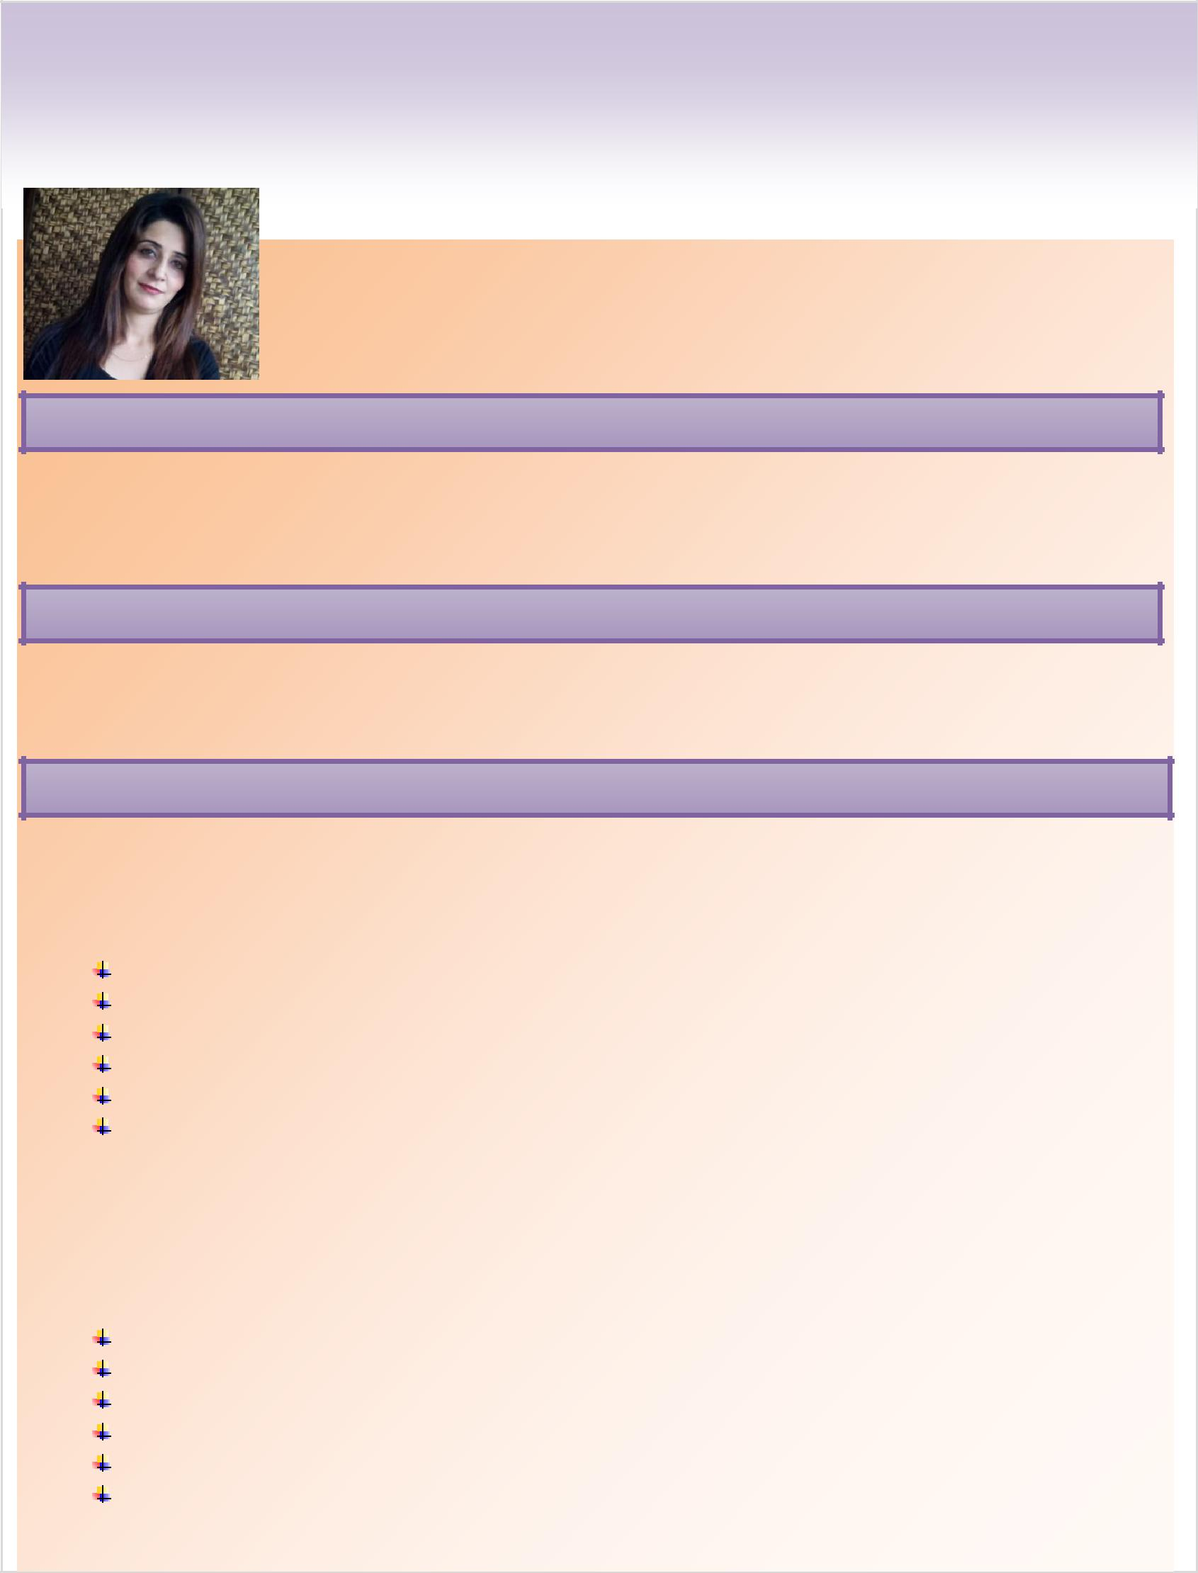
LUBNA

E-Mail: Lubna.382837@2freemail.com

OBJECTIVE

Result-oriented professional with a proven record of achievement in conceiving & implementing effective ideas; targeting top level assignments in accounts, banking and sales & marketing with a leading organization of repute

SKILLS & ABILITIES

Expert in handling counter cash and daily transactions, book keeping.

EXPERIENCE

Sales Lady,Jannat MAll

1-Year Working Experience as a Sales lady in Jannat Mall from December 2016 to December

2017.

Launching and distributing several products

Recruiting, interviewing and training several sales staff

Boosting sales in my department every month

Researching the market on a regular basis for related products

Arranging several effective client demonstrations

Liaising with the suppliers in order to make sure that existing orders increase

Cashier, Faysal Bank

1-Year Working Experience as a Cashier in Faysal Bank Rawalpindi from December 2015 to December 2016.

Help customers in person and telephonically

Deal with customer inquiries and complaints

Process sales and payments

Issue refunds and credits

Process returns and exchanges

Balance sales and receipts

Maintain records of all transactions

Wrap merchandise

Monitor inventory

Assist with product display and pricing

Teller, The Bank of Punjab

2-Year Working Experience as a Teller in The Bank of Punjab from December 2013 to October 2015.

Greeting customers when they come to the till, enquiring about their banking needs.

Processing customer deposits, withdrawals, and payments in a professional manner.

Tactfully recommending bank products that meet a customer’s precise needs.

Checking cheques and making sure they have been correctly written out and dated. Shredding confidential documents that are no longer needed and must be destroyed.

Checking and verifying the identification of customers who ask for banking services.

Answering basic customer questions regarding interest rates and the banks services. Transferring large and small funds from one customers account to another.

Addressing bank customers by their name, along with a smile and direct eye contact Opening new accounts for customers by helping them to fill in the right forms.

Completing all given tasks on time to legal requirements and negotiated deadlines

EDUCATION

Bachelor of Commerce, Punjab University.

Intermediate of Commerce, Mirpur Board.

Matriculation , Mirpur Board.

CERTIFICATION

Post Graduate Diploma in Information Technology from Skill Development Council Punjab Lahore.

Proficient in MS Office (Excel, Word, PowerPoint, Outlook) & in Page.

PERSONAL DETAILS ₂

Date of Birth:

Marital Status:

Languages Known:

Address:

Citizen:

Visa Status :

Driving License (Pakistan)

10th December 1985

Single

English, Punjabi, Urdu and Kashmiri (Read, Write and
Speak) and Arabic (Read & Write)

Bur Dubai UAE.

Pakistan.

Visit visa

Yes

I hereby declare that the above information is true to the best of my knowledge and belief

3

