ABDUL

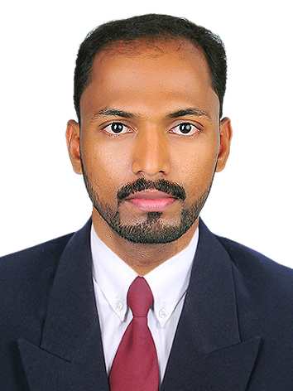
E-mail : abdul.382849@2freemail.com

Qualification : M Com. Finance
Position : Accountant
Visa Type : Visit Visa (UAE)

CAREER OBJECTIVE

Seeking a challenging position in a progressive organization offering a challenging job that commensurate with my qualification and experience in Accounting, whereby I can utilize my talents and skills acquired for enhancing career prospects and also to contribute a lot more for the betterment of the organization employed.

INTER PERSONAL SKILLS

- Energetic Personality with good communication skills.
- Ready to work under pressure.
- Advanced administrative, commercial and management reporting skills.
- Adapts changes and able to learn new job and task quickly.

PROFESSIONAL EXPERIENCE

More than 5 years experience as Accountant.
Organization : Lock mate Locks and Hardwares, Ramanattukara, Calicut, Kerala
Period : From 02/06/2011 to 31/032018

MY ROLE

- Compile and analyze financial information’s and documents to prepare books of accounts and its finalization.
- Maintenance of Day Book and ledgers
- Maintain Cash and accurately record cash transactions.
- Prepare Income Statement and Balance Sheet
- Preparation of cash flow and fund flow statements
- Payroll preparation and Accounting
- Preparation of Purchase and Sales registers. Monitoring Payables and Receivables; produce monthly statement of accounts.
- Reconciliation of banks, creditors, debtors accounts etc.
EDUCATIONAL QUALIFICATION

Course | Board/University | Year of Pass | Class
M Com. | Madurai Kamaraj University, Tamilnadu | 2011 | Second Class
(Finance)
B Com. | University of Calicut, Kerala | 2008 | Second Class
VHSE | Board of Vocational Higher | 2005 | First Class with
 | Secondary Education, Kerala |  | Distinction
SSLC | General Education Department, Kerala | 2003 | First Class
DIFA | Diploma in Indian and Foreign Accounting | 2008 | A Grade

LANGUAGES KNOWN

Languages | Read | Write | Speak
English | Excellent | Excellent | Excellent
Arabic | Moderate | Moderate | Minimal
Hindi | Excellent | Excellent | Minimal
Malayalam | Excellent | Excellent | Excellent

COMPUTER KNOWLEDGE

- DIFA- Diploma in Indian and Foreign Accounting(Tally ERP 9, Peachtree, Daceasy& Wings Accounting)

- Thorough knowledge in VAT accounting, Computerized Accounting packages and MS Office package
- Good knowledge and skill in MS Excel and Word processing.
- Thorough knowledge in Internet, E-mail and good knowledge about hardware and software.

PERSONAL DETAILS
Age and Date of birth |  | : | 31 Years, 08-09-1986
Sex |  | : | Male
Religion |  | : | Islam.
Marital status |  | : | Married
Nationality |  | : | Indian

DECLARATION

I do hereby declare that the details given above are true to my knowledge and belief.

