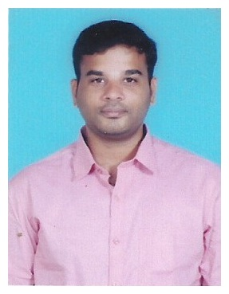

KARTHIK

E-mail: karthik.382851@2freemail.com

Visa Status: Employment Visa

OBJECTIVE:

To pursue a professionally satisfying growth and challenging career. Seeking a quality environment where my knowledge can be shared and enriched for the growth of the organization and self.
Working Experience:

S. No | Name of the Job | Experience of Years | Name of the Company
1 | Relationship Officer | Dec 2017 to July 2018 | Dunia Finance LLC, Dubai-United Arab Emirates
2 | Senior Back office Executive | July 2016 to July 2017 | Intelenet Global Services-Chennai-India
3 | Back office Executive | April 2014 to  January 2016 | TATA Business Support Services-Chennai –India
Company: Dunia Finance LLC.
Designation: Relationship Officer - (Loan & Credit card)
Job Responsibilities:
- Analyze Applicant’s financial status, Credit Card, Auto Loan and property evaluation to determine loan feasibility.
- Perform daily maintenance of the loan applicant database
- Adhere to all federal and state compliance guidelines relative to retail mortgage lending.
- Carefully analyze documents and inform clients of missing items

Company:Intelenet Global Services Ltd
Team size: 18
Designation:Senior Customer Service Executive -Backend Operations(Banking Process)
Job Responsibilities:
- Good comprehension skills with a typing speed of 35 wpm (expertise in working MS Office tools)
- Motivated team of call center operators on both inbound and outbound calls.
- Supervised inbound team to make certain they answered questions knowledgeably and thoroughly.
- Supervised outbound team to ensure they followed computer-generated lead order and exhibited courtesy at all times.
- Did spot-checks listening in on calls to make certain team followed provided scripts.
- Ran monthly goal contests with rewards.
- Loan and Personal Account calculate interest of start date and end date of payment.
- Wrong calculated interest is refund the interest amount.Deal with customer issues regarding loan payments including delinquent payments.Worked with customer to make necessary adjustments to loan terms
- Achieved 100% Quality and maintaining the SLA in a team. Preparing the metrics for client side operation for monthly and weekly.
- Preparing and reviewing the various Trackers for Journal, Recons, Query and Rejections and also Metrics.
Software Skill Sets:
Accounting Applications: Customer Gateway(CG), Tallyman, Customer Complaint Tool(CCT)
Front End Tool:Remediation Tool (Workflow Tool)
Operating System/Working Platforms: Ms-word, Ms-Excel, Ms-Powerpoint

Company:TATA Business support Services
Team size: 10
Designation:Customer Service Executive- Backend Operations
Job Responsibilities:
- Attracts potential customers by answering product and service questions; suggesting information about other products and services.
- Opens customer accounts by recording account information.
- Maintains customer records by updating account information.
- Resolves product or service problems by clarifying the customer's complaint; determining the cause of the problem; selecting and explaining the best solution to solve the problem; expediting correction or adjustment; following up to ensure resolution.

EDUCATION OVERVIEW:

Academic Record:

NAME OF THE COURSE | INSTITUTE | YEAR | CLASS
Master Of Computer Application (M.C.A) | VELS University -Chennai | 2014 | First Class
Bachelor Of Computer Application (B.C.A) | Bharathidhasan University | 2011 | First Class

PERSONAL DETAILS:

DOB :29thNovember, 1989
Sex :Male
Nationality :Indian
Languages Known : English, Tamil

I hereby declare that the above written particulars are true to the best of my knowledge and belief.

