RESUME
MAHALINGAM
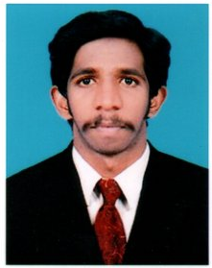
E-Mail: mahalingam.382854@2freemail.com

Career Objective:
Being an optimistic person and good team worker, hunting for a challenging position where I can contribute my skills to the best in an innovative and competitive world.
EDUCATION DETAILS:
Course/Class | Name of Institute | Board/ University | Academic/Passed  Year | Percentage of Marks
SSLC | ICI Gov. Boys higher sec school, Tenkasi | State Board | 2009 | 48 %
HSC | ICI Gov. Boys higher sec school, Tenkasi | State Board | 2011 | 68 %
DCE | Arulmigu senthilandavar polytechnic college – Ayuikudi | DOTE | 2014 | 71 %

Passport Details:
- Date of expiry : 12.04.2027
- Date of visit visa expiry : 13.10.2018
Personal strength:
- Zeal to accept challenging work, Dedication towards work.
- Good interpersonal and communication skills.
- Fast learner, self – motivated, Enthusiastic and innovation individual.
- Enjoy team works.
Project works:
- A study of strength on Mangalore tile waste as coarse aggregate in concrete

Other skills:
- Dynamic and fully dedicated to the job that given to me.
- Willingness to learn.
- Good communication.
- Cordial movement with team members and management.
Areas for Interest:
- Planning and drawing
Work Experience:
- Worked as a site supervisor from 15thJanuary 2015 to 23rd march 2017 in loyal builder’s Tenkasi.
PERSONALDETAILS:
Date of Birth : 21.11.1993
Sex : Male
Nationality : Indian
Language : Tamil, English (Read & write)
Marital status : Unmarried

DECLARATION

I hereby declare that the above mentioned information are true to the best of my knowledge.

