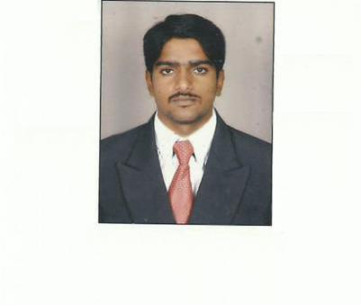
ARUL.R

E-mail: arul.372856@2freemail.com

PROFESSIONAL OBJECTIVE

Aim to be placed in a challenging organization that gives me scope to

update my knowledge and skills in accordance with the latest trends and be a part of team

that dynamically works towards growth of organization thereof.

EDUCATION

- 2010-2013: Park College Of Technology, B.E(Civil Engineering),Coimbatore-First Class(72.20%).

- 2007-2010: Maruthi polytechnic college, DCE(Civil Engineering),Thalivasal-First class (87.67%).

- 2005: St Antony Higher Secondary School,(Melnariyapanur) (61.25%).

RESPONSIBILITIES

- Daily work progress report and Daily labor report

- Daily quantity measurement & Instrument report

- M-Book writing

- Material requirements allocation

- Site work execution and Billing

- Reconciliation Report

- Monthly Report, Weekly Report

WORK EXPERIENCE AND RESPONSIBILITIES

April 2010 to September 2010 – kallai builders – CADD Design Work in Kallakurichi.

June 2013 toJanuary 2015: omega Constructions Pvt . ltd,(Coimbatore).

- During the tenure I am working as an Site engineer-,(Railway Major Bridge work-(Thiruthuraipoondi (to) Nagappattinam) ,

January2015to2018 : Almathal Trading& Contracting Est.(Oman)

- 1) Woman Association Building in Jalan Bani Bu Ali, (Ministry of social developments)

Comprise of Wedding Hall, Multipurpose Hall, Classrooms, Offices With Pump room ,Substation&AC etc.

Making External arch, Marble flooring, wooden stage, roads, car parking etc.

- 2) Multipurpose Hall (type-c) in Manah----(Ministry of interior) Properly making, Site layout and Site facility& location of Signboard, Soil compactmethod &( MAS and SHOP DRAWING) schedule Roof steel structure work, AC duct, Retaining wall, Holding tank.

SOFTWARE SKILLS

- AutoCAD

- Rivet Architecture

- Primavera

- Microsoft Office

AREA OF INTEREST

- Site work

- Quantity survey

- Billing and Estimation

CO-CURRICULAR ACTIVITIES

- Participated divisional level VOLLEY BALL match and won 3rdplace.

- Participated district level FOOT BALL and won 2nd place held in China Salam.

HOBBIES

- Playing volleyball and Cricket and Football

- Collection of Interior Design Ideas ,New Construction materials and Ideas

PERSONAL DETAILS

Date of Birth | : | 15 April 1990
Gender | : Male
Nationality | : | Indian
Marital Status | : | Single
Languages known | : English, Tamil, Hindi, Arabic
 |  | DECLARATION

I hereby declare that the above given details are true with the best of my knowledge.

