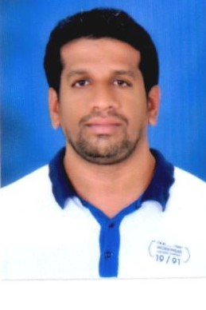RESUME

ABDUL

DEIRA DUBAI

abdul.3825858@2freemail.com
SUMMARY
Responsible valet driver who has the utmost respect for all customers, their cars and their belongings. Adept at driving any type of vehicle, working within a system and making sure that customers vehicle is retrieved quickly. Specializes in hotels, malls, and casinos.
HIGHLIHGHTS
- Always works hard to maximize customer satisfaction
- Able to drive standard and automatic vehicles
- Has never experienced a loss of accident while on the job
- Consistently receives large tips from appreciative customers
- Willing to work long hours when needed
- Responsible employee that a company and customers can trust
WORK EXPERIENCE
September 2008 to October 2010 in ELITE VALET LLC, Jumeirah and Sheikh Zayed Road.
- Worked as a key controller, and as a Cashier at paid parking
- Work to make sure that Customers Car was retrieved quickly
- Watch closely for the actions of other valets and drivers to avoid Accidents

December 2010 to December 2016 in EMAAR VALET LLC, Downtown Dubai and Marina Dubai.
- Maintaining healthy relationship with the Customers
- Worked as a Driver, Lobby in charge, and a Team Leader
- Able to drive all Automatic Luxury Cars and Manual Cars
- Worked in Dubai’s 5-Star as well as 4-Star Luxurious Hotels and Malls
- Can handle Lobby at any busy situations.
- Often requested: by repeat Guests because of excellent service
Total Year of Experience in UAE: 10 Years
QUALIFICATION
PRE-UNIVERSITY education from S.V. JUNIOR COLLEGE, KARNATAKA, INDIA.

PERSONAL PROFILE
- Date of birth : 20th Jan 1979
- Gender : Male
- Marital status : Married
- Nationality : Indian
- Religion : Muslim
- Languages known : English, Arabic, Hindi, Urdu, Kannada.

PASSPORT DETAILS
- Date of issue : 28/3/2009
- Date of expiry : 27/3/2019
- Visa type : Visit visa
DECLARATION
I hereby declare that the information and the facts stated above are true and correct to the best of my knowledge and beliefs.
(ABDUL)

