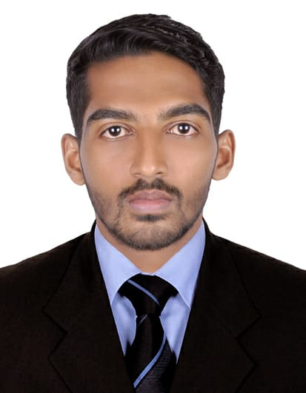
CURRICULAM VITAE
RASHAD

E-Mail ID: rashad.382888@2freemail.com
I am looking forward to work in an organization where I can apply my experience and enhance my knowledge and skills for the development of the organization as well as personal and professional development.
OBJECTIVE

OBJECTIVE
SKILLS
- Good communication (written & oral) with good interpersonal skill
- Perform consistently and effectively under pressure and places highest priority on getting thing done
- Works in team and displays a high level of concern for team members
- Customer friendly attitude.
- Takes leadership role, capable of conceiving and executing significant concepts to successful completion
- Skill of reflective and critical thinking and analysis

OBJECTIVE
EXPERIENCE:

Organization: INDO-ARAB TRAVELS [THALASSERY –INDIA]
Position : TRAVEL AGENT [2017 – 2018]
Job Profile:
- Make reservations for planned travel
- Hotels and airline booking
- Assessed the sales performance
- Handling customer complaint
- Follow up with clients about travel plans
- Processed the payments by cash , cheque and credit cards

Organization: HOTEL EUPHORIA [BANGALURU –INDIA]
Position : HOTEL CONCIERGE [2013 – 2014]
Job Profile:
- Assist guests
- Personal assistant and lifestyle manager
- To handle Customer complaint
- Good verbal and written skills
- Making good customer relationship
- Booking and co-ordination

EDUCATIONAL QUALIFICATION
PROFESSSIONAL QUALIFICATION:
- Indian Accounting [TALLY ERP9] at GURUKULAM Education Thalassery
- Microsoft office and Keyboard skills

ACADEMIC QUALIFICTION :
COURSE | University /Board | Year of Passed
Bachelor of vocation in tourism | Pondicherry university,puduchery | 2017
Plus Two [commerce] | HSE Kerala | 2013
S.S.L.C | Kerala Board | 2011
- Speed keyboard typing skills
- Volunteer work
EXTRA-CURRICULAR ACTIVITIES:

PERSONAL DETAILS:
Date of Birth : 13th October 1995
Marital Status : Single
Religion : Muslim
Nationality : Indian

LANGUAGE KNOWN:

Language | Read | Write | Speak
English | Yes | Yes | Yes
Malayalam | Yes | Yes | Yes
Hindi | Yes | Yes | NO
Arabic | Yes | Yes | No
I hereby declare that the information furnished above is true to the best of my knowledge.

DECLARATION:
Issue Place : CALICUT
PASSPORT DETAILS:

