Naina, CMA
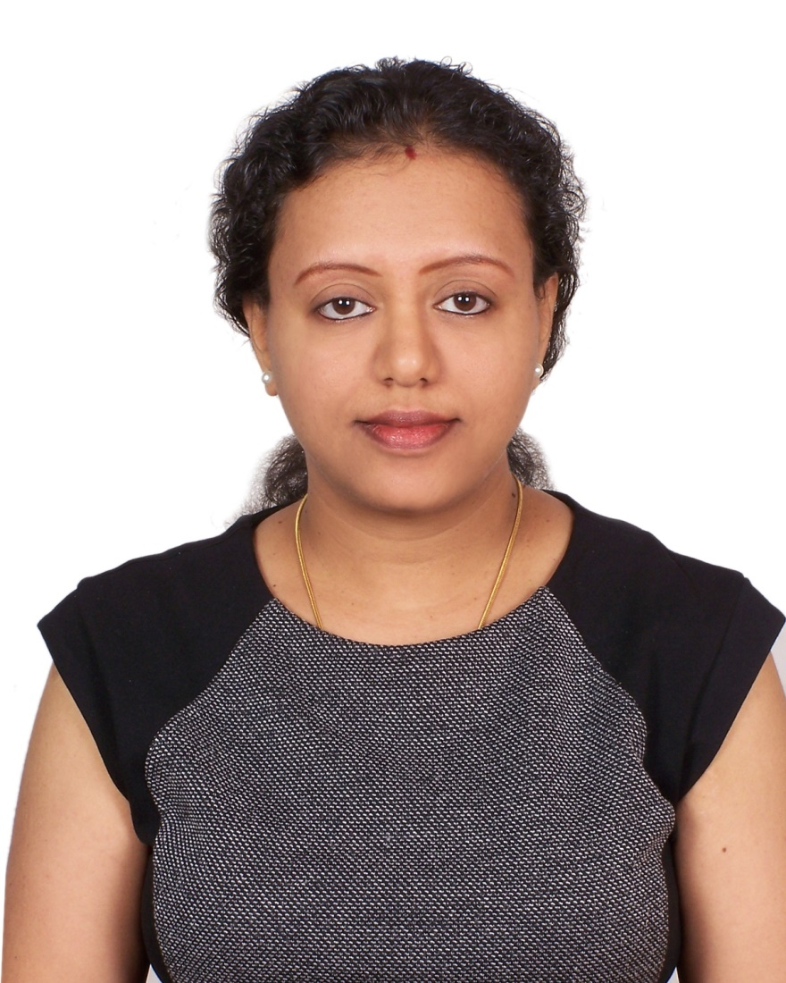

Email Id: naina.382937@2freemail.com

Career Objective:

Seeking position as an Accounts & Finance Executive, where extensive knowledge and experience will be further developed and utilized and also to continue my education in accounts and finance field.

Areas of Expertise:

● Accounting & Auditing | ● Finalization of Accounts
● Accounts Reconciliation | ● Financial Statements Reporting
● Budget Preparation | ● Tax Returns Preparation

Professional / Academic Qualification:

- Passed CMA from the Institute of Management Accountants in August 2017.
- Pursuing AICPA (IFRS) Certification Program as my CPE Requirements.
- Certification Courses done from National Stock Exchange (NCFM – Certification in Financial Markets) and Bombay Stock Exchange (CPCM – Comprehensive Program on Capital Markets) in 2005.
- Passed B.Com with Accountancy (Hons) from Mumbai University in 2000.

Computer Proficiency:

- MS Office 2010(Word, Excel, Power Point)
- Accounting Software – QuickBooks, Peachtree, TALLY
- Diploma in Microsoft Certified E-Commerce Program (Year 2001)

Professional Work Experience:

Anwar Delhi Cafeteria, Sharjah, UAE.
Accounting Manager – (May 2017 - till Date)
- Created Chart of Accounts and ensured all Sales, Purchases, expenses and journal entries are accounted and posted to general ledger.
- Developed budget and compared actuals to estimated costs/ revenues.
- Reconciled general ledger accounts, bank statements and managed Petty cash and Payrolls.
- Ensured documentation of financial transactions, reconciled financial discrepancies and took corrective measures.
- Prepared Monthly Financial statements (Balance Sheet, P&L and Cash Flow)
- Computed Quarterly Tax amounts and Compiled with federal tax filing requirements.
- Additionally, also co-ordinated with staff in executing special event orders.
- Responded efficiently to customer complaints and maintained quality Customer service standards.
- Provided training for the service staff in handling POS System and also ensured compliance with licensing, hygiene and safety regulations.

Alphatek International FZC, Dubai, UAE.
Accounts Assistant (Jan 2013- Jan 2016).
- Recorded all transactions, Journal entries and maintained day to day books of accounts in Peachtree.
- Prepared Monthly Financial Reports, Reconciled payments with the bills and also weekly Bank Reconciliation.
- Responded to queries relating to invoices & also liaised with Company auditors.
- Prepared Invoices for all the sales/ services rendered and followed up for the payments.
- Performed general office duties and administrative tasks as and when required.

National Stock Exchange (NSE-IT – Mumbai, India)
Software Consultant (Client Services – Software Audit (Dec 2004 to July 2005))
- Interfacing with Clients directly for various client queries and responsible for identifying defects in financial application product (PROBOS).
- Reviewed, assessed, analyzed the functionalities of the products accounting module and provided feedback through testing to ensure compliance with accounting policies and with Business requirement specification of the clients.
- Prepared detailed test cases and ensured defect free releases within the deadline.
- Prepared Power Point Presentations, for training, on all the accounting features of the PROBOS financial application for colleagues and for the clients.

RGN Price & Co.(Chartered Accountants – Mumbai, India)
Audit Assistant (Aug 2001- to Sept 2004).
- Performed full scale financial and operational audits in compliance with the audit plan and professional accounting standards for the clients like {Bank Of India, Citibank, Citicorp Capital Markets Ltd., Reliance Industries}.
- Assisted and executed audit work in accordance with professional auditing standards and prepared audit programs in compliance with RBI Guidelines.
- Prepared draft Audit report and followed up for the Auditee’s responses and assisted senior auditors in finalizing the draft reports.

Personal Profiles

- Date of Birth: 2nd May’ 1980.
- Marital Status: Married.
- Nationality: Indian.
- Languages: English, Hindi, Marathi & Malayalam
- Visa Status: Residence, Husbands Sponsorship.
- Driving License: Valid License Issued by RTA Dubai.
- Hobbies: Reading, Travelling.

I, do hereby declare that the above information given by me is true to the best of my knowledge and belief.

