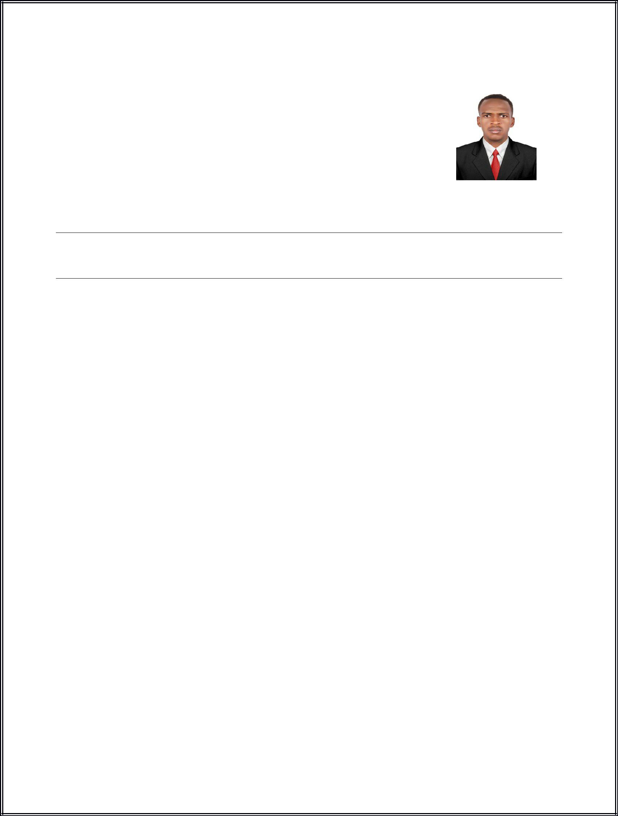

 |  |  | Haitham
E-Mail: Haitham.382951@2freemail.com |  |  | Mechanical Engineer
/UAE,Dubia

Career Profile

I seek a job as a Mechanical Engineer in Mechanical Electrical Plumping (MEP) Company, I Wish to Contribute towards Organizational Goal through my Technical Skills, Hard work and Creativity.

Experiences

Design and Site, Engineer( Mechanical Engineer)

June 2014 – Jan 2018 National Construction and Contracting Company, Saudi Arabia Riyadh, Client AL-ETQUAN Consulting Engineering Office
(Over 4 years GCC Exp) Field in Heating Ventilation and Air Conditioning (HVAC) and fire Protection System.

Executed and maintenance work for HVAC System (VAM SYSTEM, CONDENSING UNIT (DX SYSTEM), PACKAGED UNIT, PRESSURIZATION SYSTEM), Fire Fighting System.
Coordinated with client & contractors. Ensure work as per approved drawings, detailed drawings, specifications & standards.
Installed (erection) of HVAC equipments like VAM, Compressor, AHUs, Chemical filter, HVAC

Piping and Fire Fighting Equipment & Piping etc Instrument, piping, ducting Erection and checking.

Insulation of Duct, piping and equipments.

Followed up the status of submittals & approvals. Attended site coordinated meetings.

Studied & Prepared Layout and Isometric as built drawings & erection of ducting and piping. Prepared Monthly, Weekly Progress Plan and fit-up & welding inspection reports.

Monitored manpower & materials for the proper utilization.

Supervisor (Mechanical Engineer)

June 2013 - June 2014 AL-Enjaz Trading and Contracting Company, Saudi Arabia, Dammam (1 year GCC Exp) Field in Heating Ventilation and Air Conditioning (HVAC), Client Saudi gov.

Executed and maintenance work for HVAC System (VAM SYSTEM, CONDENSING UNIT (DX SYSTEM), PACKAGED UNIT, PRESSURIZATION SYSTEM), Fire Fighting System.

Coordinated with client & contractors. Ensure work as per approved drawings, detailed drawings, specifications & standards.

Installed (erection) of HVAC equipments like VAM, Compressor, AHUs, Chemical filter, HVAC Piping and Fire Fighting Equipment & Piping etc.

Instrument, piping, ducting Erection and checking. Insulation of Duct, piping and equipments.

Followed up the status of submittals & approvals. Attended site coordinated meetings.

Studied & Prepared Layout and Isometric as built drawings & erection of ducting and piping. Prepared Monthly, Weekly Progress Plan and fit-up & welding inspection reports.

Monitored manpower & materials for the proper utilization.

Education

University

: Sudan University of Science and Technology, 2008 - 2011

College

: College of Technology

Department

: Mechanical Engineering

Professional Courses

Auto desk Rivet (MEP) (24/11/2017- 30 Hours)
Auto CAD, 2D and 3D (28/11/2016- 30 Hours)
Heating Ventilation and Air Conditioning(HVAC), Code(ASHRE) (20/11/2016- two week)
Integrated fire Alarm and firefighting Systems, Code(NFPA) (1/9/2016- 24 Hours)

Skills

Computer: MS office (word, excel, power point). Team Work

Time Management Leadership

Problem Solving

Language: Arabic - Mother Tongue /English - Intermediate
Saudi driving License

Interests: football- swimming-travel.

