WORK EXPERIENCE
4+ Years

AGE
28 Years

ALI

Structural Engineer

Ali.382953@2freemail.com

ABOUT ME

Dedicated Structural engineer skilled in design engineering operations. Consistently finished designing projects with optimization and ahead of schedule. Forward thinking professional familiar with all aspects in construction with Residential and commercial. Committed to designing environmentally-conscious and cost effective public Infrastructure solution and learn every new methodology in field of construction and make myself think innovatively on every aspect of work and life.

Education

Masters, Structural Engineering | JNTU University - 2014 |  | University Topper 86.75%
Bachelor, Civil Engineering | JNTU University - 2012 |  | College Topper | 73.58%
Higher School Education | CBSE Board | - 2008 | First Class | 80.50%
Secondary School Education | CBSE Board | - 2006 | First Class | 60.30%

Professional Qualifications and Affiliations

• American society of civil engineer |  | 9127310 | 2012- present
• Institute of Research engineers and doctors |  | SM10100051080 | 2015 – Present
• | American concrete institute | 01302732 | 2014 – present
• Licensed and Registered civil engineer |  | Kurnool Municipal Corporation | 2012- present
• | Certified AutoCAD Professional | Autodesk | 2012-Present

 |  |  | Skills
• Certified AutoCAD | • | Staadpro | • | ArcView
Professional 2D & 3D | • | Etabs & Safe | • | Ansys

Roles and Responsibilities

- Client handling, preparing and reviewing preliminary design to client

- Experienced in complete analysis and design of steel structures with software and manually.

- Capable of preparing and reviewing Structural drawings, shop drawings and IFC drawings

- Experience in Steel Connection Design and errection design

- Worked as project Engineer Unofficially taking up from start to end of project

- Capable of preparing and checking fabrication drawings by making 3d drawings for easy fabrication and clash free

- Developed Unique Fabrication Techniques for easy and quickly fabricating steel Components.

- Capable of extracting complete bill of quantities, preparing various excel sheets for any type of manual calculations.

- Created reports using Word and Excel optimizing time and obtaining productive results.

Projects Handled in Gulf

Mar’ 16 – Mar’ 18 | Al Yamamah Steel Industries co. |  | Structural/Design Engineer | Jeddah, KSA
1) SPACE FRAME: ADMINISTRATION BUILDING - FADHILI GAS PROGRAM, SAUDI ARAMCO
COST OF PROJECT |  | : 768,622.00 SAR
PLAN AREA |  | : 37.480m X 15.5m
FRAME AREA |  | : 39.000m X 15.5m
FRAME DEPTH |  | : 1.2m
HEIGHT OF STRUCTURE |  | : 8.4m
WEIGHT OF STRUCTURE |  | : 8.210 TONNES
COVERING |  | : 75mm Thick Sandwich Panel
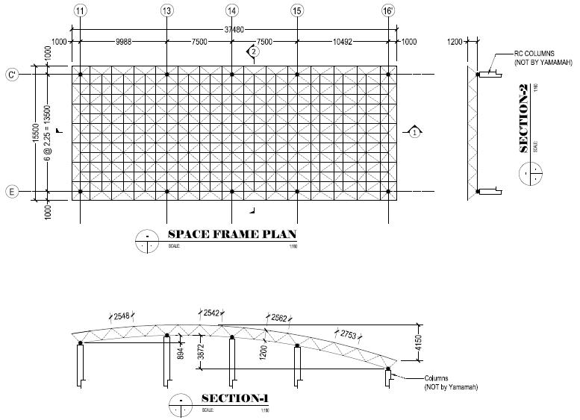

2) SUNSHADE (MAIN GATE HOUSE) FADHILI GAS PROGRAM, SAUDI ARAMCO
COST OF PROJECT : 968,622.00 SAR
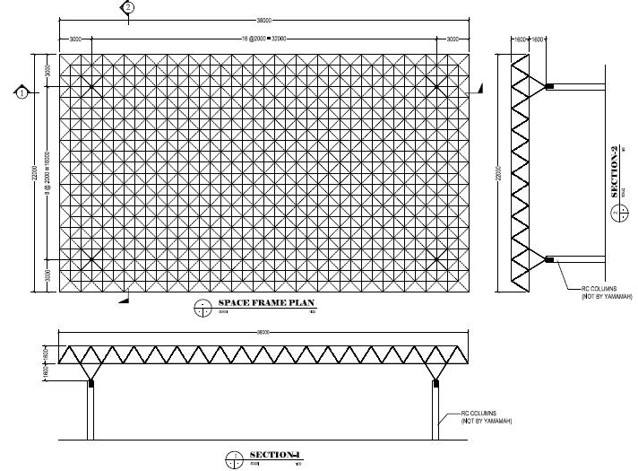

PLAN AREA
FRAME AREA
FRAME DEPTH
HEIGHT OF STRUCTURE
WEIGHT OF STRUCTURE
COVERING

: 38.00m X 22.00m
: 38.00m X 22.00m
: 1.6m
: 7.9m
: 22.616 TONNES

: 75mm Thick Sandwich Panel

Design of this frame complies with SAES-M-100 Saudi Building Code and 12-SAMSS-14 Pre-Engineered Metal buildings.

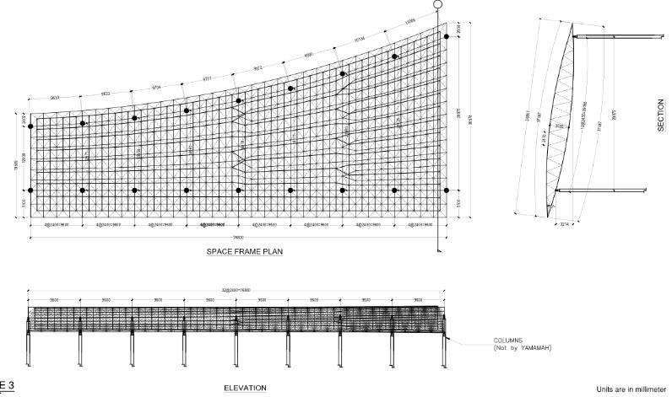
3) North Border University -Ministry of higher education, Kingdom of Saudi Arabia
COST OF PROJECT : 2,553,517.00 SAR

PLAN AREA
FRAME AREA
FRAME DEPTH
HEIGHT OF STRUCTURE
PROJECT STATUS
COVERING

: 76.890m X 36.578m
: 76.890m X 36.857m
: 3.535m
: 14.1m
: Design Stage

: 4mm Aluminum Composite Panel
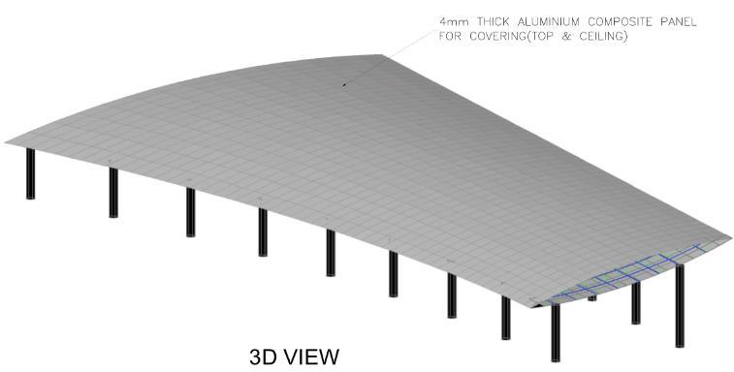

Design of this frame complies with SAES-M-100
Saudi Building Code and 12-SAMSS-14 Pre-Engineered Metal buildings.

Above are few Aramco projects I have done and there are many
Steel space frames I have designed for swimming pool,
Gatehouse, sunshade, industrial buildings and complex shaped steel
Special projects for ministry of education Saudi Arabia.

Projects Handled in India

Sept’ 14 – Mar’ 16 | Zedcon Consultants Pvt Ltd | Structural Design Engineer | Hyderabad, Telangana
1)Residential Apartments Cellar + Ground + 5 Floors
Cost of Project | :2,41,80,480 INR
Location | :Bandlaguda jagir village,
Client | : M/s Giridhari Homes Pvt. Ltd.
Typical Floor Area | : 1343.6Sqmt
No. of Units | : 72
Building Height | : 18m
2) Residential Apartments Cellar + Ground + 5 Floors
Cost of Project | :2,25,37,920 INR
Location | :Bandlaguda jagir village,
Client | : M/s Giridhari Homes Pvt. Ltd.
Typical Floor Area | : 1173.85Sqmt
No. of Units | : 60
Building Height | : 18m

- G+3 Residential Building for Srusti Planners Kamala Nagar, Anantapur Project Cost: 80, 40,000 INR

Plot Area
slab Area

Project Duration

: 2178 Sqft

: 1800 Sqft
:8 Months

As per the provisions of IS-456 2000 with the loadings as per the provisions of IS-875 and the detailing as per the provisions of SP-34

Few are above Residential projects and have designed many RCC G+1,G+2 up to G+5 residential and commercial projects

Computer Proficiency

- Word
- Excel

- Power Point

Languages

- English

- Hindi
- Urdu
- Telugu

- Kannada

 |  | Personal Details
Nationality | : | Indian
Date of Birth | : | December 23, 1990
Marital Status | : | Married
Visa Status | : | Visit Visa

