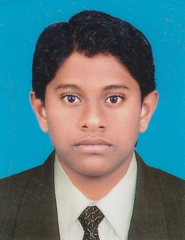
MUSFIK
Ticketing Executive

Email: musfik.382991@2freemail.com
Nationality: Sri Lankan
Availability: Currently based in Dubai and available for an interview immediately

Professional Profile
An ambitious and passionate Travel & Tourism industry professional, who combines sound technical knowledge
with significant knowledge of Airline fares/E Ticketing,GDS, Reservations & Marketing. Recognised as a strong and
effective leader who communicates effectively with a diverse range of people, demonstrating excellent negotiation
and influencing skills. Confident overcoming problems and resolving operational issues, and actively looking for
continuous improvement. A highly organised professional, who works with full attention to detail and rapidly learns
new skills and processes.
Objective
Now looking for a challenging position within the Travel and Tourism Industry that will maximize existing skills and experience whilst providing opportunities for further development and career progression.

Professional Experience
Ticketing Executive
Rameez Travels and Tours (Pvt) Ltd June 2017 – July 2018
Puttalam, Sri Lanka

- Reservations and Customer services
- Solid understanding of International Air Transport Association regulations
- Proficient in common airline booking software and database management
- Comprehensive experience with handling multiple booking issues
- Capable of working multiple shifts including evenings and weekends
- Good communications and problem solving skills

Computer Data Entry Operator and Graphic Designer
Right Click Computer Systems (Pvt) Ltd March 2012 – March 2015
Puttalam, Sri Lanka

Qualifications
Diploma in Airline Fares/ E Ticketing, GDS, Reservations, Marketing 2014
Cargo and Airport options (Travel & Tourism)
- Completed the 1 Year in academic period and 3 month Training successfully.
- Successfully completed Computer Graphics Designing Studies at I-Soft College of ICT Education, Puttalam, Sri Lanka.
- Studied at I Soft College of ICT Education and pass the examination in Certificate in English for Careers held in 2013/2014.
- Also successfully completed Diploma in English at Royal Institute Colombo.

IT Proficiency
Microsoft: Office applications (Word, Excel and PowerPoint)
Industry systems: GDS System –Galileo
Web: Internet and email applications

Personal Details
Date of Birth : 12th April 1994
Languages : Fluent English, Tamil & Sinhala, Arabic (Excellent in reading and writing)
Marital status : Single

Personal Skills
- Microsoft Office Professional and computerized database tools.
- Technical contractual requirements and interfaces with other bodies.
- Working with all other project positions in support of overall project success.
- Working under own initiative, action-oriented, solution based reliable.
- Flexible response to changing needs and able to cope with complex tasks requiring delivery to short timescales
- Participated in Football, Volleyball and Cricket in school level tournaments

