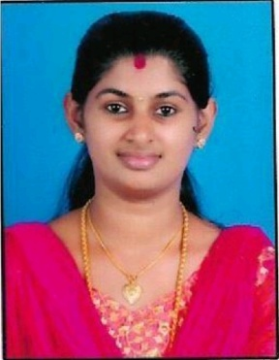
RAJANA
Rajana.383000@2freemail.com

Career Objective

Seeking a position as a Teacher using profound ability to instruct students in both literature and language along with keen skills in curriculum development.

Professional Experience

Chemistry teacher
Private tuition centre
2017 - 2018
•Demonstrate solid knowledge and understanding of the content matter

•Establish, communicate, and demand high expectations for student learning, and quality of work

•Use a multitude of instructional strategies and activities that are academically rigorous and highly engaging

•Execute detailed lesson plans mapped to a year-long academic plan to address learning needs

•Take full responsibility for student failure and constantly working to respond to the students’ learning needs

Academic Qualification

B-Ed
Kannur University, Kerala
2015 - 2017

BSC
Kannur University
2012 - 2015
B.sc in chemistry from Kannur University during the year 2012-2015 with 73%aggregates

Higher Secondary School
TMHSS Vellora
2010 - 2012
Grade 12 from TMHSS Vellora during the year 2010-2012 with 75% aggregate

Secondary School Leaving Certificate
TMHSS Vellore
2010
Grade 10 from TMHSS Vellora during the year 2010 with 81%aggregate

Computer skills

•DIPLOMA IN COMPUTER APPLICATION

• Programming C word, excel, Power Point, word processing in English and Malayalam

• Basic knowledge of windows, XP, Linux and basic functions of system

Personal Details

Date of Birth : 22 October 1994
Sex : Female
Nationality : Indian
Marital Status : Married
Languages : English, Malayalam
Visa status : Visit visa

