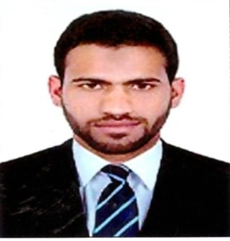
CURRICULUM VITAE AMAD
Email: amad.383002@2freemail.com
POST APPLIED FOR TYPIST/DOCUMEN CONTROLLER
CAREER OBJECTIVE:
SPECIAL SKILLS:
• Proven ability to type 50 WPM.
• Demonstrated ability to handle high typing volume.
• Excellent telephone conduct
• Outstanding interpersonal and organizational skills.
• Exceptional written and verbal communication skills.
• Able to proofread effectively
• highly skilled in high volume typing and proof-reading technique.
- Print all document when require.
- Answering the call and operat the telephone.
TYPING SKILLS
- DHA (Medical typing.
- OHC typing
- Eid typing.
- Gdrfa typing (online)
- Labour and tasheel typing.
- Insurance typing.
- Evision typing for all kind of visa.
- Data entry to system etc......
WORK EXPERIANCE:
- 5 years experience in Alsayad Documents clearing in Dubai.
- 1 year experience in VFS Tasheel in Wafi mall in dubai.
- Currently working in Daman businessmen services.

Data Entry Operator:
- Operated data entry equipment to enter verify data.
- Keep quality , speed and equrateness at acceptable standard ect•••••

DOCUMENTS CONTROLLER.
Keep all original documents in file and keep the all company records
Prepare all the documents when necessery for company porposes.
PERSONAL DETAILS:
Date of Birth: 20 Aug 1993
Place of Birth: Kohat, Pak
Visa status: Employment (Transferable)
Language Known.
English, Urdu, Hindi, Arabic.

