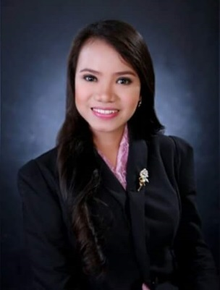
Nicola
Nicola.383024@2freemail.com

Career Objective: To have a challenging career in corporate world and to be a successful professional.

SKILLS AND QUALITIES
- Able to listen and act on instructions
- Flexible
- Good Interpersonal skills
- Knowledgeable in Recruitment and Sourcing
- Willing to learn and take new tasks
- Hardworking
- Sufficient skills in Microsoft Office, Word, Excel, Power point and Internet

EDUCATIONAL BACKGROUND

Tertiary Level
School : University of the East
Address: Claro M. Recto Ave., Manila
Course : Bachelor of Science Major in Psychology- Graduate

JOB EXPERIENCE
*Phillip Morris Fortune Tobacco corp.
Under iPlus intelligent Network inc.
- Accounts Payable Analyst (January 2017-May 2017)
-Match goods received through PO system with receiving documents and invoice totals; perform the matching process through invoice verification module in SAP
-Investigate and resolve price or quantity differences between purchase orders and related invoices.
-Support the processing of vendor invoices using SAP system

*iPlus Intelligent Network inc.
- HR Associate (June 2017-April 2018)
-Handling Admin, Sales and IT position
-Coordinating with Service delivery Manager
-Sourcing of candidates using Job portals (Jobs180, Indeed and Jobstreet)
-Screening and sending invitation to applicants
-Conducting Initial interview to applicants
-Updating Profile of candidates using database
-Administering and checking tests
-Endorsing candidates to clients
-Meeting/Attending Final interview with clients
-Job offers/Contract signing
-Guiding candidates until they were on boarded
-Job fairs from different Colleges/Universities
-Order supplies

ON THE JOB TRAINING
*SPI Global
-Assisting applicants
-Giving language and hearing tests
-Checking the tests
-201 Filling
-Encoding

*Fullhouse custodial care center
-Case study
-Interview
-Testing

*San sebastian college
-Interview
-Checking the tests

PERSONAL INFORMATION
Age: 23
Birthdate: March 24 1995
Birhplace: Antipolo City, Philippines
Gender : Female
Religion: Roman Catholic
Civil Status: Single
Languages Spoken: English and Filipino
Visa status: Visit

