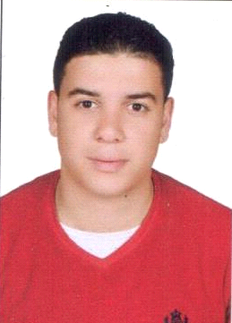
AMIN
E-mail : amin.383034@2freemail.com
Marital Status : Single.
Gender : Male
Nationality : Egyptian
Statue : Visit visa
ــــــــــــــــــــــــــــــــــــــــــــــــــــــــــــــــــــــــــــــــــــــــــــــــــــــــــــــــــــــــــــ
Career Objective:
I am seeking employment with a company where I can utilize my talents, experience, education, computer and language skills to grow and expand the company. Looking for both personal and professional growth makes me capable of working confidently under pressure.

Educational Background:
I graduated from Faculty of language and translation(Al-Alsun), English and turkish department at Ain shams University on May 2015.
_General Diploma of Education from El Faywm university on may 2016
Extra Courses:
- Conversation work shop at Resala association.
- Essential English course at Berlitze company.
- General Turkish course at Al Nile Turkish center.
__________________________________________________________________

Work Experience:

- Customer service agent for Turkish & English speakers at Jade Tikistel Egypt from August 2017 to July 2018.
_Retail at El Tawheed& El Nour shop in Egypt from Desember 2016 to June 2017.
_Retail at El Awaal Stationary at El Rehab city in Egypt.
_Customer service agent at Orange company for one year.
_Call center agent at Etisalat International from March 2014 to February 2015
_parking cashier at city stars mall in Egypt.
-cashier At AL Baik restaurant at City stars mall in Egypt .

Extra Activities:

- Volunteer in Resala Association.
- Member in IRC, US embassy.
- Member in El-Sawy Culture Wheel.
- Member at Hope maker team.

Computer Skills:

- Very good user of Windows, Word, Excel and Outlook.
- Good user of Access ,Excel ,Outlook and PowerPoint.
- Good surfing skills on the Internet .

Language Skills:

Excellent of Arabic both written and spoken.
Excellent of English both written and spoken.
Excellent of Turkish both written and spoken.
_______________________________________________________________________

HOBBIES:

- Surfing the Internet.
- Practicing football Sport.
- Reading.

