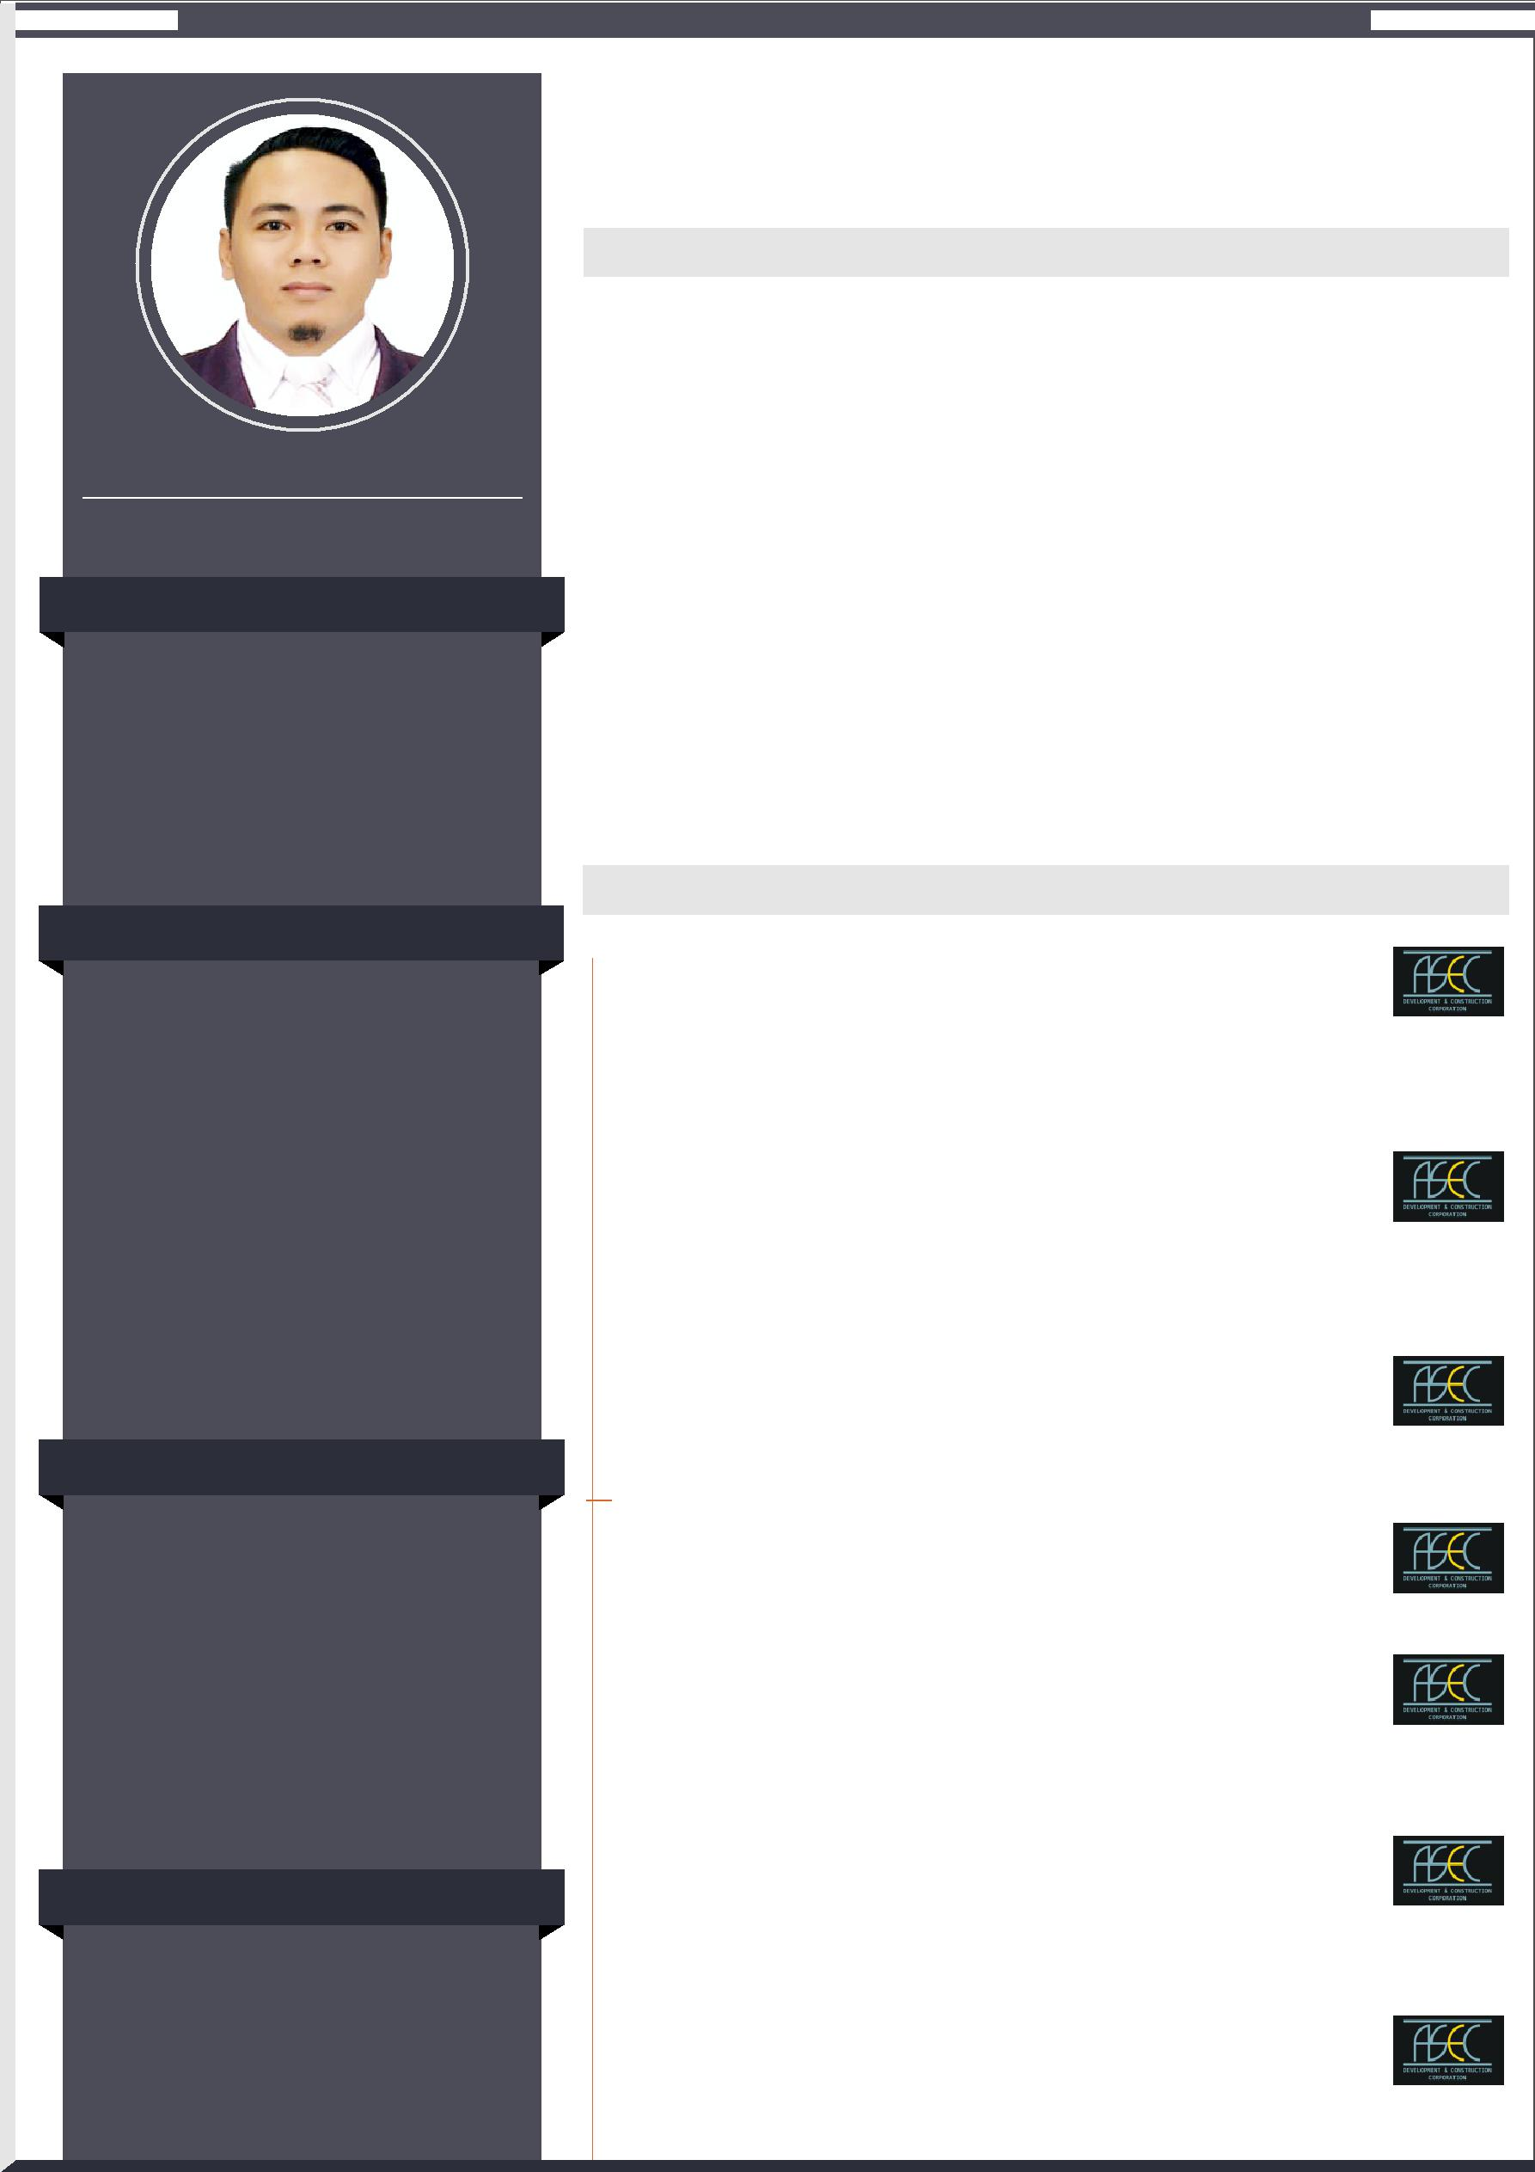
1/3

KEDAR

ELECTRICAL ENGINEER

CONTACT

kedar.383049@2freemail.com

TECHNICAL SKILLS

Installation And Termination Testing and Troubleshoot Supervision and Monitoring Critical-Thinking Project Management Quality Assurance Operation Control Safety Concern Electrical Engineering Electrical Wiring Power Distribution Electrical Design MEP Coordination

SOFT SKILLS

Exceptional Leadership Skills
Excellent Communication Skills
Able to work under pressure
Keen to details
Time Management
Flexible and adapt to any situation
Problem Solving Abilities
Management skills
Excellent interpersonal skills
Dedicated Team player

IT FORTE

AutoCAD
Microsoft Word
Microsoft Excel
Email Operation
Internet

- Aspiring for a challenging career in a professionally managed concern, as an Electrical Engineer (High Rise Building Structure) ~

PROFILE SUMMARY

Top Performing Electrical Engineer with 08+ Years of Experience working with Construction industry in Philippines .
Experienced with Electrical Construction Firm, Structural and Architectural Construction Development Company In the Construction Industry.
Expert In Implementation, Development, Maintenance of Project and MEP (Mechanical, Electrical, and Plumbing) Coordination.
Comprehensive Understanding Of Electrical Health And Safety Regulation.
Project leader with repeated successes in delivering and deploying suitable, high performance, cost effective systems on time.
Adept in readily gathering and translating complex requirements into
viable solutions.
Excel at collaborating across departments, coordinate with staff, sub contractors and management to complete projects on time.
Enjoys being a part of a team, as well as managing, motivating and training a productive team and thrives in high pressure and challenging working environments.

PROFESSIONAL EXPERIENCE

Designation: ELECTRICAL ENGINEER/MEP COORDINATOR
Company: ASEC Development & Construction Corporation

Location: Cubao, Quezon City, 1109, Philippines

Tenure: September, 2011 to May, 2018

Project: 18-Story Savoy Hotel

Tenure: November, 2015 - May, 2018
Client: Mr. Andrew Tan - Mega World Corporation

Location: Lapu-lapu City Cebu, Philippines

Project: 12-Story Building

(Chong Hua Hospital, Chong Hua Cancer Center Institute) Tenure: September, 2014 - November, 2015
Client: Mr. Lim Liu - Associacion Benevola De Cebu, Inc.

Location: Mandaue City Cebu, Philippines

Project: Berhin sa Regla Parish Church - Additional Works/Renovation

Tenure: January, 2015 - September, 2015
Location: Lapu-lapu City Cebu, Philippines

Project: 29 - Story Marco Polo Tower II Residences

Tenure: December, 2012 - September, 2014
Client: Metro Bank - Federal Land Inc.
Location: Nivel Hills Lahug Cebu City, Philippines

Project: Oakridge Pavilion

Tenure: September, 2012 - December, 2012

Client: Oakridge Realty Development Corporation
Location: Mandaue City, Philippines

Project: 28-Story Condominium, Citiloft One Condominium

Tenure: April, 2012 - September, 2012
Client: J-King and Sons Company Inc.

Location: General Maxilom Avenue Cebu City, Philippines

Kedar - Electrical Engineer - kedar.383049@2freemail.com 2/3
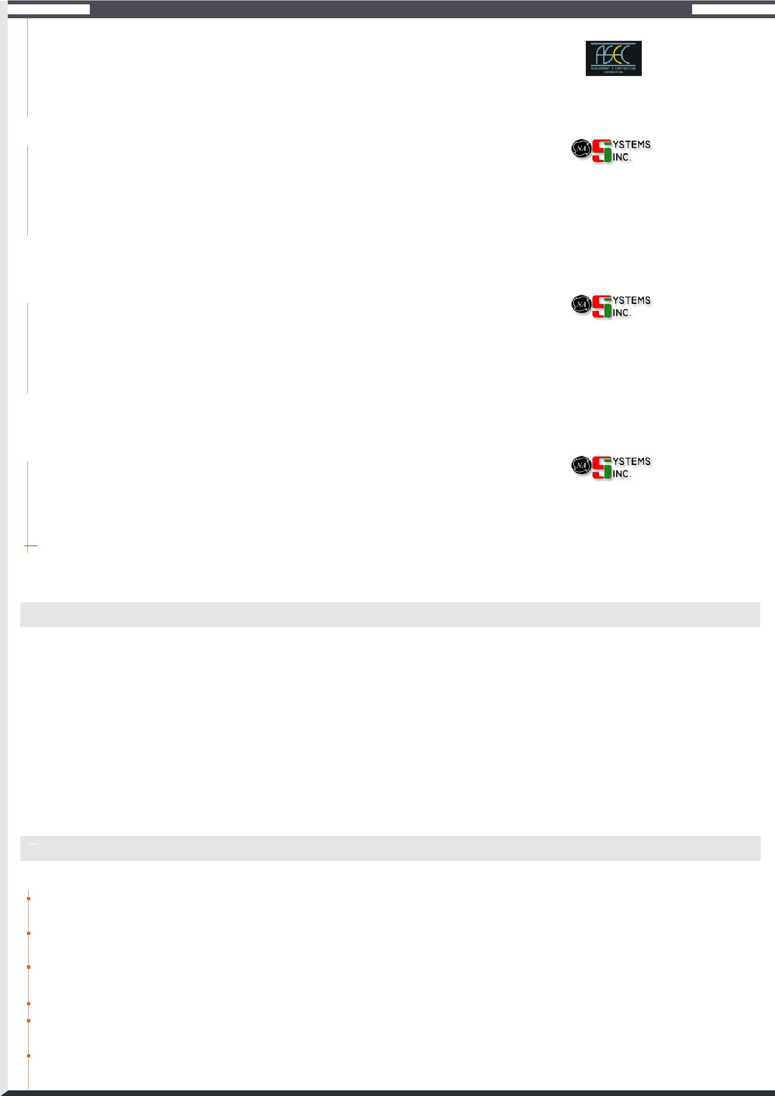

Project: 33-Story Building, Ramos Tower Condominium

Position: Electrical Engineer

Tenure: September, 2011 - April, 2012
Client: J-King and Sons Company Inc.

Location: Cebu City, Philippines

Designation: SAFETY OFFICER/ELECTRICIAN
Company: N.A. Systems Inc.

Tenure: January, 2010 to July, 2011

Location: CebuBusiness Park, Cebu City 6000 Philippines

Project: 18-Story Building, E-Bloc 2

Client: Cebu Holdings Inc., An Affiliate of Ayala Land, Inc.

Location: I.T. Park Lahug Cebu City, Philippines

Designation: PROJECT ENGINEER/ELECTRICIAN
Company: N.A. Systems Inc.

Tenure: October, 2009 - January, 2010

Location: CebuBusiness Park, Cebu City 6000 Philippines

Project: 12-Story Building, Chong Hua Parking Building.

Client: Mr. Lim Liu - Associacion Benevola De Cebu, Inc.

Location: Cebu City, Philippines

Designation: ON THE JOB TRAINING/ELECTRICIAN
Company: N.A. Systems Inc.

Tenure: July, 2009 - October, 2009

Location: CebuBusiness Park, Cebu City 6000 Philippines

 | Project: | Latter-Day Saints Temple
 | Client: | Mormon's
 | Location: | Cebu City, Philippines

PROFESSIONAL CERTIFICATES

 |  | Employment Certification (Electrician, Project Engineer, Safety Officer) |  |  |  |  | Year: August, 2011
 |  | Company: | N.A. Systems, Inc.
 |  | Location: | Cebu City 6000 Philippines
 |  | Certification in Construction Safety Training |  |  |  |  | Year: October, 2010
 |  | Company: | Department of Labor and Employment (DOLE Regional Office VII)
 |  | Location: | Cebu City 6000 Philippines
 |  | Certification On The Job Training (Electrician) |  |  |  |  | Year: September, 2009
 |  | Company: | N.A. Systems, Inc.
 |  | Location: | Cebu City 6000 Philippines

EXPERIENCE HIGHLIGHTS

KEY HIGHLIGHTS WITH ASEC DEVELOPMENT AND CONSTRUCTION CORPORATION AND N.A. SYSTEMS INC.

Coordination among consultants, civil and MEP for technical matters, regarding work progress and execution conflicts of both external and internal works.
Conducting, daily site walks with either consultants, civil or MEP team for progress details, in order to comply with construction program.

Arranging and attending meetings with consultants, MEP and civil for resolving technical matters that were unseen in the coordination drawing, etc.

Supervision of material submittals and its availability at site.
Implementing methods to monitor approvals for MEP clearances to commence civil activities and vice versa, for progress monitoring.

Supervision in the installation of equipments like Control panels, Power Transformers, HV and LV Cables etc.

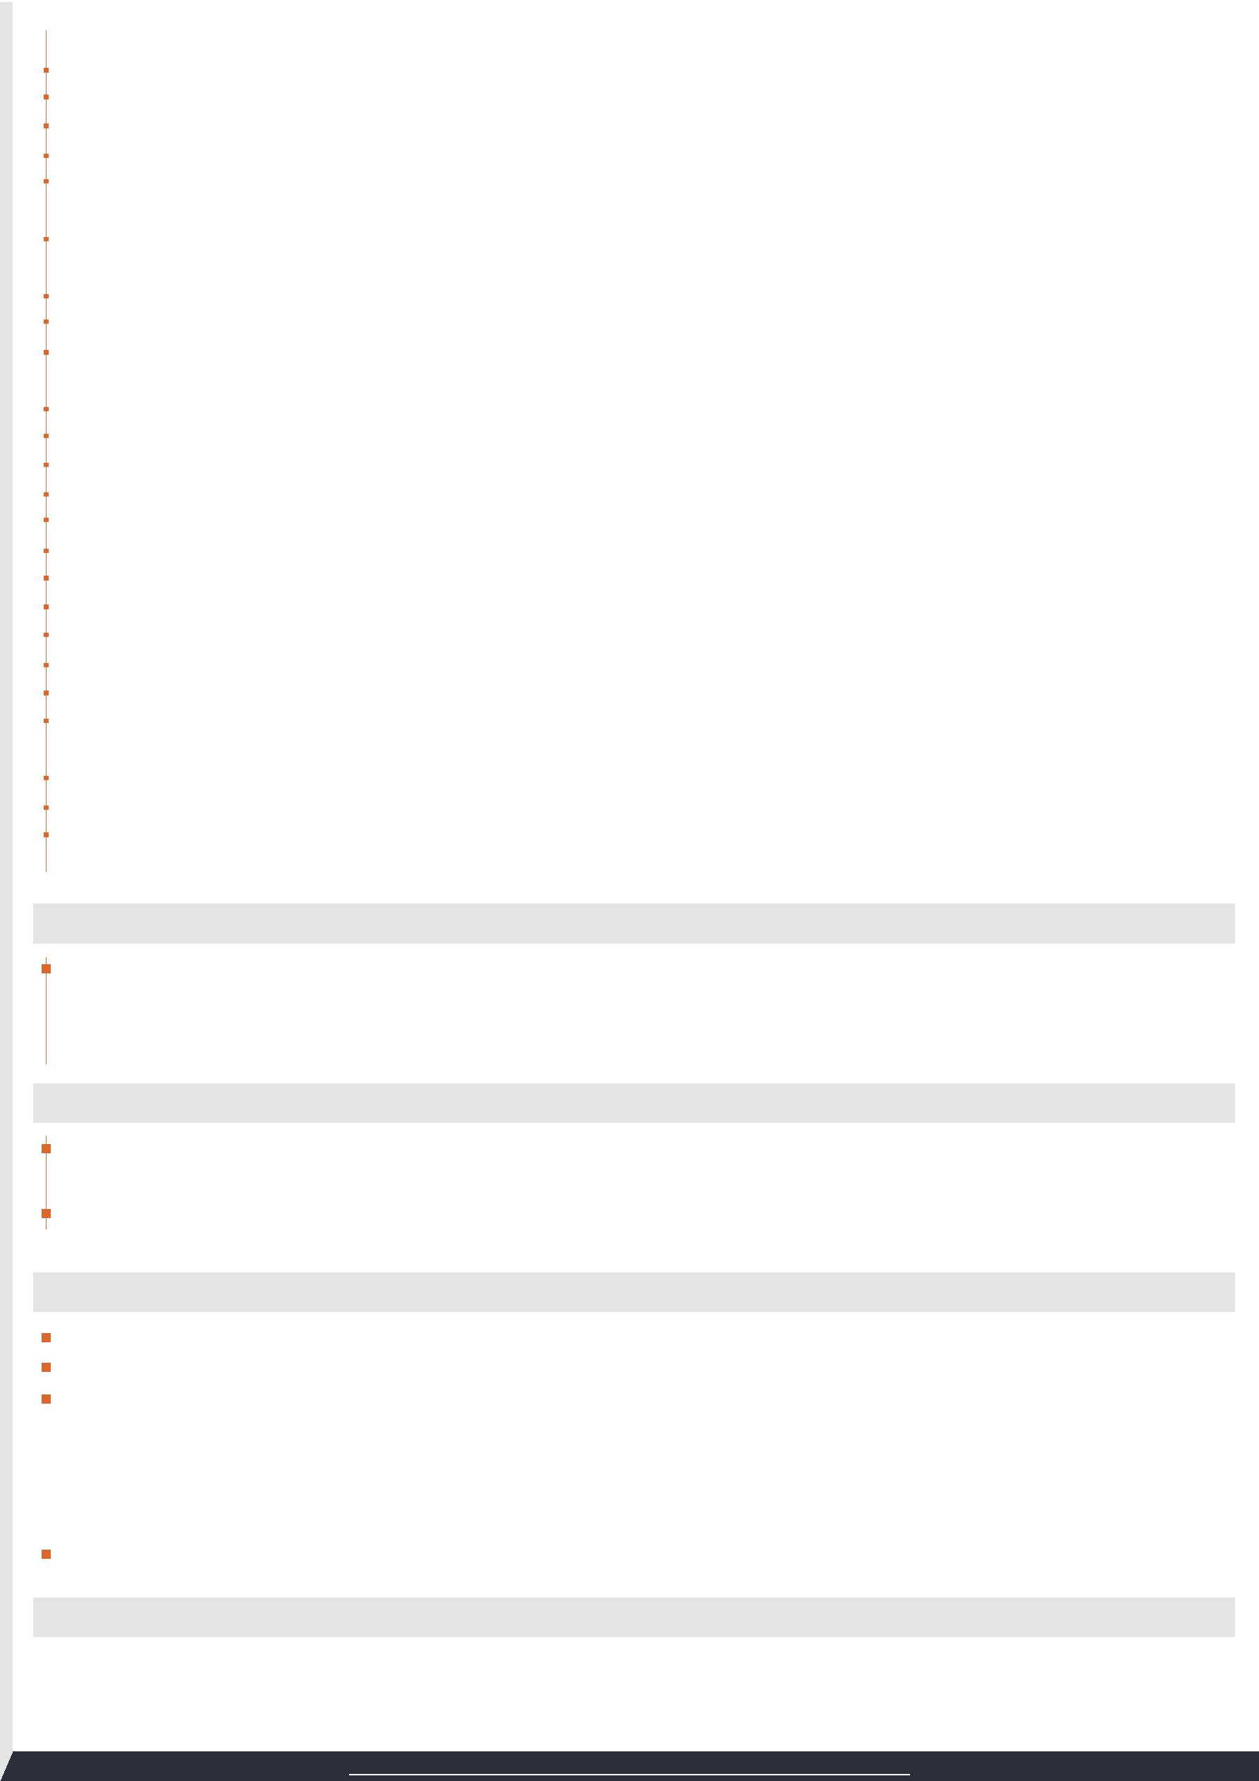
 | Kedar - Electrical Engineer - kedar.383049@2freemail.com | 3/3

Co-ordination and monitoring the progress of Electrical, Sanitary plumbing and mechanical system( Lightings, Power, Fire alarm, CCTV, HVAC and PPR Pipes etc.) Such as installation and testing. Co-ordination with consultant/supplier/contractor for inspections and witness testing, energization, etc.

Supervision of sub contractor's Man Power Details and reporting to the Senior Project Manager in charge.
Checking of the Pre Pour areas day by day and attaining MEP Clearance. Snagging of all electrical works & co-ordinate with subcontractor to implement the remedial measures and complete the job in time.

During initial stage of project, Execution and maintenance of all MEP services, including cable laying, power termination, water supply, fire alarm, fire fighting and drainage for mobilization of site office, camp and site.

Preparation of Load Schedule for site offices, store and site mobilization works in order to arrange generators.
Preparation of daily, weekly and monthly reports for MEP division manager.
Preparation of as built drawings for MEP services.
KEY CONTRIBUTION:
Completed the project on time, within budget and to the desired quality.
Designed, Applied the temp. Power, Water supply and Internet connection are completed in time and schedule. Successfully Managed over all Electrical Maintenance supply for structural, architectural works and office facilities Completed the structural works, Sanitary Plumbing and Fire Protection for Sleeves Installation. All subcontractors and trade contractors are provided temporary electric and water supply.

Completed the assigned scope of works base on the time frame schedule.
Received the building permit including Structural, Mechanical, Electrical, Sanitary Plumbing, and Fire Protection Permit.
Managed over all Electrical Maintenance supply for structural, architectural works and office facilities.
Oakridge Pavilion Project completed within 3 months schedule.
Assisted the MEPF for the testing start up and Permanent operation.
Developed and Implemented power riser supply.
Resolved the problems and connected wires to circuit breakers, transformers and other components within designated schedules.

Completed the Lightings, Power and Aux. Lay-out for embedded and exposed piping installation.
Supported and assisted the Installation of riser bus duct.
Supported and assisted in the operation of cable pulling and termination of secondary supply for generator (Chong Hua Hospital).

ACADEMIC QUALIFICATIONS

Bachelor of Science in Electrical Engineering
Institute: University of Cebu

Location: Sanciangko St. Cebu City, 6000, Philippines
Year: October, 2009

SEMINARS ATTENTED

The installation of SPECSEAL Firestop Products.
Year: January, 2014

Auto Deck/Auto CAD
Year: 2011

PERSONAL VITAE

 | Age: | 32 yrs
 | Sex: | Male
 | Civil Status: | Single
 | Citizenship: | Filipino
 | Religion: | Roman Catholic
 | Birth Date : | March 23, 1986
 | Languages: | English, Tagalog and Bisaya

DECLARATION

The information provided above is true to the best of my knowledge. If I were placed in your esteemed concern, I will discharge my duties with at most sincerity and to your full satisfaction.

Kedar

Note: Authenticate Documents are available upon request.

