- PERSONAL SUMMERY: -

Nalak
Senior surveyor
(Metro Rail Project - Dubai)

- Contact Information: -
E mail: nalak.383104@2freemail.com

- Language Known: -
Bengali, Hindi, English, Gujarati, Nepali(Basic)

Highly competent individual who has extensive knowledge and experience of managing, directing and monitoring both small and large scale civil project Survey work. On the technical side, I am able to accurately prepare document data to the highest standards- particularly Co-Ordinates, drawings, plans, work schedules and Auto Cad design work. I believe my significant technical knowledge and essential team management skill that guiding me up the stairs of excellence. Capability of Operating latest survey instruments also keep me in confidante. Now looking for a suitable position with an ambitious & forward-thinking company.

- AREA OF EXPERTISE: -
- Metro Rail (Elev. & UG). ● Crude Oil Storage Project.
- Hydro-Power Project. ● Aluminum Refinery Project.
- Road and Railway Project.
- Export – Import RAW survey DATA to Survey Instrument

- KEY SKILL: -
- Able to calculate detailed co-ordinate calculations and sketches without recourse of CAD support and with Auto Cad support also.
- Ability to motivate multidisciplinary survey teams.
- Knowledge and understanding of construction management.
- Ability to operate latest Survey motorized & Digital Instruments.
- Ability to remain flexible in a demanding work environment and adapt to rapidly changing priorities.
- Close, Open and Loop Travers work with Triangulation and Set Collection Method.
- Initial Topography data development and superimpose in Auto Cad. Able to design mobilization site areas as per requirements.
- Field & design data import-export from instrument and its development for submission.
- Level value calculation by HI or Rise-Fall Method.
- Quantity & Cut-Fill calculation, material stock assessment work.
- Drawing & designing work including initial stage of project.
- Good communication skill in oral and written in English.

- Academic Information: -➢
• Civil Land Survey from Industrial Training Institute, WB, 2002.
• Diploma in Civil from Sridhar University, Rajasthan, 2013.
• Secondary from JZS, Jalpaiguri, West Bengal in the year 1998.
• Higher Secondary from A.C. College of Science in 2000.

- Software: -
*Auto Cad 2D & 3D *Magnet Field *Civil 3D *MDT
*Surfer 16 *Geo-Office *TMS Application *Tunnel One *Tera Model *Google Earth *MS Office * Primavera (Basic) *Photoshop
- Work Experience overview: - (Total Experience 15yrs)
0yrs 1yr 2yrs 3yrs 4yrs 5yrs 6yrs 7yrs
- Metro Rail / Rail Transport.
- Oil & Gas (UG)Project.
- Hydro-Power Project.
- Refinery Project.
- Miscellaneous Project.

- Experience and Responsibilities In detail: -
Present Employer

A) Employer Alstom – Acciona - Gulermak Joint Venture (Expo link 2020).
Project Name Dubai Metro Project (Route 2020).
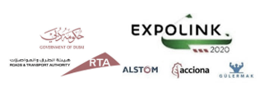
Designation Senior Surveyor.
Client RTA (Roads and Transport Authority)
Consultant SYSTRA and PERSONS
Location Dubai, UAE.
Duration June 2017 to till date.

Job Responsibilities:
- Working as survey In-Charge for Station & Viaduct Survey with 6 nos. of team by day and night shift work control. Joint Record, documentation for client billing, ITR data sheet attachment for combined report.
- Attending RTA(Dubai) site visit, all planning, safety, PRM meetings for schedule progress of project.
- Raw data making with Civil 3D, Sokkia Link, MDT and Auto Cad software.
- Export and import data in survey total station, GPS, digital level instrument for escape manual error.
- Arrange data for field work – Span alignment, Balance Cantilever, Bearing Installation, Survey plate checking, Bearing Plate Installation, report making for stressing and distressing of segment. Gantry and Portal beam checking for intercrossing of road and viaduct.
- Alignment check for Pile, Pile Cap, Pier, Pier head, Spine Beam, Wings, Tendon, Bearing Plinth, Escalator, Stair, Tie Beam, Station Block work etc.
- Checking verticality of still column, cross basing alignment, structural steel beam, viaduct wings at plat form level, SSL and FFL of Ground and concourse level slab.
- Preparation of Embedded bolts and concrete slope for grouting of column.
- Preparation of road and utilities drawing comparing with design data of EMICOOL Chamber, ETISALAT Duct line, TABREED line, Sewerage and drainage line, street light cable, DEWA cable alignment etc.
- Plotting or rotate design drawing as per original or global co-ordinates for direct layout at site.
- Responsible for all MEP and Electrical opening and sleeves co-ordinate data arrangement and layout at vertical wall. Measurement and layout of riser and outlet.
- Arrange data for basement, basement wall, buried wall, MEP layout, column bolts erection for still structure.
- Block wall and station rooms layout. Plotting for all mechanical, electrical and operation room.
- Close Traverse by Total station calculated with triangulation method, Establishing BM and TBM using fly & fly check level followed by HI method.
- Raw data co-ordinate arranges from GFC Drawings for Pile, Pile cap, Pier and Pier head. Verify station foot print highlights obstacles (Topography work) for working place.
- All Utility Identification and it’s plotting and submission for further design work.
- Control Survey teams work of day and night shift, daily work planning and DPR.

Previous Employers

B) Employer Dinesh Chandra R. Agrawal Infracon Pvt. Limited.
Project Name Ahmadabad Metro Project (Phase I).
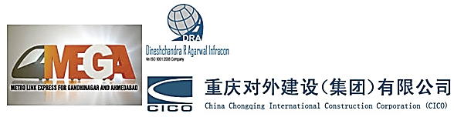
Designation Chief Survey Engineer
Client MEGA
Consultant RITES, SYSTRA, OCG and AECOM
Location Ahmedabad, Gujarat.
Duration December 2015 to June 2017.
Job Responsibilities:
- Responsible for six no of stations Survey related work and its design data arrangement.
- Alignment check of pre-tension and Post tension girder, Bearing Pedestal, Corbel level.
- Close Traverse by Total station calculated with triangulation method, Establishing BM and TBM using fly & fly check level followed by HI method.
- Raw data co-ordinate arranges from GFC Drawings for Pile, Pile cap, Pier and Pier head. Verify station foot print highlights obstacles (Topography work) for working place.
- Guider Erection Schemes Preparation, check Pier Verticality, Establishing of Casting yard & batching plant layout.
- Control Survey teams work, daily work planning and DPR.
- Contractor billing measurements verify and process for bill.

C) Employer Salani - Impregilo (Impregilo S.p.A. Branch).
Project Name Riyadh Metro Project (Pakage2, Line 3).
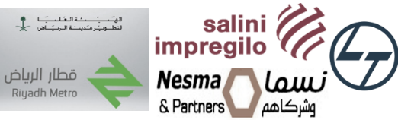
Designation Senior Survey Engineer.
Client Ariyadh New Mobility (ANM).
Consultant Riyadh Metro Transit Consultants (RMTC).
Location Riyadh, Saudi Arabia.
Duration November 2014 to till November 2015.

Job Responsibilities:
- Directly responsible for 8.5 km Viaduct all kind of survey including part of Cut & Cover and Underground tunnel (TBM) Work.
- Close Traverse of 43KM underground and elevated metro by GPS(GR-5) and Total Station for control point Co-Ordinate establishment. Use digital level (DNA 03) for TBM establishing.
- Responsible for Pre-cast match cast Segments alignment for a full SPAN including EJ segment. Calculating of Co-Ordinates for each match cast segment by MC3D Software.
- 750m long precast yard Gantry Crain railway track alignment @ 5nos separated BAY for precast mould alignment.
- Responsible for Shot Line and Long line Mould erection, high survey towers, Gantry shatter alignment, foundation of gantry shade column etc. work.
- Also, responsible for arranging raw data import and export for field survey work.
- Arrange raw data for pilling and micro pilling of metro stations and joint check with client before concrete pouring.
- Responsible for Viaduct Section – Pier alignment, Bearing Pedestal & pocket alignment, Pier head line and level checking etc. work

D) Employer SK E&C – KCT JV.
Project Name Underground Rock Cavern (Part-I) for Strategic Storage of Crude Oil Project.
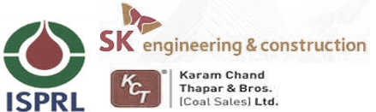
Designation Manager Survey.
Client ISPRL (Indian Strategic Petroleum Reserves Ltd).
Consultant EIL (Engineers India Ltd.)
Location Mangalore, Karnataka.
Duration March 2012 to October 2014.

Job Responsibilities:
- Section taken by Tunnel Profiler of every excavated bench (There were 4nos. stage tunnel excavation) - Max ht. of the tunnel 66m and developing sections by its software (tunnel One Software) and convert to Auto Cad for client Submission.
- Close Traverse for carry TBM from Permanent Bench Mark to TBM for daily work.
- Daily wise monitoring of field survey works, team work management, work divide of every survey team as per bar chat schedule.
- Implementation infrastructures office layout, Batching plant erection, non BOQ/Extra item section and quantity calculation.
- Use of survey Software works like Tunnel One, LT Contour Software, Leica – Trimble – Sokkia profiling software etc.
- Topography and route Survey of pipe line for Initial Flooding in WC Tunnel and established structures for laying the pipe line. Tunnel utility Pipe Lines for Inlet and Outlet gradual slope pipeline.
- Data transfer from instrument to computer and upload database system to instrument CF card, plotting, section developing, and client approval taken for over break and undercut for monthly RA Bill.
- Reporting Client Engineers for field technical works time to time for further progress.
- Attending weekly and monthly meeting for work progress discussion, further work program plan and divide the plan to survey hands for achieve the given target.

E) Employer Hindustan Construction Company (HCC) Limited
Project Name Hydro Electric Power Project (Stage VI).
Designation Surveyor S2
Client Lanco Infratech Limited.
Consultant No any Consultant.
Location Rangpo, Sikkim.
Duration January 2009 to February2012

Job Responsibilities:
- Cross Section taken by Leica Tunnel Profiler of every excavated bench of 2 stage tunnel excavation Horse Shoe Shape tunnel and developing sections by TMS Application (Leica Software) and Leica Geo Office software and convert to Auto Cad for client Submission.
- Steel rib erection data preparation.
- Monitoring survey team and looking for entire survey work with schedule wise alignment and working Temporary Bench Mark.
- Involve with survey related client and contractor billing.
- Auto cad designing for initial infrastructures, countering & layout before starting of structure.
- Quantity Calculation and field measurement for Quantity Survey Work.
- Tunnel Section plotting and submission to client for taken approval of farther work.
- Layout of Crasher and Batching plant with silo.

F) Employer Simplex Infrastructures Limited
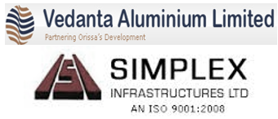
Project Name Aluminum Smelting Project.
Designation Surveyor
Client Vedanta Alumina Limited (VAL).
Consultant DCPL.
Location Jharsuguda, Orissa.
Duration June 2006 to December 2008.

Job Responsibilities:
- Layout of Anode Baking Shop, Furnace, Silo, Anode Roding Shop, Induction Furnace, Fume Treatment Plant etc.
- Alignment of conveyor belt according to foundation.
- Bolt fixing of 1.5 km long conveyor belt foundation every 6.0 meter interval.
- Layout of Bore Pilling Point for bore hole.
- T.B.M. fixing to the entire sub foundations from reference BM, Cross Sectional Leveling of existing ground for the actual quantity as per required cutting or filling area.
- Fixing with proper Co-Ordinates and level at civil foundations due to steel structure erection, Crain Grader fixing at proper line and elevation.
- Checking verticality of Silo and chimney by Wild T2 Theodolite.

G) Employer Joyprakash Associates Limited (Jaypee Group)
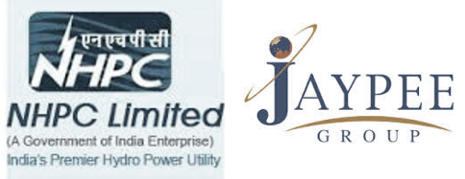
Project Name Hydro Power Project (Teesta V).
Designation Jr. Surveyor
Client NHPC.
Consultant No any Consultant.
Location Balutar and Dikchu, Sikkim.
Duration April 2005 to May 2006

Job Responsibilities:
- Profile marking at the rock surface for proper line drilling and blasting pattern marking.
- Co-Ordinate axis fixing and elevation marking for maintain of verticality of 84 m DAM.
- Centre point alignment of 32 diameters SURGE SAFT and 87-meter depth APS TOP.
- Centralized the 150-Megawatt Turbines with APS TOP. Gantry curbs shutter alignment.
- PR and all field measurement record maintain and report to immediate boss.

H) Employer D. K. Engineering & Construction Pvt. Ltd
Project Name NF Railway Patch Doubling Project.
Designation Surveyor
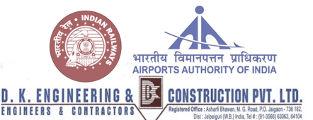
Client NF Rail way.
Consultant No any Consultant.
Location Malda, West Bengal.
Duration May 2003 to March 2005

Project Name PMGSY Package Road Project.
Designation Trainee Surveyor
Client PMGSY (Siliguri Corporation).
Consultant No any Consultant.
Location Bagdogra, West Bengal.
Duration November 2002 to April 2003.

Job Responsibilities:
- Embankment, Cambering, Blanketing with proper alignment and levelling.
- Layout of minor bridges and culverts.
- Turfing with proper 1:2 slopes maintain.
- Fly level and fly check up to 16 km. for T.B.M. Fixing.
- Auto level use for profile and cross section and fly levelling of T.B.M. checking.
- Road embankment, cambering with proper line and level.
- Soil, RBM and bitumen work. Cross sectional level for calculation of cutting and filling area.

Area of Interest:
All fields related to Civil Survey (i.e. Construction Field, Metro Rail/LRT – Light Rail Service/Bullet Train/Tram Line/Bridge/Infrastructure/Road, etc.)

Declaration: I hereby declare that all the information shown above is true to the best of my knowledge and belief.
Preferred job and job category are my basic requirement; salary and other facilities could be negotiable
depend on project location and project type.

NALAK

