|  |
| --- |
| **Marian**  marian.383164@2freemail.com |
| **SUMMARY OF QUALIFICATIONS:** | |
| **Nine** (**9) years**of experiencein providing optimum Customer Service in Philippines. Diversified and extensive experience in call center settings and restaurant management. Ability to perform with sense of urgencyand can work independently without supervision. | |
| **CAREER TIMELINE:** | |
| * 2016 - 2018🡪**Restaurant Assistant Manager**– Ban’s Resto Bar – Lapu-lapu City, Philippines * 2013 - 2016🡪**Customer Service Associate**- Calltek Center International Inc.- Cebu City, Philippines * 2012 - 2013🡪**Customer Service Associate**- Convergys Phils. Inc. - Cebu City, Philippines * 2010 - 2012🡪**Supervisor**- Herbalife International Inc. - Cebu City, Philippines * 2009-2010 🡪**Admin. Asst.**- Paradise Cebu Tours Inc. - Cebu City, Philippines | |

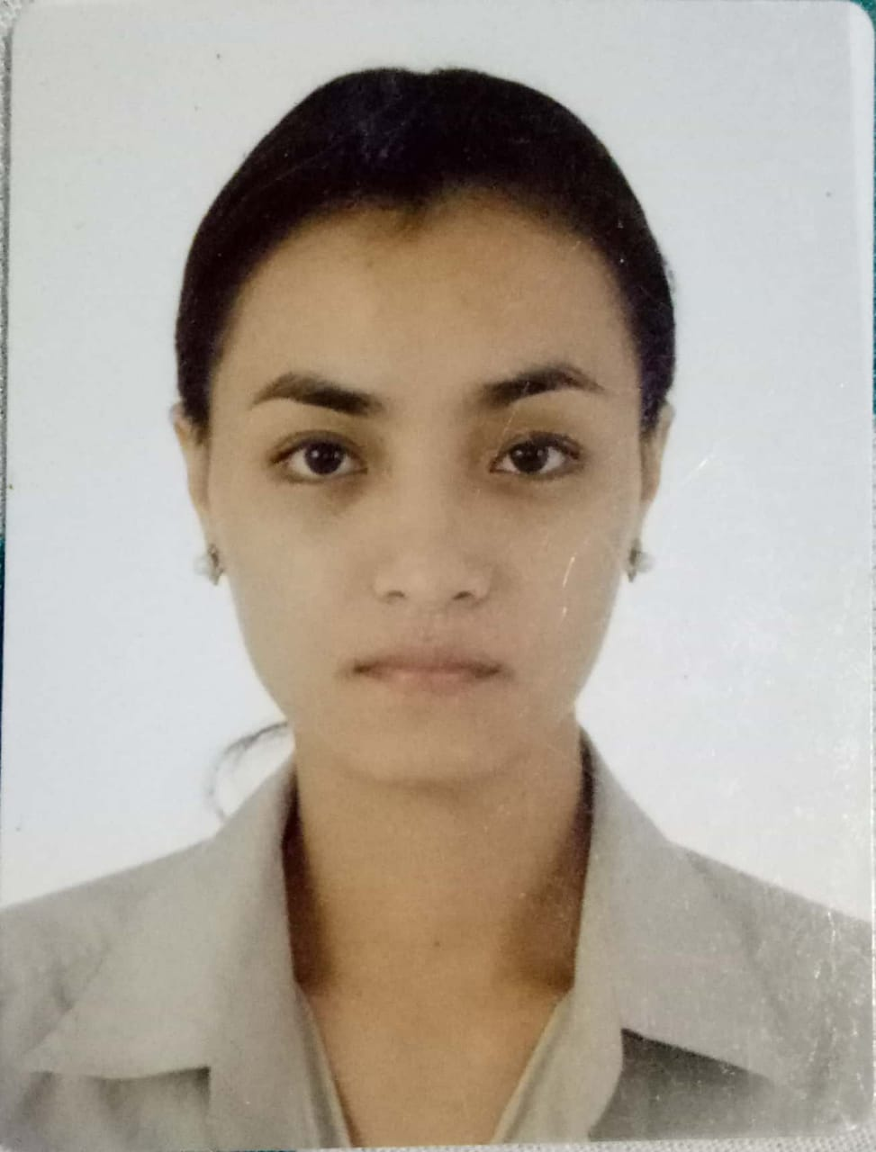

|  |  |
| --- | --- |
| **PROFESSIONAL EXPERIENCES:** | |
| **Ban’s Resto Bar**  **December2016 – February2018**  **Position:**  **Restaurant Assistant Manager** | * Primarily assists the Restaurant Manager on daily operations, focusing on customers’ excellent experience. * Ensures superiorquality on foods and services. * Trains employees properly to ensure customer satisfaction and company policy adherence. * Maintains the daily records on sales and inventory. * Prepares the required documentation for sales reports and monthly reviews. * Updates employees’ daily tasks and time logs. * Liaise between Restaurant Manager and employees to provide the service most suitable to the customers’ needs. * Handles cash and salary distributions. * Maintains proper sanitation and hygiene standards in kitchen and the entire restaurant. * Estimates the future needs and acquisition of goods, kitchen utensils and cleaning aids. |
| **Calltek Center International Inc.**  ***March 2013 – January 2016***  **Position:**  **Customer Service Associate** | * Assisting customer queries through phone calls * Interacts with customers to provide the company’s products and services * Deal with and resolve customer complaint * Received incoming, outgoing calls to the department where the caller wants to be connected * Take down message in case of unavailability of person concerned and relay the message as soon as person is available * Monitor the fire alarm control panel, electric fault line and report immediately to the person concern, such as guards and electrician * Report defective telephone apparatus or telephone line problem to the electrician or PLDT |
| **Convergys Phils. Inc**  **August 2012 – February 2013**  **Position:**  **Customer Service Associate** | * Providing good service to customer with satisfaction * Accountable for handling customer enquiry, complaints, giving right information to callers in well manner * Endorsing company product and insist quality information to be able to avail and purchase * Always giving customers information, right details, suggestion for the company product * Facilitate follow up on the status of each quotations submitted * Handle company profile to submit to prospective clients |
| **Herbalife International Inc.**  **Sept. 2010 – February 2012**  **Position:**  **Supervisor** | * Manage the whole business operation which includes procurement of the items/materials/productsneeded that will sustain the monthly operation process. * Attend customers suggestion/s, concern/s or feedback (internal or external customers). * Supervises the work of the staff meeting their target and quotas * Primarily oversee for the job to be efficiently done. * Provides monthly sales report to the management. * Ensure that all documents are properly signed and validated. Should be kept in the right place and in the right file/archive. |
| **Paradise Cebu Tours Inc.**  **February 2009 – August 2010**  **Position:**  **Admin Assistant** | * Performs general clerical duties and facilitate courier packages. * Responsible for general administrative duties including telephone support and the management of internal and external mail * Maintain the sales order and following up the payments. * Responsible for managing supplies and maintenance of storage areas |
| **SKILLS AND COMPETENCIES:** | * Verbal and Written Communication * Accuracy | Organization * Goal Oriented | Future Oriented * Critical Thinking | Resiliency * Leadership | Teamwork * Can work under pressure I Adaptive * Can do multi-tasking I Hard working |

|  |
| --- |
| **EDUCATIONAL QUALIFICATIONS:** |
| * **Bachelor of Science in Tourism**- University of San Jose - Recoletos (Philippines) - 2008   **Vocational Course** - Commercial Cooking NCII- 2009 |

|  |  |  |
| --- | --- | --- |
| **Personal Information:** | **Interests:** | |
| **Birth Date** September06, 1985  **Nationality** Filipino  **Civil Status** Single  **Language**  Fluent in English & Filipino | | Cooking & Baking  Reading |

**REFERENCES:**

Available upon request

I hereby certify that the above information is true and correct to the best of my knowledge and belief.