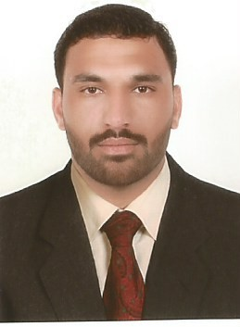KIRAMAT
Email : kiramat.383166@2freemail.com

OBJECTIVE :
To obtain a challenging position in a reputed organization where I can utilize and enhance my knowledge and skills regarding my education with ample opportunities for learning and advancement. SKILLS :
  - Very Energetic result oriented and organized
  - Efficient and well behaved person
  - Extremely hardworking self motivated and able to work independently in a team environment under supervision.
  - Keep excellent inter personal relations with colleagues and ready to help them.
  - Playing all games district level such as Football, Cricket, Baseball, Badminton , etc.

WORK EXPERIENCE
  - still working as a sales Representative at DIAMOND STAR TAILORING & TEXTILE –UAE
Since (27 March 2013)

PERSONAL DETAILS
Date of Birth : 07th AUGUST 1989
Place of Birth : Shapur Shawa Abad, Tehsil & District Kohat Gender : Male
Religion : Islam
Marital Status : Married
Nationality : Pakistani
Academic : Under Metric, Kohat board 2005
Languages : Pashto, English and Urdu

PASSPORT DETAILS
Date of Issue : 19/12/2012 Place of Issue : Pakistan Date of Expiry : 18/12/2022 Visa Status : Employment, Transferable

LICENSE DETAILS
Date of Issue : 06/09/2015
Date of Expiry : 06/09/2025 Permitted Vehicles : Light Manual

DECLARATION

I hereby certify that the above information is true, correct and accurate to the best of my knowledge and belief.

KIRAMAT KHAN

