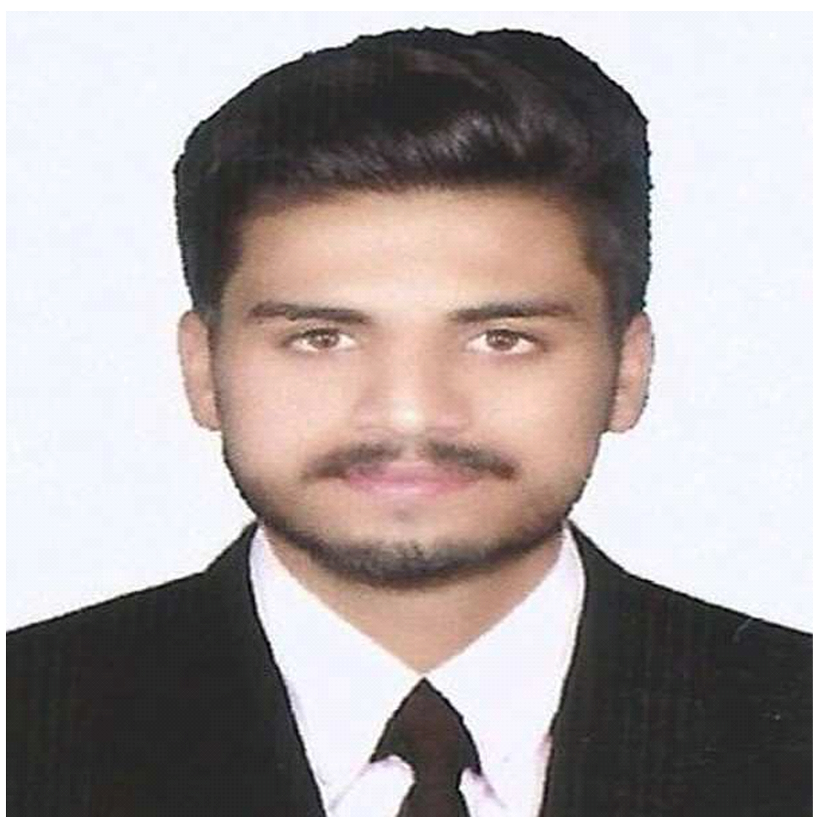
FAISAL (DRAFTSMAN)

Email: faisal.383179@2freemail.com

CAREER OBJECTIVE

As a Draftsman with 01 year experience, I am looking for my career in a field, where my technical and interpersonal skills would be well utilized and I would augment to the profit and cost cutting of the organization.

QUALIFICATION

- Quantity Surveyor from Government College of Technology Rasul, Pakistan (2017-18)
- Intermediate in Computer Sciences (ICS) from Board of Intermediate & Secondary Education Gujranwala, Pakistan (2014-16)
- Matriculation (Science) from Board of Intermediate & Secondary Education Gujranwala, Pakistan (2014)

TECHNICAL AND COMPUTER SKILLS

- AutoCAD
- Microsoft Office
- Using Email/MS Outlook
- Web Designing

PROJECTS

Worked as Draftsman trainee/internee in Al Asar Builders (Pvt) LTD. of Dream Land Marriage HallsPhaliaMandiBahauddin (Pakistan). Project total cost estimate is Pak Rupees 100.000 Million.

Learning from the project:

- To make shop drawings from provided structure and architecture drawings of project.
STRENGTHS

- Can work under challenging situation and tight schedules
- Good communication skills
- Good learner and have Can-Do attitude
- Can work better as a team player
- Can work out for new and unique ideas

PERSONAL INFO

Date of Birth: 24-Feb-1998
Marital Status: Single
Mobility: Can travel/work in any UAE State
Joining: Can join immediately
Languages: Urdu, English (read, write, speak, listen)
Nationality/Religion: Pakistani/Islam

VISA STATUS

Visa Type: Visit Visa

References will be provided on demand.

