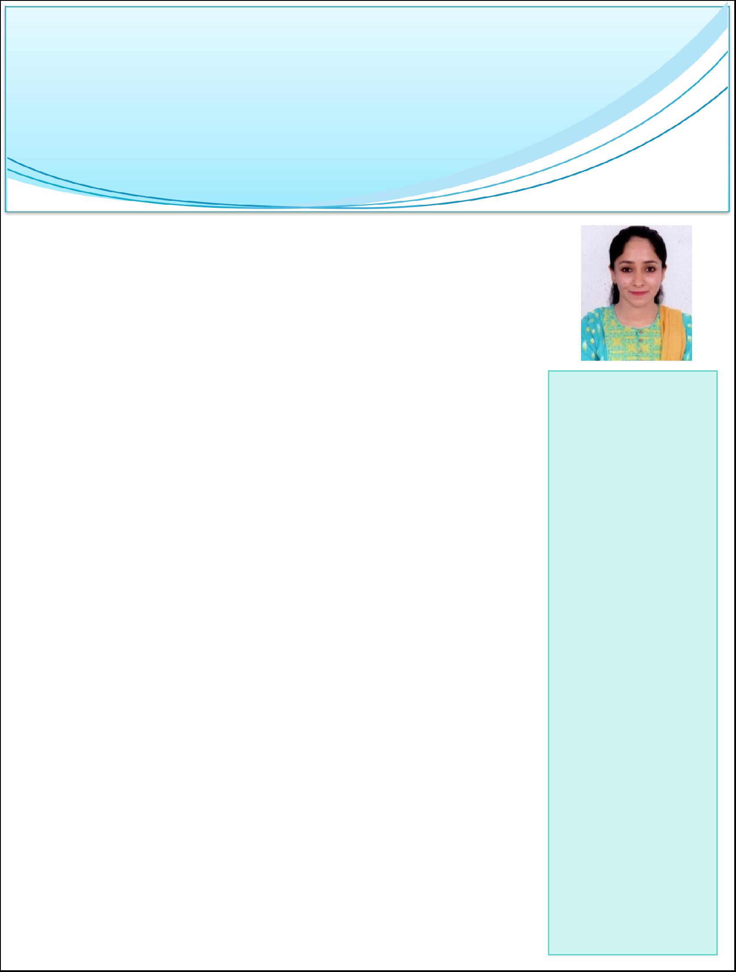
Alfa

HR Executive

alfa.383218@2freemail.com

Objective: - To secure a challenging and rewarding position as HR executive and utilize the inherent talent of the incumbent to the maximum. 6 months work experience in the field of human resources management after completion of MBA with specialization in HRM

Experience

Reliable Business solution & services, India | 07-12-2017 – 28-06-2018
Role: HR executive

- Handling bulk recruitments.

- Generating employee codes of the new joiners.

- Conducting employee orientation and facilitating newcomers joining formalities.

- Maintaining and regularly updating master database.

- Resolving queries that any of the employee have.

- Conducting the exit interviews of employees.

- Co-ordinating with consultancies and candidates for scheduling appointments.

- Oversee daily operations of the HR departments.

- Conducting the first round of the telephonic interviews.

- Preparing and submitting all relevant HR letters / docs / certificates

- Batch visit of the new joined candidates while they are in training.

Infinx services PVT LTD, INDIA 3 Months - INTERSHIP

Role: HR executive (03-09-2017- 30-11-2017)

- Reviewing resumes and applications.

- Manage the administrative tasks.

- Using online portals for recruitment.

- Spoke of 5 consultancies, Giving them the daily data of walk-ins.

- Takes 1st round of interviews just to check their MTI issue and general knowledge
- Forwarding daily track records to all departments.

Skills

*Identify & Pursue New Business Opportunities

*Team management

- Negotiation and persuasion

- Self-motivated

and passionate to succeed

- Quick in

grasping new concepts

& ideas

- Computer literacy and good keyboard skills

- Negotiating, good Judgment, decision making skills

Education

- Master’s in management studies (MBA)

Specialization: human resources (HR) University of Mumbai, INDIA 2016- 2018

- Bachelor’s in management studies (BMS) University of Mumbai, INDIA Grade-A

- Higher secondary examination (commerce)

Board of higher secondary examination, government of Mumbai, INDIA

Courses

- Government Diploma in MICROSOFT OFFICE 2012

Achievement & Skills

- Knowledge in operating system window and internet application

- Advanced user of MS Office application

- Excellent communication skills and interpersonal skills

Strength

- Highly motivated result oriented professional

- Excellent and strong analytical problem-solving abilities

- Good communication interpersonal and team work skills

- Ability to work under pressure meets tough dead and work independently

- Determination dedication honesty hardworking quick learner

Personal Profile

Date of Birth

Nationality

Religion

Marital Status

Languages

Visa Status

: 30-04-1995

: Indian

: Islam

: Married

: English, Hindi, Urdu

: Visit Visa

Declaration:-
I hereby declare that all the above mentioned information is true and correct to the best of my knowledge and belief

