Key Skills

Operations & Maintenance

Installation & Configuration

Project Management & Execution

Network Performance Management

Budgetary & Cost Optimization

Strategic Planning & Execution

Technical Support & Assistance

Reporting & Documentation

Cross-functional Coordination

Soft Skills

Collaborator
Change Agent

_{Analytical} Communicator

Thinker _{Planner}

TASKEEN
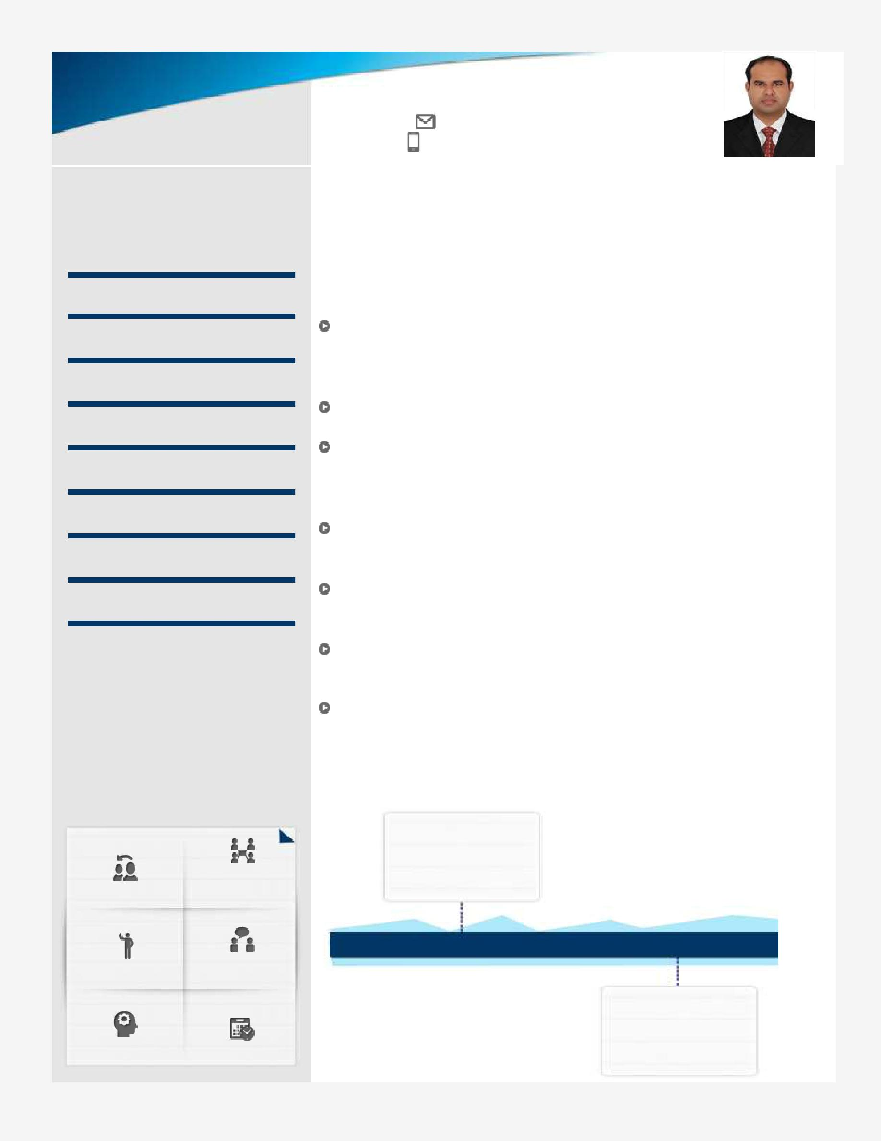

Taskeen.383219@2freemail.com

High-energy Technocrat with 10 years of experience; targeting strategic assignments in IT/Telecom Operations & Maintenance/Project Management with an esteemed organization

Location Preference: GCC/India
Driving License: Having UAE valid driving license

Profile Summary

An established professional with rich experience in managing Telecom Projects including planning, estimation, scheduling, scope definition, financial estimation, risk assessment, resource administration, process management and compliance with quality standards

Exhibited excellence in installation, maintenance and technical support of ISP related Subscriber Premises Equipment and Network elements Recognized for formulating strategies for projects across UAE & India; managing the complete range of project activities right from conceptualization to installation, maintenance & troubleshooting of various Telecom equipment

Rich experience in applying solutions/policies that would meet or exceed functional, operational, performance, analytical and security requirements while minimizing technical risks in implementation

Distinguished capabilities of setting out quality standards for various operational areas, ensuring a high-quality customer experience while adhering to the SLAs for their services and TRAI guidelines

Consistent record of delivering results in extending high-end technical support and ensuring high customer satisfaction levels through promptly addressing client’s problems

Leverages key analysis, insights & team approach to drive organizational improvements and implementation of best practices

Career Timeline

Oil and Natural
Gas Corporation
(ONGC) Dehradun

India

2006-2009 2009-2017

ETISALAT - Emirates
Telecommunication Corp.

Dubai (UAE)

Work Experience

April 2009 – September 2017 with ETISALAT - Emirates Telecommunication Corp., Dubai as Engineer – IT, Network Operation.

Key Result Areas:

Administered the project progress as per scheduled deadlines for various tasks and took necessary steps for ensuring completion within time and effort parameters
Responsible for designing proposals for Large Enterprises and Govt. Sector based on RFPs

Coordination with Business, Marketing and Solution Architect teams in solution designing (HLD/LLD) for L2/3 services, Advanced MPLS (VPLS, L2VPN, L3VPN), Global VPNs.

Supervised quality management, fault management, escalation management, preventive maintenance as well as performance management operations

Monitoring critical Data circuits for Business customers and arranging with concerned Engineering and Field support sections to enhance the performance of the network on a 24/7 basis.

Safeguarded the goals of the incident management process, restored normal service as soon as possible based on customer perspective and within defined SLAs

Reporting the status of different circuits and networks to the top management including Directors, VP, SVP and CTO.

Analyzed performance of core network elements through various KPIs, capacity utilization & capacity requirement Provided the technical support including installation, maintenance, training & demonstration for various hardware & software products

November 2006 – March 2009 Oil and Natural Gas Corporation (ONGC) India as Network Support Engineer.

Highlights:

Installing and managing routers & switches.

Client/Server management platform i.e. deploying domain structured network, streamlining user and group policies, security measures, and backup strategies for domain controller, managing user accounts using active directory. Perform troubleshooting end-to-end between the site ONGC Hospital and Tel Bhawan. And design the layout of cable installations.

Implementation SNMP on devices to allow for network management

Operate and troubleshoot the system infrastructure on LAN/WAN network.
Maintain documents of work perform during the day.

Education

3 Years Higher Diploma in Computer Science from Rajasthan University (INDIA)
1 Year Diploma in E-Commerce

Diploma in Hardware & Networking from NBC institute (INDIA)

Certifications

MCP (Microsoft Certified Professional)
CCNA (Cisco Certified Network Associate)

CCNP (Cisco Certified Network Professsional)

Trainings & Seminars

PMP (Project Management Professional) from Etisalat Academy Dubai (UAE) Installation, Maintenance and Configuration of Huwai and Zone ONTS and OLTS Value Added Sales and Promotions Techniques Behavioral Model for Customer Interface Staff

Seminars:

Huawei IOT Platform
Cisco Web 2017 in Atlantis, the Palm Dubai (UAE)

Six thinking hats
Structure Cabling Solution from KRONE, UK

Personal Details

Date of Birth | : 28th November 1985
Languages Known : English, Urdu & Hindi
Gender | : Male
Marital Status | : Married
Visa Status | : Visit Visa valid
Hobbies | : Reading Books, Travelling
Present Address: | : Ajman (UAE)

