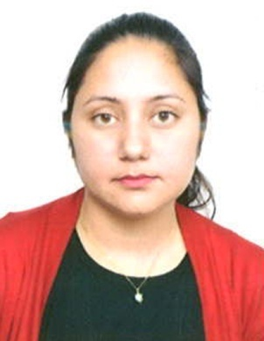
CURRICULUM VITAE
JYOTI

Email id : jyoti.383233@2freemail.com

OBJECTIVE:
"Seeking a challenging position in an organization where my experience will be fully utilized. To provide best service. I will focus on the nature of the work and try to learn the system of work which will help me for the better entry in this job. I will try my level best for the optimum results."

ACADEMIC QUALIFICATION
- 10th passed from Haryana Board with 58% Marks
- 12th passed from Haryana Board with 50% Marks
- B.Com ( Commerce ) passed from Nanital University with 50% Marks
- B.Ed ( Education ) passed from Kurekshetra University with 60% Marks

SKILL KNOWLEDGE
- Basic Computer Application
- Tally & ERP9
- Internet Knowledge

EXPERIENCE:
- 08 July 2013 to 05 August 2018 Work Experience in Giga Infotech Computers Pvt Ltd. As a Receptionist cum data entry Operator.
- One year work Experience in Amrita Knitwear Ludhiana as a Computer Operator
- Two year Teaching Experience in Parshuram Senior Secondary School Haryana

STRENGTH
- Excellent Communication
- Learning and quick grasping.
- Punctual
- A Good leader & listener

EXTRA CURRICULAR INTERESTS
- Reading Books
- Cooking
- Travelling

PERSONAL QUALITIES
- Honest and Punctual.
- Dedication to work.
- Adaptability to change.
- Hardworking and team work.

PERSONAL PARTICULARS

Marital Status Married
Gender Female
Date of Birth 04 August 1987
Language Known English , Hindi , Punjabi
Nationality Indian
Passport Place of Issue Chandigarh

I , Jyoti hereby declare that all the details furnished above are true to the best of my knowledge.

