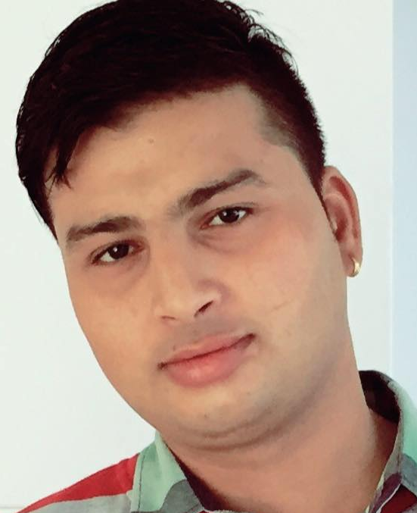
CURRICULUM VITAE

Mahesh
Email: Mahesh.383261@2freemail.com

Objective
Seeking a challenging career by occupying suitable position where I can utilize my skill & experience to contribute towards the progress of organization and have the prospect for professional growth and development of my career.
Qualifications
- Good communication, motivational, interpersonal and hardworking skills.
- Good knowledge of police and security procedures including locating prohibited items.

Education
- S.L.C. from Government Examination Board, Nepal

Training
- Heavy bus driving in Dubai and Nepal
- Fundamental of computer

Work Experience
- Worked as a Driver: 04 Aug 2011- 10 Feb 2017
Organization: School transfer service LLC, Dubai, UAE

- Worked as a Senior Driving instructor: 01Mar2017 – 15 Aug 2018
Organization: Kalika Construction PVT LTD, Nepal

PERSONAL DETAILS
Nationality : Nepalese
Date of Birth : 25th August, 1988
Sex : Male
Height : 6ft
Weight : 85 kg
Language Known : Nepali, Hindi, English
Visa status : On visit Visa

I hereby declare that the above-mentioned information is correct up to my knowledge and I bear the responsibility for the correctness of the above-mentioned particulars.

