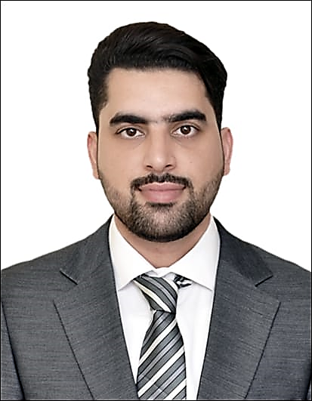
Ozair
Procurement Executive

Dubai, United Arab Emirates
Ozair.383262@2freemail.com

Executive Profile
A procurement Professional with a master’s degree in supply chain management.Having extensive experience of more than 6 years in the field of procurement, logistics and supply chain operations in Pakistan, Qatar and UAE,seeking a position where I can add value with my experience and achieve my career goals.

Expertise
- Supply Chain Operations
- Logistics
- Inventory Management
- Budgeting
- Microsoft Office
- Decision Making
- Strategic Sourcing
- Imports & Exports
- Warehouse management
- Cost Controlling
- ERP Software
- Leadership
- Procurement
- Vendor relationship
- Negotiation
- Contract Management
- Multi-Tasking
- Technical &IT

Experience

- AAGT International | Dubai, UAE.
An International Procurement and Sourcing company

Procurement Executive June 2016 – Present

Key Responsibilities
- Successfully handled all aspects of procurement from sales inquiry up till export.
- Vetted out suppliers by supplier evaluation and added them in our database
- Expertly negotiating with vendors to reduce costs.
- Proactively handled all export shipments by identifying key information and documentation.
- Staying up to date with the commercial market to see fit the best time to purchase.
- To get various certifications like FERI certificate, COC Certificate, COO Certificate etc. where required, depending on the country goods are being exported to.
- Efficiently prepared reports to have a clear idea of the status of tasks and what needs to be done.
- Coordinated with management to figure out key issues and had them resolved.

Key Achievements
- I Have handled a multimillion Dollar luxury apartment in purchasing Civil, Electrical, Mechanical
and Interior material like shower panels, decorative lights, wall papers, wall panels etc.
- Successfully won a project for tea bag machines, tea filling machines, tea filter papers and batch, production & Expiry machines by sourcing cheap goods with good quality from China and shipping through LCL.
- Have helped the company in negotiating and managing the contracts by adding key points
tosecure company’s interests.
- Have worked with my company for Projects in Iraq, Karbala and Kamzain in providing all goods
related to hotels likeKitchen equipment, electric appliances, furniture etc.
- Helped the company register Cosmetics through Dubai Municipality and Montaji for clients in India.
- Have helped the company to procure good quality packing material based on the time lines on which
they were at the cheapest of prices from China.

- Doha Connection W.L.L | Qatar
An IT company working on IT recruitment and providing IT Solutions

Procurement Executive June 2015 to Apr 2016

- Procurement of IT solutions and electronic items.
- Tahir Builders (Pvt.) Ltd. | Pakistan
A construction company making residential buildings for Pakistan Airforce

Purchase & Warehouse Manager January 2012 to May 2015

- Procurement of building materials to fulfill the requirements at Pakistan Air-force Base.

Education

- MBA/MS (Supply Chain Management)
IQRA University Islamabad, 2013

Core Area of Study

- Supply Chain management
- Strategic Logistics Management
- Procurement and Sourcing
- Distribution and Channel Management
- Proactive Supply Chain

Thesis

- Importance of Bullwhip Effect on Supply Chain Operations Efficiency

Profile

Place of birth Luton, United Kingdom
Religion Muslim
Marital Status Married
Gender Male
Date of Birth 21-jan-1988
Languages English (Fluent), Urdu/Hindi (Fluent)
Availability 1 months’ notice
Visa Status Employment Visa (Transferable)

References

Available upon request.

