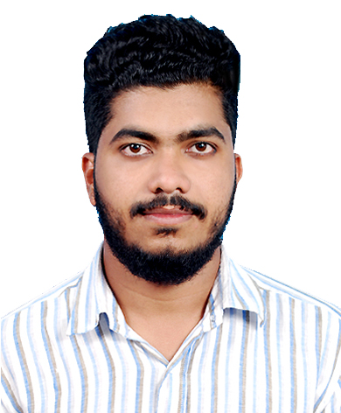

SHAMSUDEEN
Civil Engineer

E-mail: shamsudeen.383284@2freemail.com

Visa Status: Visit Visa

CAREER OBJECTIVE

Secure a challenging position in a leading company thereby contributing my maximum efforts by effectively utilizing my good qualities and join with a team that works for the better development of the company.

PROFILE SUMMARY

- Skilled civil engineer in a variety of engineering aspects.
- Professional presence with ability to work independently with very little supervision.
- Motivated individual who is committed to delivering the highest quality service in challenging environments.
- Focused on environmental safety, and health issues.

ACADEMIC QUALIFICATION
Bachelor's Degree in Civil Engineering from Visvesvaraya Technological University (VTU), INDIA
PROFESSIONAL EXPERIENCE
Company: Sigma Builders, Kerala , India, PH: +91 460 223 1921
From : 20/6/2017 to 25/6/2018
Designation: Site Engineer cum Draughtsman
❖ Checking plans, drawings and quantities for accuracy of calculations.
❖ Ensuring that all materials used and work performed are as per specifications.
❖ Overseeing the selection and requisition of materials and plant.
❖ Liaising with any consultants, subcontractors, supervisors, planners, quantity surveyors and
the general workforce involved in the project.
❖ Day-to-day management of the site.
❖ Overseeing quality control and health and safety matters on site.
❖ Resolving any unexpected technical difficulties and other problems that may arise.
❖ Preparation of the plan of the residential buildings as per the client’s needs.
❖ Preparation of detailed Estimation of building
COMPUTER PROFICIENCY
- Auto CAD with sound knowledge of 2D.
- Microsoft Office Package.
- Basics in STADPRO.
TRAINING DETAILS
- Participated in seminar conducted by Indian Green Building Council on March 25,2017 at Good Shepherd Auditorium in Bangalore ,Karnataka.
- Attended the “ONE-DAY HANDS-ON WORKSHOP ON SOFTWARE PACKAGE CYPE AND ITS APPLICATION IN CIVIL ENGINEERING” on May 17, 2017 at Bearys Institute of Technology, Mangalore , Karnataka.

PROJECT DETAILS
.
Title : Design and Analysis of Multi Storey Residential Building using ETABS
CERTIFICATION
- ISO approved certification in AUTOCAD( Civil based)
- Experience certificate as Civil Engineer .
PERSONAL DETAILS
Gender | Male
Date of Birth | 02/12/1994
Nationality | Indian
Languages Known | English, Hindi, Malayalam
Martial Status | Single

DECLARATION
I hereby declare that the above mentioned information is correct up to my knowledge and I bear the responsibility for the correctness of the above mentioned particulars.
SHAMSUDEEN

