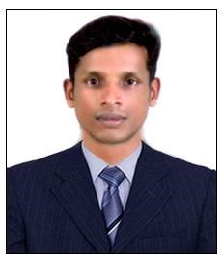

LINJU

E
-
mail:
Linju.383297@2freemail.com

CAREER OBJECTIVE
To seek a challenging and responsible assignment in a reputed organization where, I can apply my current skills, learn new techniques and grow with the organization.

WORK EXPERIENCE
- 1 year worked as Office Staff cum Sales Executive in Webzone IT SolutionsKanjirappally, Kottayam, Kerala (May 2017 to June 2018)
- 1 year worked as a Computer Teacher in Twinkle Stars School, Hyderabad. [2015]
- 1year experience as an Office Staff in DreamzoneErattupetta, Kottayam, Kerala
[2013-2014]
- Worked as a Sales Executive in Matrixx Info Systems Kanjirapally, Kottayam, Kerala from Aug 2010 to December 2012

EDUCATIONAL QUALIFICATIONS
- Graduation in Bachelor of Arts from M.G University in the year 2006. CERTIFICATIONS
- MCSA (Microsoft Certified Solutions Associate)
- MCP (Microsoft certified Professional)
- Diploma in Hardware & Networking
- MS Office

RESPONSIBILITIES
- Computer assembling and maintains.
- Installation of different operating systems like windows XP, windows 7, windows 8, windows server 2003/2008/2012.
- Hard disc partitioning and giving permissions.
- Installing software’s and applications to user’s standards.
- Installing and updating antivirus and other applications.
- Giving IP address and troubleshooting network problems.

PERSONAL DETAILS

Name : | Linju
Date of Birth : | 15-11-1984
Gender : | Male
Nationality : | Indian
Marital Status : | Single
Languages Known : | English, Hindi & Malayalam
Visa Status : VISIT VISA

DECLARATION
I do hereby declare that the information furnished above is true and correct to the best of my knowledge and belief.

