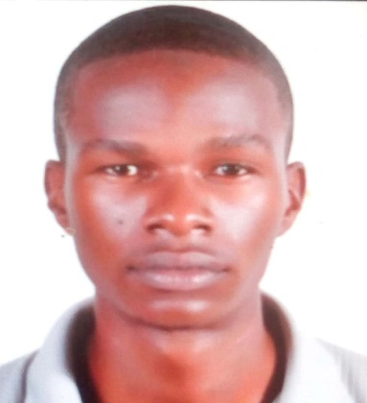

OJILONG
EMAIL: ojilong.383299@2freemail.com
VISIT VISA

PERSONAL INFORMATION
Full Name: Ojilong Abraham
Gender: Male
Date of Birth: 21st September 1993
Marital Status: Single

CAREER OBJECTIVE

As a recent graduate, I am eager to build a long-term career in the field of Information Technology and basketball coach. I would like to work with other professionals to improve my skills which will allow me to further contribute in the field of Information Technology and sports.

TECHNICAL SKILLS
- Web development and web design
- Database design and implementation
- Hardware troubleshooting and maintenance
- Microsoft Office Suite
Operating Systems: Windows and Android
Applications: MS Office, Visual Studio and Dreamweaver
Languages: C, HTML/XHTML, CSS, JavaScript and PHP
Database Systems: MySQL
PERSONAL SKILLS
- Excellent English skills
- Good verbal and written communication skills
- Motivated and always willing to learn new things
- Collaborative and able to work in teams or groups
- High level of maturity and sense of responsibility
- Sound time management skills
- Highly resourceful, objective and reliable

EDUCATION
Diploma in Information Technology
Multitech Business School
Kampala, Uganda
2014 – 2016
Uganda Advanced Certificate of Education (U.A.C.E)
Mengo Senior School 2012
Uganda Certificate of Education (U.C.E)
Mengo Senior School 2010

Interests: travelling, basketball, reading history and politics, watching documentary films, watching sports
Languages:
English – fluent.

REFERENCES
Referees in regard to my competence, work ethic, performance and / or any other aspect with respect to me are available on request.

