Dr. Saina
Dentist
United Arab Emirates
Visa Status: UAE Residence Visa
E-mail: saina.383302@2freemail.com

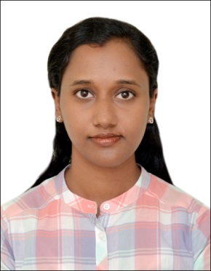

AREAS OF EXPERTISE
Diagnosis of Dental Diseases
Crown and bridgework
Root canal procedures
Tooth Extractions
Artificial Dentures
Teeth whitening

PROFESSIONAL
Eligible for DHA license
Registered with Kerala Dental Council

PERSONAL SKILLS
Able to concentrate for long periods
Attention to detail
Communication skills
Languages: English, Malayalam, Hindi, Tamil

PERSONAL DETAILS
DOB: 04/08/1989
Nationality: India
Marital Status: Married

Summary

A confident communicator who can relate well to dental patients. A confident healthcare professional with an excellent track record of effectively diagnosing and treating patients' dental conditions. Able to work as part of the dental team, and has a flexible approach to work.
Looking for a General Dentist opportunity to work with a forward thinking and highly regarded dental organization.

Experience

GENERAL DENTIST April 2015 – July 2018
Divine Dental Clinic & Orthodontic Centre, Kerala, India

Worked as part of a dental team in a busy dental facility providing a full scope of dental treatments to patients to help them maintain oral health.

Duties:
- Examining patients and diagnosing their orodental conditions.
- Restoringthe form and function of carious, fractured and otherwise defective teeth.
- Taking impressions, interpreting radiographs and setting artificial dentures to replace missing teeth.
- Dental Extractions and Root Canal procedures.
- Tooth preparation to receive crowns & bridges.
- Removable Orthodontic procedures including myofunctional appliances.
- Reassuring anxious patients and clearly explaining procedures to them.
SENIOR DENTAL HOUSE SURGENCY TRAINEE April 2017 – May 2018
Govt. Taluk Head Quarters Hospital,Kottarakara, Kerala, India

Completed one year Senior Dental House Surgency training in the dental department of Govt. Taluk Head Quarters Hospital,Kottarakara, India.

Duties:
- Examining patient’s teeth and diagnosing their dental conditions.
- Dealing with routine appointments and check-ups.
- Extensive knowledge of medical tools andequipments used in dental treatments.
- Dealing with emergency cases.
- Updating patient’s medical records.
- Root canal procedures.
- Non-surgical and surgical extractions.
- Minor oral surgical procedures.

INTERNSHIP Feb 2014 – Feb 2015
Azeezia College of Dental Science and Research, Kerala, India

- Completed one year internship in various dental departments of the institution as part of the course curriculum.
- Hands on experience in using specialist equipment used for Dental treatments.
- Worked as part of a dental team, comprising of Professors, Dental Health Educators, Dental Nurses & Dental Hygienists

Key Skills and Competencies
Well-presented and articulate.
Experience of advising patients on diet, brushing & other aspects of dental care.
Keeping up to date with the latest developments in dentistry.
Able to write prescriptions for antibiotics and other dental medication.
Excellent listening, communication and interpersonal skills.

Academic Qualifications

Bachelor of Dental Surgery (2015), 66.87%
Kerala University, India

References
Available on request

