Curriculum Vitae
Name : Amith
Address : Al Karama
United Arab Emirates
Date of Birth :7th March 1992
Nationality : Indian
Gender : Male
Email : amith.383316@2freemail.com
Languages known : English, Hindi, Kannada, Konkani and Tulu
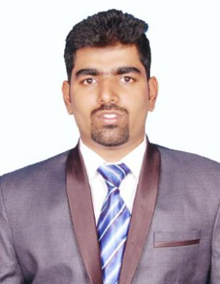
PROFESSIONAL SUMMARY

- To enhance my capabilities and skills by effectively using my education and experience in a challenging role for the benefit of the organization I work with.

- To take up a challenging career in a prestigious and esteemed organization where my skills and abilities can be utilized which can help me to grow along with the organization.

- To positively contribute towards taking the company to a next level with my skills, diligence and pursue challenging and rewarding assignments with your well appreciated company.

WORK EXPERIENCE
- Position - Senior process Executive
Company-Cognizant Global Services private limited ,Mangalore
Duration – 30th September 2015 – 3rd April 2018

Job Responsibilities Involved:

- Providing tax servicing and mortgage processing to the clients offshore as an organization and provide support functions as a part of a team.

- Tax servicing of Escrow and Non-Escrow accounts of US based clients.

- Managing and providing team support to team members.

- Working in a team to Meet deadlines, Set goals and establishing stable working conditions.

- Accepting new challenging initiatives and on spot responsibilities.

- Providing customer support to clients off shore by completing requests with utmost quality.

- Coordinating with the team to provide 100% efficiency to the clients by best utilizing company resources.

Competencies, Personal & Organizational Skills

- Coordinating tasks, setting goals, meeting deadlines and multi-tasking.
- Ability to perform in any stress related situation .
- Possess strong commitment to team environment dynamics with the ability to contribute expertise and follow leadership directives at appropriate times.
- Analyses issues, gathers information and develops strategies.

MAJOR STRENGTHS

- Ability to effectively interact with members at all levels of the organization.
- Flexible to different kinds of work environment.
- Willingness to learn and work hard.

EDUCATIONAL QUALIFICATIONS

2013-2015 SDM College of Business Management :
Master in business Administration
2010-2013 St Aloysius College (Autonomous), Mangalore :
Bachelors in Business Management

Computer Skills

- MS Word, MS Excel, MS Power Point, Tally.

Personal Interests

- Adventurous, learning new things, exploring opportunities.
- Travelling, visiting new places and meeting new people.
- Listening to music, dancing.
- Finding solutions and easier ways to complete daily tasks.

I, Amith, declare that the above information is true and correct to the best of my knowledge and nothing has been concealed or distorted.

Yours Sincerely,
(AMITH)
Reference will be provided on request.

