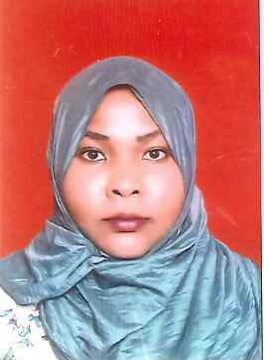
Cv
Naeima
Dental technician
Eligbitiy latter from DHA
Personal information
Date of birth; 04\02\1988
Nationality: Sudanese
Material status: single
Email: neaima.383319@2freemail.com
Education information
University: Khartoum
Faculty: dental technology
General grade: very good
Gradation year: 2010
Training courses:
Course porcelain from faculty of dentistry Alexandria 12/12\2009
Qualification
Intermediate diploma from faculty of dental technology Khartoum University
Eligbitiy letter from dha
Practical experience
Work as teacher assistant in laboratory of faculty of dentistry of Khartoum 2010-15/8/2011
W0rk as dental techcian laboratory and teacher assistant in national university from 6/8/2014-21/09/2016

Skills
Pouring casts
Waxing pattern
Removable complete /partial denture
Finishing metal
Build up proclaim
Inlaly/only
E max
Language
Arabic
English

