C.V
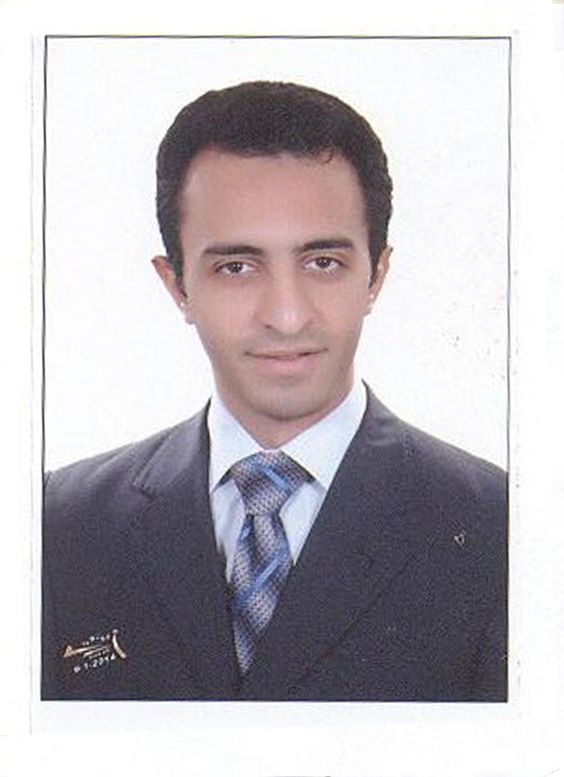

Personal Date
Name: Shawky
DateofBirth: 11/08/1988
Nationality: Egyptian
Religion: Muslim
MaritalStatus: Single
MilitaryStatus: Done
Driving License: UAE
E-Mail: shawky.383328@2freemail.com

Qualification
- Egypt's Higher Institute of Engineering and Technology, Mansoura University (MTI)
- Bachelor of Civil Engineering
- Project: Material (Very Good)

Languages
- Arabic (Mother Tongue)
- English (Good)

Computer Skill
- ICDL ( Excel , Word , PowerPoint, photoshop ), Autocad , civil
- Internet

Experiences

- Site Civil Engineer to implement renovations of the mosque Ahmadi Ghuarbya Governorate. Including all works (restoration of buildings columns, walls, bathrooms, ceramics and paints)
the project cost 750,000 LE and the duration was 15 month.

- Site Civil Engineer and Quantity surveyor to implement the renovations of Wastewater Treatment Plant in Menoufia. And it all works (aeration tank and thickener and review the levels of internal sewer lines)
the project cost 500,000 LE and the duration was 24 month.

- Soldier site civil engineer (Military service) for implementation of social housing at 6th October governorate, Dahshur Includes everything (Buildings - water systems - mosque – Club).
the project cost 780,000,000 LE and the duration was 12 month.
- Civil engineer consultant for Al TAWFEEQ engineering consulting office Saudi Arabia (Dammam and Najran).

*Site Civil engineer to Supervising the implementation of Saudi Post Offices
cost of the project is 16,000,000 SR and the duration was 12 month.

*Site Civil Engineer to implement workers housing in Jubail city cost of the project 16000000 SR and the duration was 16 month.

*Quantitative Engineer plus Assistant Site Engineer in Wastewater Treatment Plant in Dammam
the project cost is 100,000,000 SR and the duration was 12 month.

*Designer of Road Networks for Residential area in Al-hssa-saudi-arabiausing Civil and autocad program .

- Civil site engineer for (Aljumeiri Construction) to do villas in dubai (EL-BARSHA / AL-JUMEIRAH / RAS ALKHOR)12 month.

Skills

- Leadership and influencer with ability to control the workers and foremen.
- Good Team Member.
- Ability to work under pressure.
- Punctual and committed with the project time frame in coordination with the planning engineer.
- Ability to coordinate required materials from the company before due time for using it.

- *

