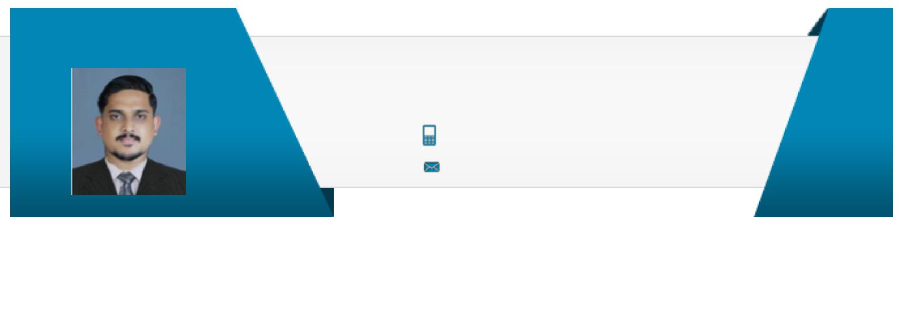
SHIHAB

Mechanical Engineer

Shihab.383354@2freemail.com

A Mechanical Engineer targeting for challenging & rewarding opportunities in project engineering field within the mechanical services area with an organization of high repute preferably in HVAC Industry Location Preference: UAE,Oman

EXECUTIVE PROFILE

A competent professional with over 3 years of GCC experience in Design & and Execution of HVAC projects of hotels, residential buildings ,villas and Cold-rooms
Expertise in detailed designing of engineering drawings or models with all important sections including Ducting & Piping, AHU, motors , pumps, Chillers and other MEP units
Successfully Completed 25 Projects At Various Parts Of Oman & UAE from 2015 to 2017
Performed negotiations and procurement with suppliers such as
Electrolux, Foster, Bitzer, Gunter, Pentair
Insightful knowledge of technologies like AutoCAD, CATIA V5 &
ANYSIS, MS office
Comprehensive knowledge of GFRP tool which helps in removal of burr & pits
Possess thorough knowledge of engineering standards
Team member of CALTECH - SAINTGITS - Art center (USA) joint research programme
Appeared in finals at TechTop National Level Technical Project organized by Mar Basalious College of Engineering in 2014
_{PROFESSIONAL EXPERIENCE} 19th Jan 2015 till 12th Sept2017

Al Ansari Trading Enterprise LLC, Muscat, Oman as Project and Procurement Engineer

Key Result Areas:

Engaged in managing ordering and post order processing activities which includes Design Review, Heating, Cooling Load Calculation,
Pipe Routing, Pump Head Calculation, Duct Sizing & Airflow Routing
Developed & submitted HVAC drawings to the clients for project approvals
Performed negotiations and procurement with suppliers such as Electrolux, Foster, Bitzer, Gunter, Pentair
Formulated & devised detailed engineering drawings with all important sections which includes Ducting & Piping for operational excellence Reviewed & understood the drawings & feasibility of the installation operations
Monitored & updated the work progress in accordance with bar chart Preparation of manpower requirements for pre-commissioning, commissioning and start-up and organization chart.

Key Impact Areas

CA Design Reviewing

Operations Management

Feasibility Study

Safety Management

MEP management

Procurement

TIA

Certifications

Advanced Certificate Course in HVAC from Keltron Knowledge centre, Kottayam

IT Skills

MS Excel | Autocad
McQuay | ANYSYS 5
Ductsizer

^{C++} CATIA

Testing & Commissioning of Variable Frequency Drive (VFD) , Variable Air Volume(VAV), Chillers, Duct, Air Handling Units (AHU) , Fain Coil Units(FCU) , Staircase Pressurization Fan (SPF), Tunnel Exhaust Fan (TEF)

Site commissioning team management, programming, commissioning & troubleshooting of Direct Digital Controllers.
Site activities for installation
Installing and managing Automation / Control modules & BMS (Building Management Systems).
Carried out Inspection of HVAC Air Balancing system in Building Automation.
Conducted FAT (Factory Acceptance Test) & SAT (Site Acceptance Test).
Modify graphical representations used for Remote process monitoring and controls using HMI.

Schedule & Execution of monthly Plant Preventive Maintenance (PPM) of MEP& BMS Systems through software’s.

Proper Engineering Documentation for site construction, pre-commissioning, commissioning status.
Well Experienced and knowledge in Overall functioning of MEP systems such as :

- Fire Alarm system operations
- Firefighting system operations

- Cooling tower & Chillers operations
- Firefighting system operations
- Electrical MEP
- HVAC systems
- Generators

- Automatic Doors
- Fire shutters and Fire curtains
- Air curtains

• BMS

Projects Undertaken:
Damac Project – Qatar
Royal Oman Police Project
Sheraton Oman
Ibis Hotel – Sohar
British Petroleum PDO Site - Khazzan
German Embassy - Oman
Royal Oman Police Project
City Hotel - Muscat
Crowne Plaza - OCEC
Marriot Hotel – Muscat
Cove Rotana – RAK

Highlights:
Formulated and evaluated the engineering drawings along with the approvals
Planned, executed and streamlined projects as per the scheduling designed/framed by the Operating Team

Performed good interactions with European suppliers such as ELECTROLUX, FOSTER, BITZER, GUNTER, PENTAIR
Entrusted with the responsibility of allocating the required resources at various project sites

Escalate all sensitive and/ or complex facilities-related issues to the Manager, Facility Management to ensure that the issues are escalated quickly to enable the company to take appropriate measures to remedy the situation and / or provide appropriate solutions
Work with nominated Facilities Management Company to ensure the building systems and infrastructure are prepared to install and operate equipment and provide building services in a safe, timely and effective manner

Take initiative and provide inputs to the departments continuous improvement process Keep adequate records of all maintenance related tasks, recreational facilities.

Liaise with internal and external providers to obtain the best level of service for the company and ensure that preventive maintenance schedules are maintained

EDUCATION & CREDENTIAL

B.Tech. in Mechanical Engineering & Management from Saintgits College of Engineering, Kottayam, Kerala, in 2014; secured 7.2 CGPA

12th from Good Shephard Public School, Kottayam, Kerala in 2010; secured 81% 10th from Good Shephard Public School, Kottayam, Kerala in 2008; secured 84%

ACADEMIC PROJECTS

Title: Design of Multi-Utility Wheel Chair
Successfully executed the fabrication of a wheelchair at reasonable cost for common people which could be used as Stretcher as well
Fabricated with adjusting facility to 80cm. which was portable & durable Title: Design of Mechanical Rubber Mat Punching Machine Location : Pasedana , USA

Worked on a joint academic course: ‘Product Design for Developing World’ by CALTECH Institute of
Technology
Successfully executed the fabrication of rubber mat punching machine for supporting the workers in mat industry

SEMINAR
Attended a seminar on ‘ Removal of Burr & Pits using GFRP Tool on Small Gears’

EDUCATION TIMELINE

 | 2010
10th | 12th | B.Tech.
 |  | Saintgits
Good Shephard | Good Shephard | College of
Public School | Public School | Engineering
2008 |  | 2010 - 2014
ACADEMIC ACHIEVEMENTS
Secured 1st position at Caltech Institute of Technology for Rubber Mat Punching Machine and received an award for the same

Awarded for developing a Multipurpose Wheel Chair

PERSONAL DETAILS

Date of Birth: 25th April 1991
Languages Known: English, Malayalam, Hindi, & Arabic
Nationality: Indian
Marital Status: Single

